ALMA QUICK TIPS: Renew an Item
- Search for a patron and click on all loans.
- Put a check mark on items that the patron wants to renew and click on Renew selected.
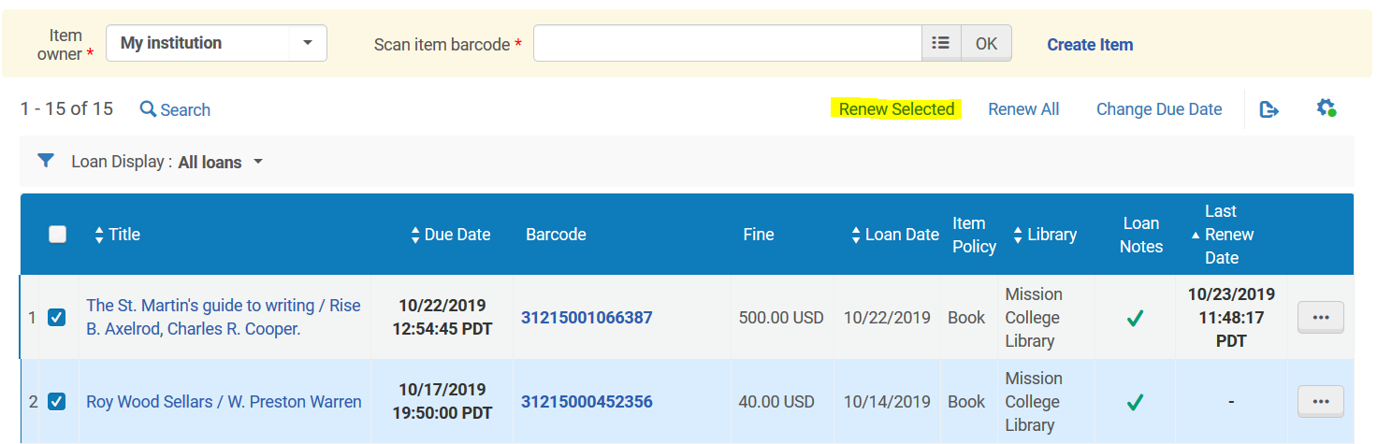
Or you can click on at the end of each row and click on Renew.
- If patron wants to renew all items, click on Renew All link on the top.
- The Last Renew Date will be updated and patron will receive a notice that the item is renewed.
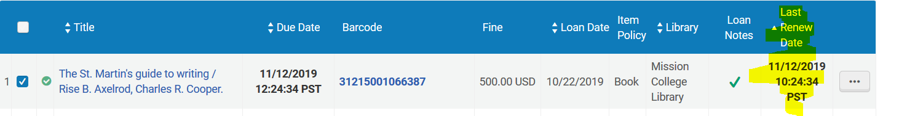
Note: You can use Change Due Date but can't choose a due date that 1) Is past the user's expiration date, or 2) a date that the library is closed.

