ALMA Quick Tips: Editing the URL of a Web-based OER on a Reading List

Step 1: Navigate to the Resource You Wish to Edit
Use the search window to navigate to the resource. Here, we’re limiting the scope to only “Electronic Titles” to produce more relevant results. An “All Titles” search would work as well.
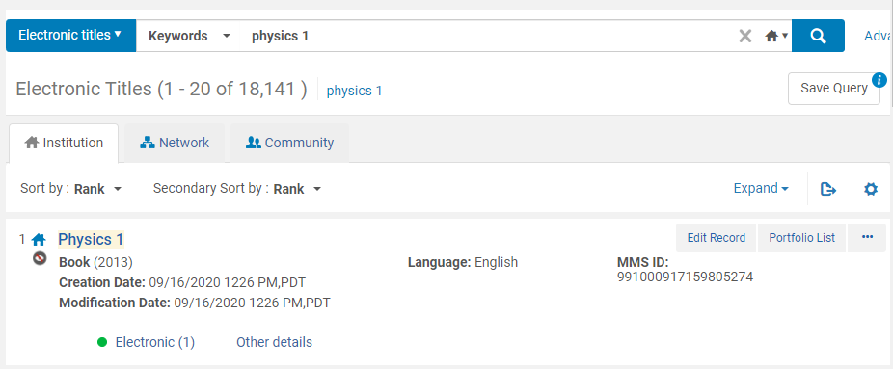

Step 2: Expand the Search Result
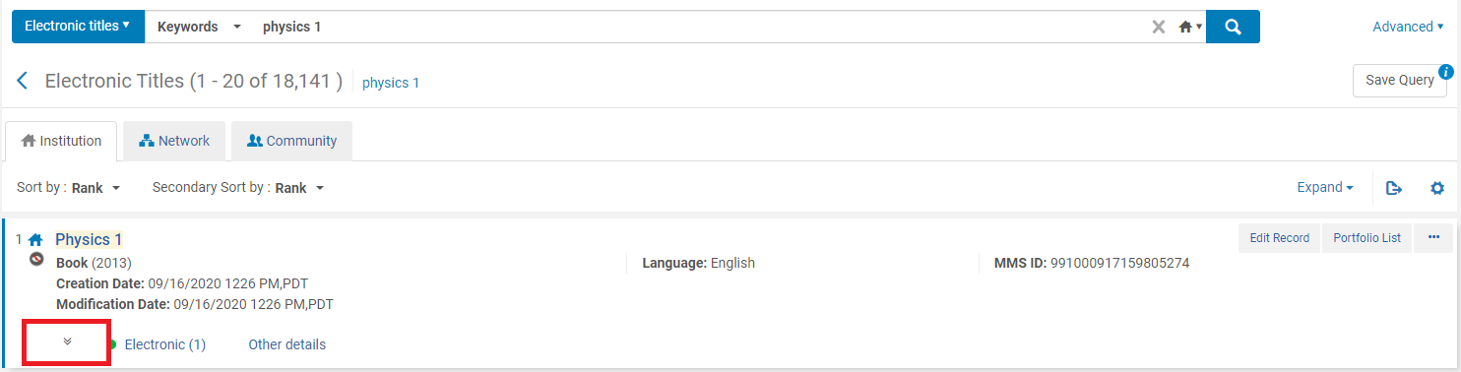

Step 3: Click on “View” under Portfolio
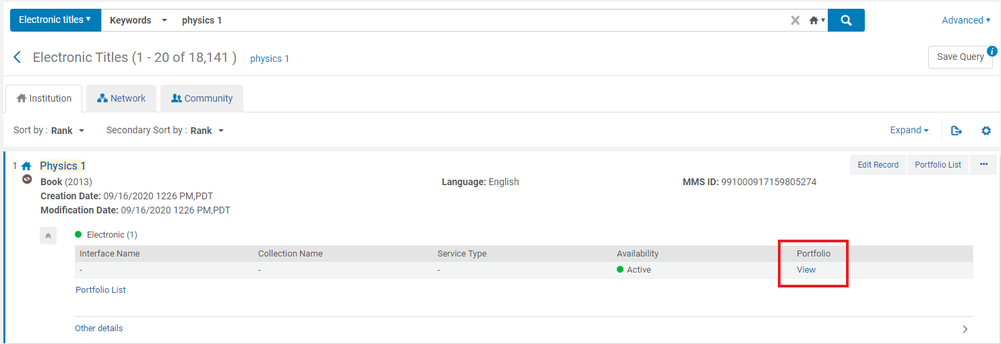

Step 4: In the Electronic Portfolio Editor navigate to the Linking tab
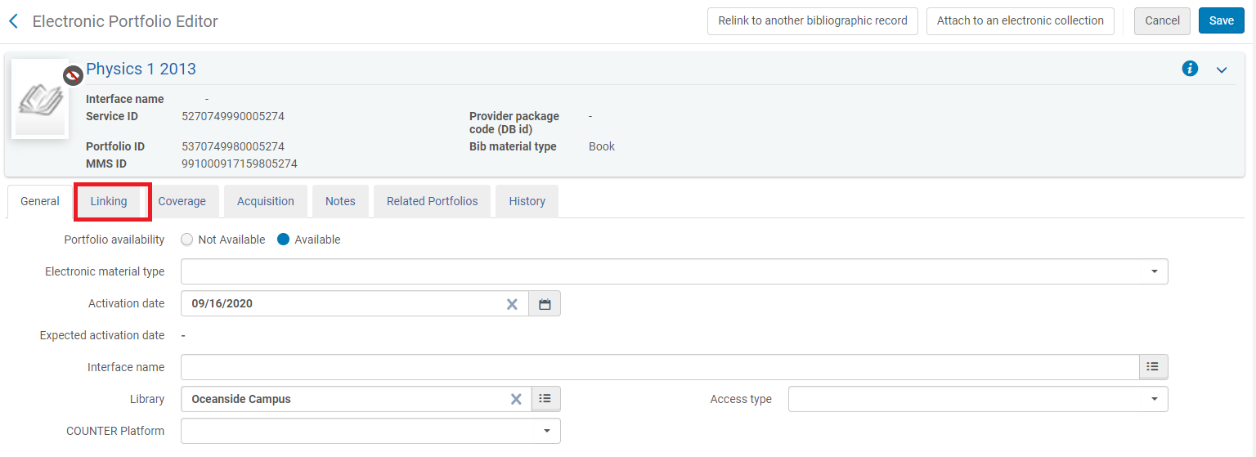

Step 5: In the Linking tab, select the existing URL and delete it.
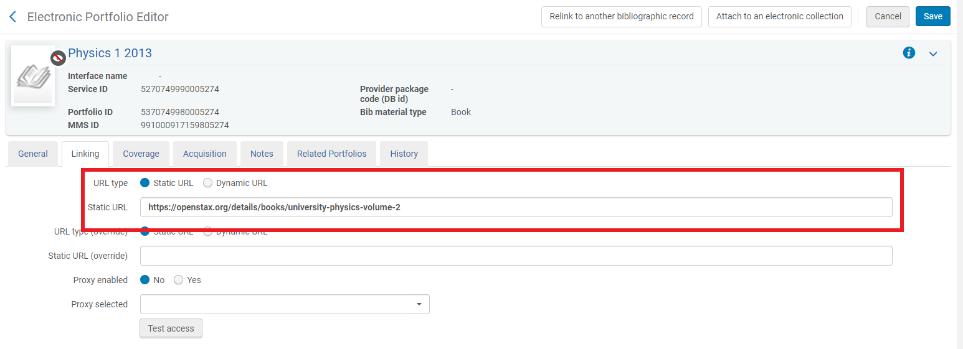

Step 6: Paste the updated URL into the Static URL field, then click save.
