ALMA QUICK TIPS: Placing a Hold and Canceling a Hold
- Search for the item to be requested in the Alma dashboard. Narrowing the search to Physical Titles is recommended.
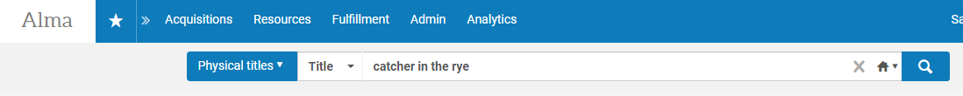
- After identifying the item in discovery, click on the “•••” box in the upper right hand corner of a result. Then, select “Request” from the dropdown. Note: depending on your institution’s configuration, shortcuts may exist for this action (a “Request” button on the item record, for example).
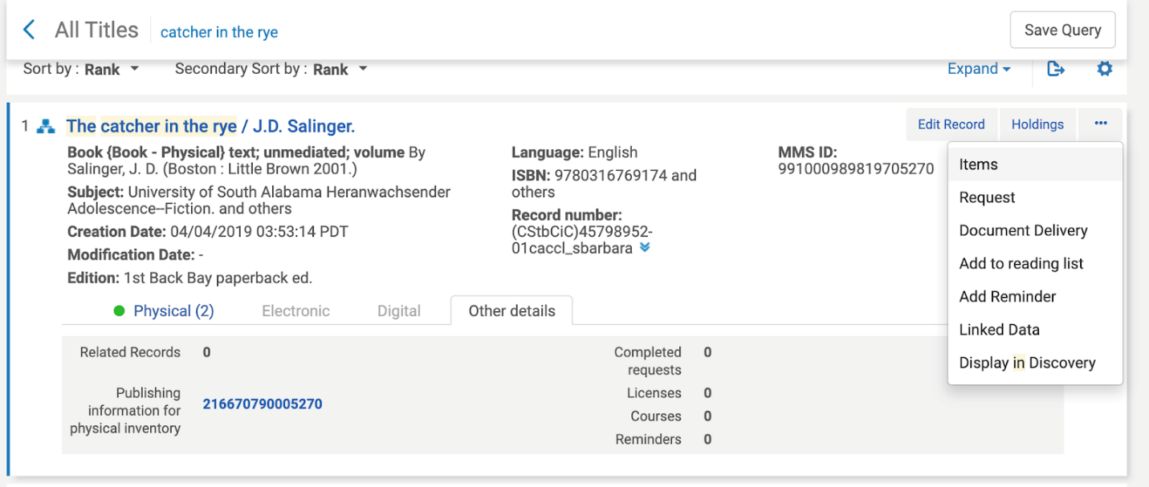
- On the Create Request screen, select “Patron physical item request” from the dropdown menu.
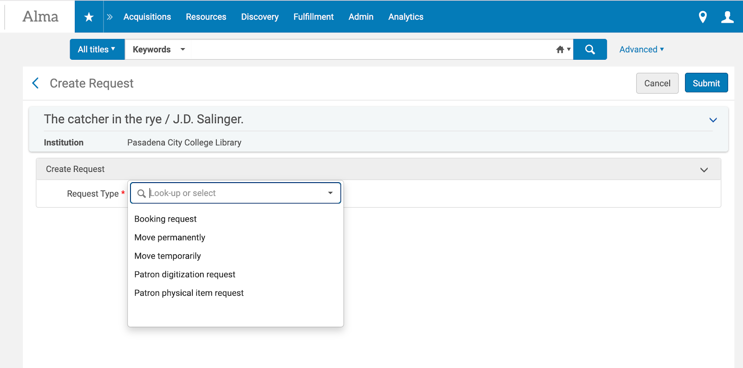

- On the screen that follows, enter the “Requester” barcode number and the “Pickup At” location.
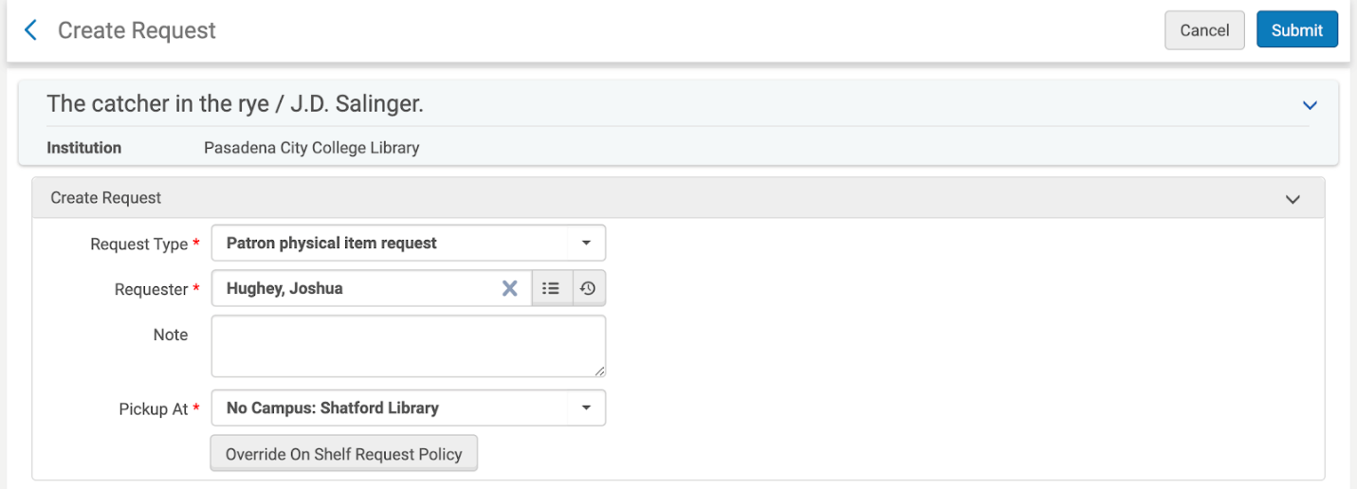
- If you do not allow “on-shelf” requests but want to override that policy, you can click on Override On
Shelf Request Policy to do just that!
- Click “Submit” to complete the request.

Canceling a Hold in Alma
There are a few ways to cancel a hold in Alma:
- Staff with the appropriate authorization/user roles can cancel a hold by going to Resource Request Monitoring under the Fulfillment drop-down menu and selecting “Cancel” on the appropriate request record.
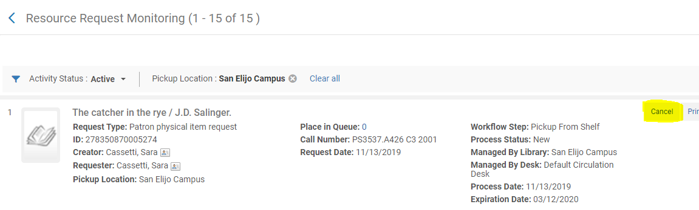

- Staff who are limited to the Circulation Desk Operator role can navigate to the requesting user’s account under Manage Patron Services, go to the “Requests” tab, and select “Cancel” from the dropdown menu under the 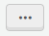 button.
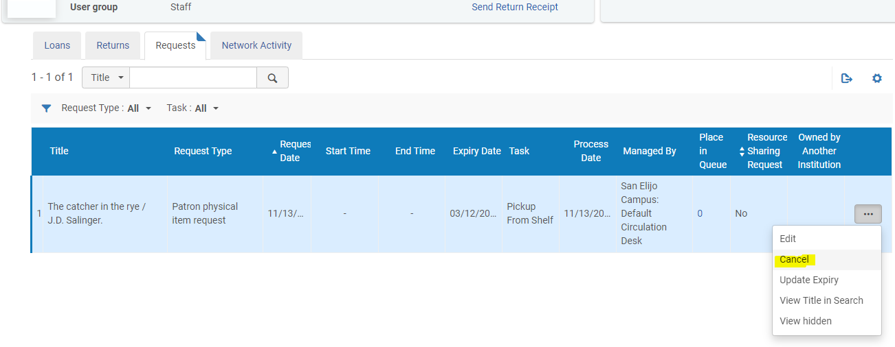
- Lastly, patrons may cancel their own requests using Primo by going to their account information, selecting “My Requests” from the dropdown menu (pictured), and selecting “Cancel” from the list of requests.
