Napa Valley College Library Spring 2021 Re-Opening Protocol
(12.2.20)
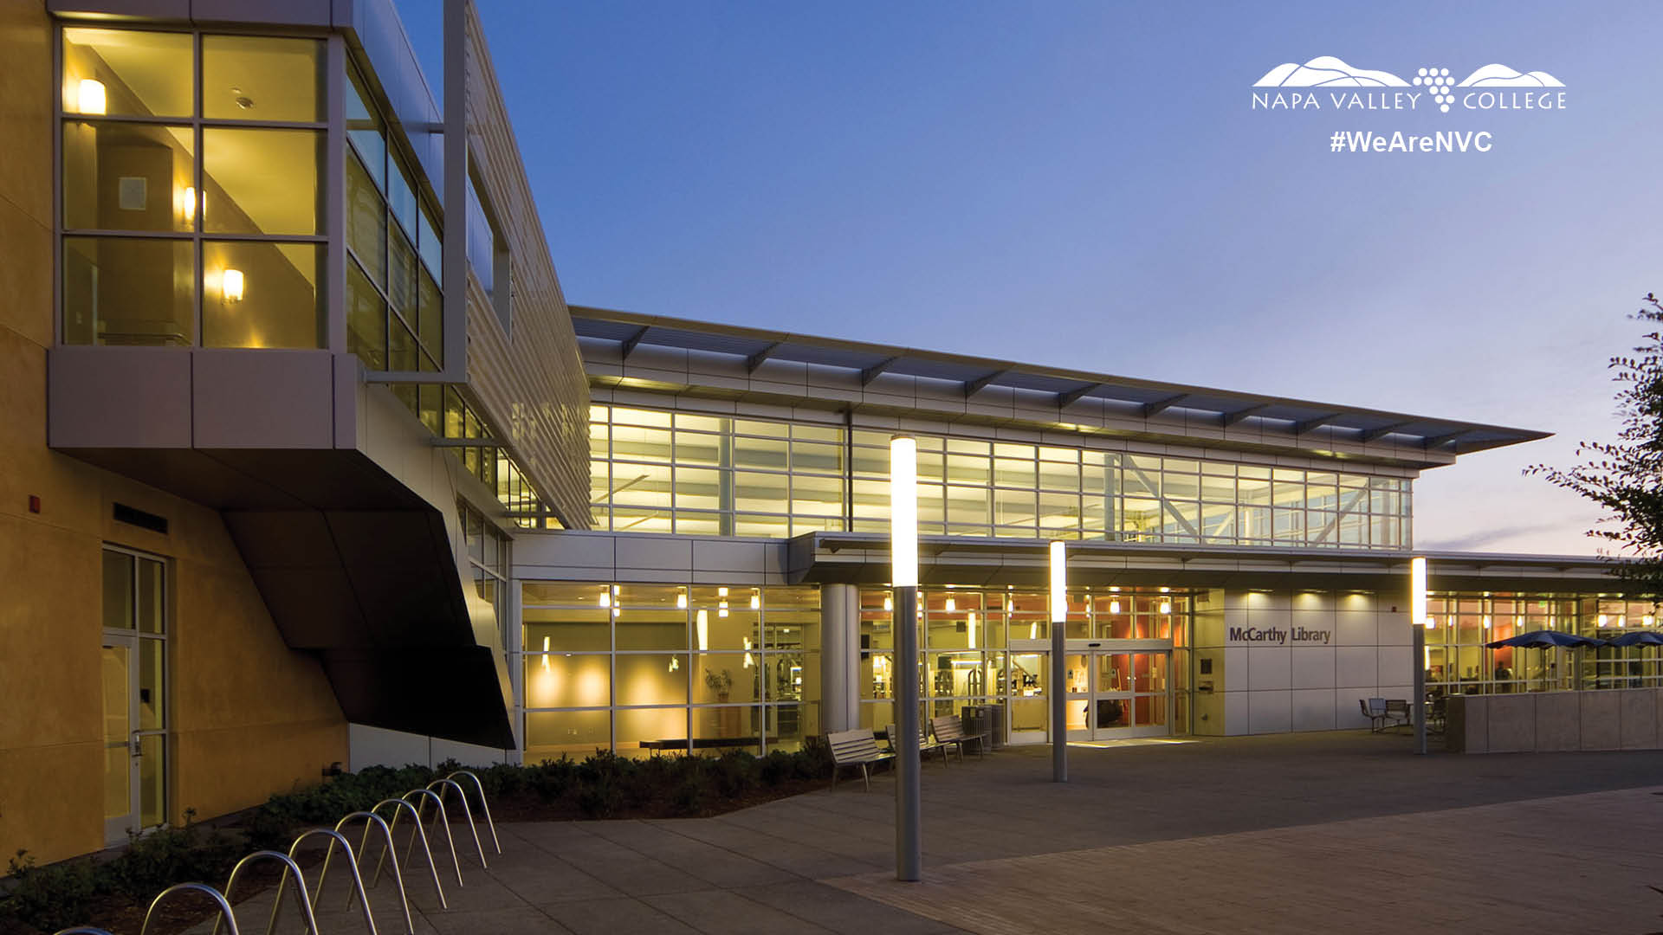

Phase 2:

Open @ Reduced Capacity (first come, first served)
Current NVC Students (and Faculty, Staff) only
For access to technology, individual study rooms, book pickup
Beginning:

Proposed Hours Monday: 10-2; Tuesday: 11-3; Thursday 2-6:00PM

Library capacity has been reduced to accommodate 6ft distance between computer workstations and seating at study tables. Plexiglas has been installed at the circulation desk, and signs and floor tape will direct students and encourage social distancing.

Computer Stations available: 25
Individual study rooms available: 4
Total Capacity: 29

Library Procedures and Policies:
- Students (also Faculty/Staff) enter first come first served
  - NVC Library Card and Mask required for entry
- Library staff will monitor gate count & direct users to circulation desk
- Front gate is open (one way entry and separate exit)
  - Floor markings and stanchions will direct students to the circulation desk and encourage social distancing
- Students will check out a workstation at the circulation desk for up to two hours, with ½ hour break for cleaning between uses; seating at tables and study rooms also will require registration/check-in at circulation desk.
- Students may also check out laptops or calculators at the circulation desk then exit
- All available workstations (desktops, individual seating at study tables) will be barcoded through the library system. Once capacity is reached no one else will be allowed entry unless a student leaves and table/computer is cleaned. Students may get on the waiting list but need to wait outside of the library building. They will be notified by phone call once a space becomes available.
- Reserve textbooks to circulate for 1 week; returns subject to 72 hour quarantining prior to checkout. Provision e-textbooks as available and educating faculty on provision of uploading textbook content into Canvas sites.
- Librarians will continue to assist students/faculty/staff online; no onsite Librarians
- Library workshops will be held online only.
- Printer/copy room closed (until a contactless, wireless printing system can be put in place)
- Stacks are closed (areas clearly cordoned off with chairs, etc.); students/faculty/staff can request books through the online catalog in advance. Staff will pull the books and notify students/faculty/staff when they are ready for pickup.
- All borrowed/returned regular library books (from open stacks/County Library, etc.), calculators, laptops subject to 72 hour quarantine before rehandling/return.
- No cash handling/fee collections
- No access to Classrooms through interior entrances in the Library

Specific Staff Duties/Needs:

  - One to two staff monitoring door/gate at all times checking in users & monitoring circulation desk
  - One staff to clean as users leave during the day ;One to two staff monitoring floor to ensure social distancing; also to clean during the open hours
  - PT staff to rotate through circulation desk coverage for breaks and lunches
  - Staggered and rotational staffing to minimize f2f contact among all staff (preferable to have flexible work arrangements approved for staff to facilitate)

Supplies Needed

- Keyboard covers
- Facilities recommends and has hydrogen peroxide spray for keyboard sanitization
- Microfiber wipes to apply hydrogen peroxide to keyboards for cleaning, Facilities to provide
- Wipes for students to clean their own workspace
- Wipes for staff to clean circulation service desk area throughout the day
- One time use masks for students who didn’t bring one (just for contingent, urgent use)

Phase 3: Beginning when College fully reopens

Reopening the Library for normal operations, full services, regular schedule
Open to NVC Students, Faculty, Staff and Public

