Questions and Answers –
Fulfillment Configuration Part I

Is there a default Time to reshelve if nothing is entered?

The default Time to reshelve will be 0 minutes or hours if nothing else is entered.

I have the options: has hold shelf and has hold shelf processing. What is the difference between these?

Has hold shelf indicates that the library allows patrons to make requests for items that are either on loan or on the shelf. Has hold shelf processing is used to indicate that the Circulation Desk can store items that need to be processed before they are placed on the Hold Shelf and the patron is notified that they are available.

Can you unpack the hold shelf processing concept?

Hold shelf processing is an option that some libraries use to provide a little time to store and examine Hold Shelf items before they are made available to requestors. This interval gives the staff operator and opportunity to review the condition of items returned, confirming that all pieces have been returned or to determine if there is anything urgent that relates to the physical item in hand. Basically, this means that the item is deemed to be not yet ready for the hold shelf. Once hold shelf processing is complete, the item is scanned at the relevant Circulation Desk after which it is placed on the Hold Shelf. At that time, or, depending on the setting for Delay for hold notification, the requesting patron is sent notification indicating that the item is ready for pickup at the Hold Shelf.

Two important bits of information regarding hold shelf processing. First, a staff operator can bypass the Hold Shelf Processing interval by enabling the option, Place directly on hold shelf, when using the Scan in Items workbench. Second, using hold shelf processing requires a second scan of the items before they are put on the Hold Shelf and the patron receives notification of availability.

We have seen the behaviour that if a hold shelf is turned OFF, NO CAMPUS or no option show in the Pickup location for patrons placing requests. Also, requests do not route properly.

If libraries allow patrons to request items that are either on loan or on the shelf, the Hold Shelf for that Circulation Desk must be enabled. In this way, libraries can process the requests properly, routing them appropriately.

We were told that if we select Handle Automatically that it wouldn't even alert us. Is that correct?

That is correct. If using “handle automatically,” the action happens automatically, behind the scenes, according to the handler selected in the Block Preferences table.

Can you show how to set up policy to Anonymize Fines and Fees 1 year after paid?

Begin by going to Configuration > Fulfillment Configuration > Fulfillment Jobs Configuration and scroll to the Anonymization Job section.

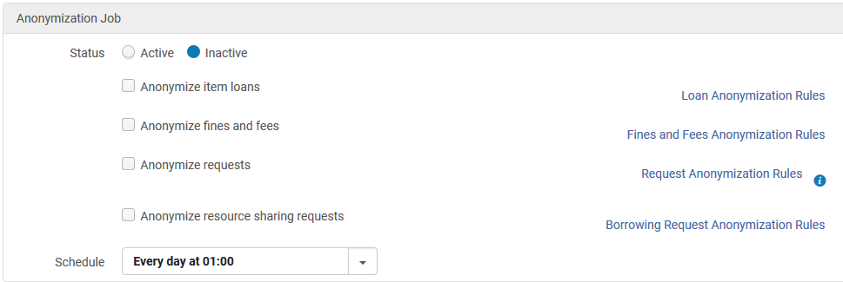

Click on the link for Fines and Fees Anonymization Rules to open the rules list. Click on Add Rule…
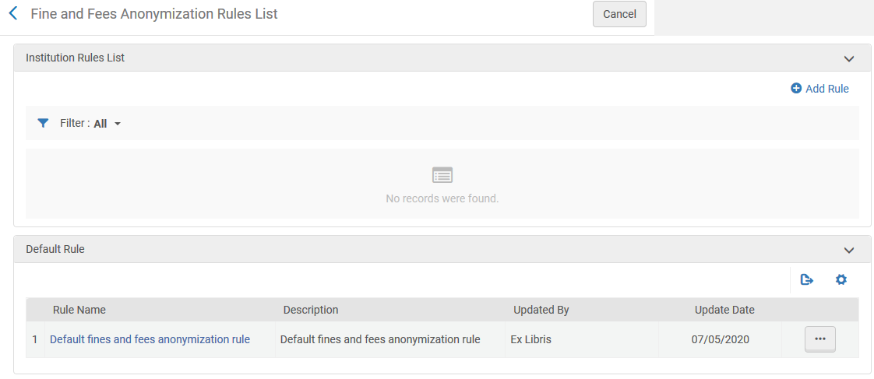

…and enter a name for the rule (description is optional).
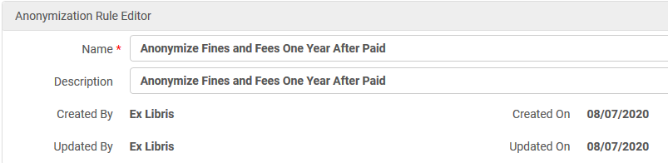

Go to the Input Parameters section and click on Add Parameter.
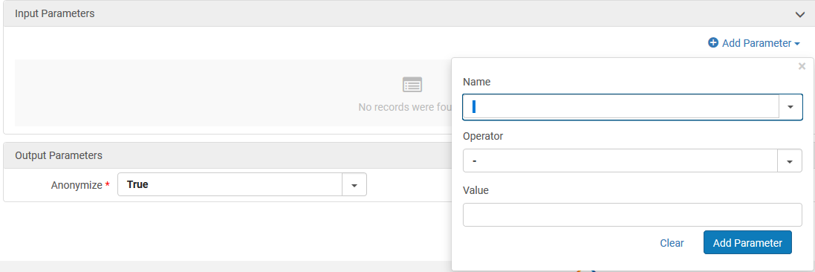

Choose and enter the appropriate parameters. In this case, Name = Days Since Fine/Fee Closed, Operator is =, and Value = 365. Click on the Add Parameter button to add this parameter.
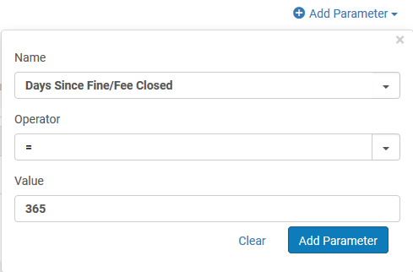

The Output Parameters for Anonymize should be set to True.
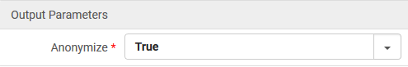

In the end, the rule looks like this:
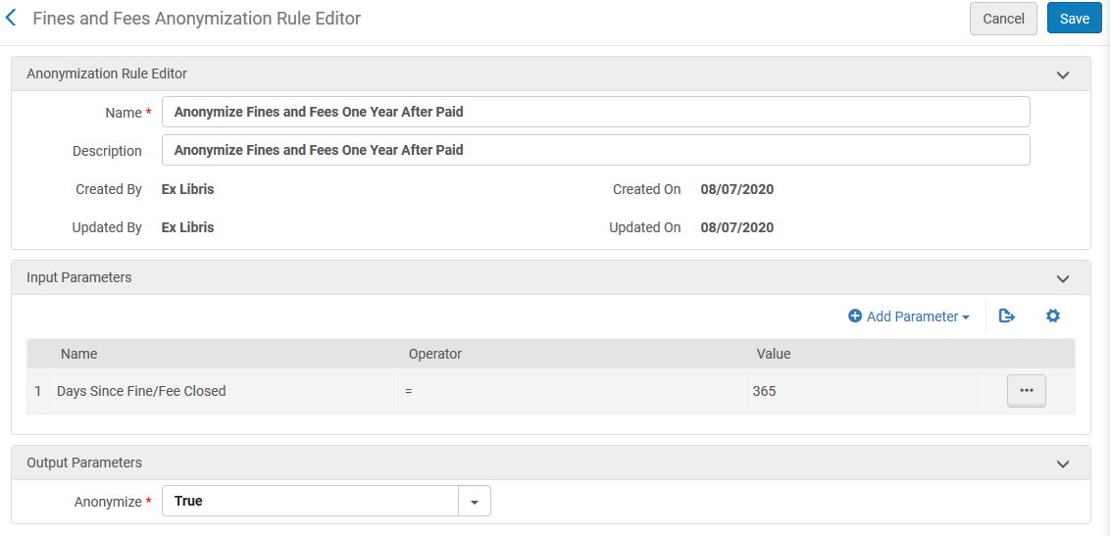

If desirable, you may add other parameters as appropriate.

Would these be batched or an individual email per item?

Letters sent in relation to the Overdue and Lost Loan Profile will include all items that meet the criteria. This means that a patron who has five items on loan with three of them that are 30 days overdue, the patron would receive a single letter that includes details for the three items via Overdue notification type 1.

