ALMA QUICK TIPS: Counting Items Used In-House
1. In the Fulfillment menu, click Scan In Items

- Check the box marked Register in-house use

“ “‘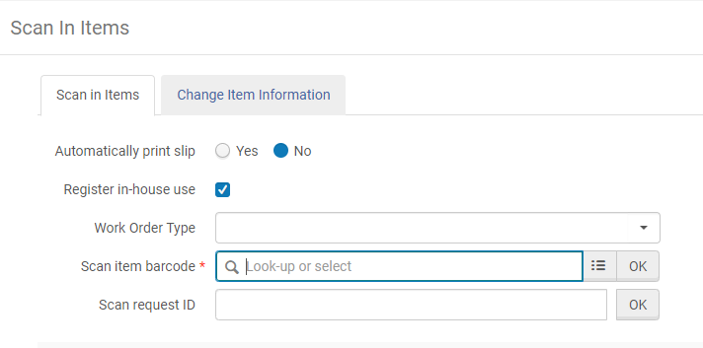

- Scan the item barcode. It will appear in a list on the lower part of the page

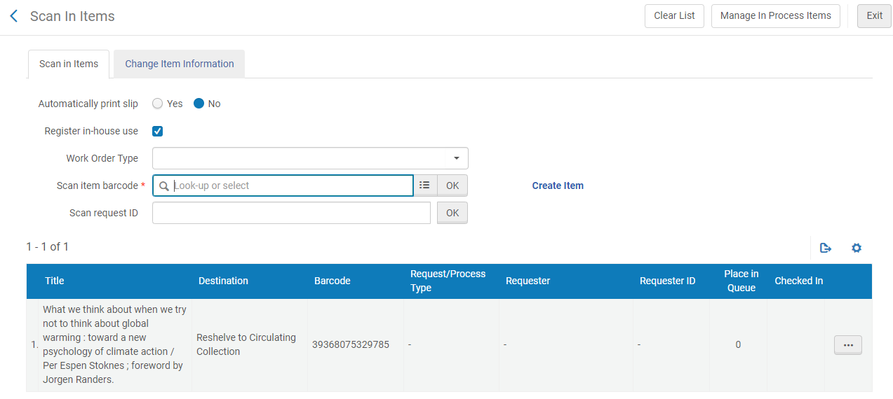

- After scanning all the items, click Clear List in the upper right corner. This records the usage

- To see the in-house use statistics on an item, search for the item by barcode
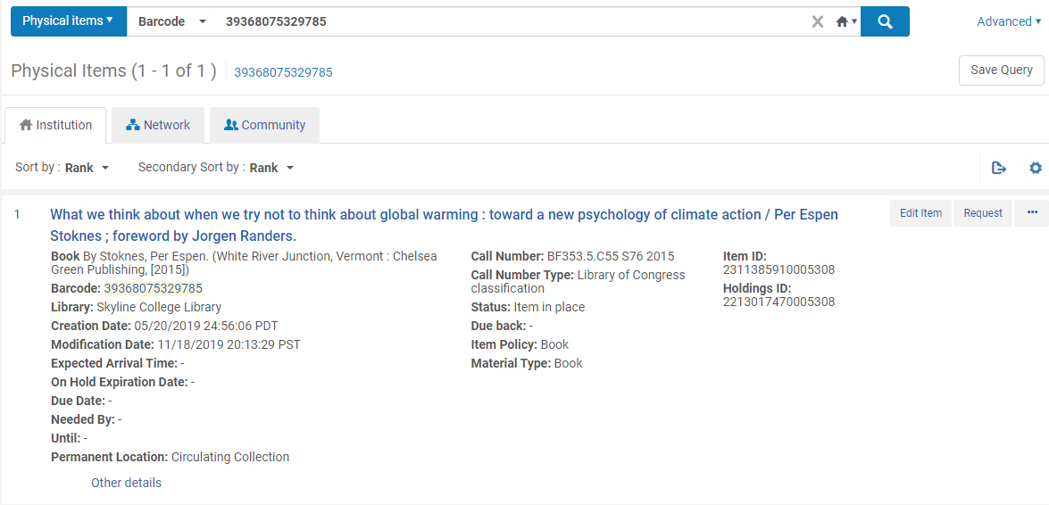
- Click on Other details. This will reveal the circulation statistics for the item

