ALMA QUICK TIPS: Counting Items Used In-House
- From the Fulfillment menu, click Scan In Items
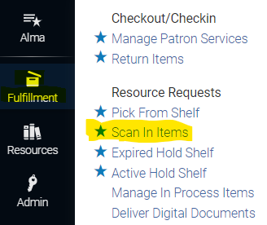

- Check the box marked Register in-house use

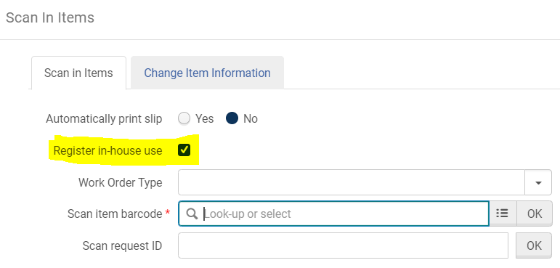

- Scan the item barcode. It will appear in a list on the lower part of the page

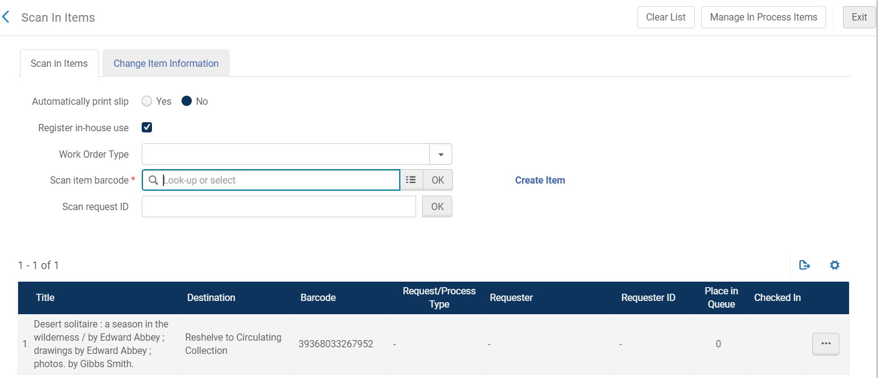

- After scanning all the items, click Clear List in the upper right corner.

- To see the in-house use statistics on an item, search for the item by barcode or another field
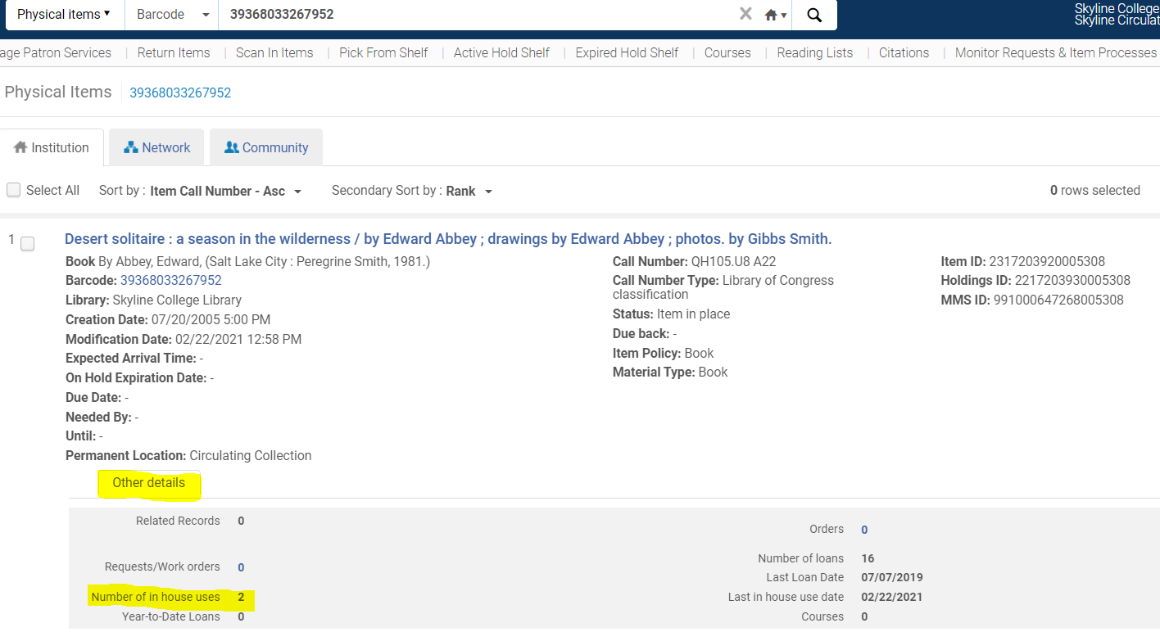

- Click on Other details. This will reveal the circulation statistics for the item

- NOTE 1: If the item is checked out when it is scanned, it will be checked in and no in-house use will be recorded. It will show up as a loan in the statistics.

- NOTE 2: If an item is scanned using Return Items and is not checked out, it will register as an in- house use.

Version 2.0, 2/22/2021

