Alma Quick Tip – Enabling the close_paid_lost_loan parameter

Summary
This guide will walk you through the process of enabling the close_paid_lost_loan parameter. This solves an issue where a lost item is paid for in Alma, closing the active fee associated with the lost item, but the item remains on the patron’s account.
A fix to this problem was introduced in the January 2019 release of Alma. In this release, the “Lost and paid” loan status was introduced. If the close_paid_lost_loan parameter is set to “True”, when an item’s status is set to Lost and any associated fees are closed, the item is removed from the user’s account. This parameter is set to “False” for customers who had an installation of Alma prior to the January 2019 release. Customers from January 2019 and onward have this parameter set to “True” by default. Nevertheless, we recommend verifying that this parameter is set for your institution’s policies.

Step 1: From Alma Configuration, Navigate to Fulfillment > General > Other Settings
From your Alma homepage, press CTRL – ALT – C. Alternatively, click the configuration button at the bottom left of your Alma homepage.
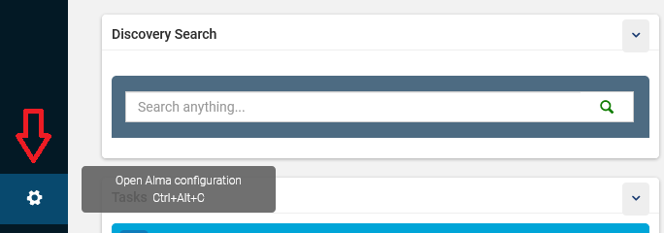

In Alma Configuration, ensure you are configuring at the institution level.
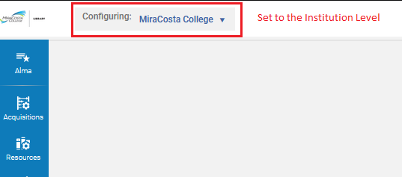
Navigate to Fulfillment > General > Other Settings.
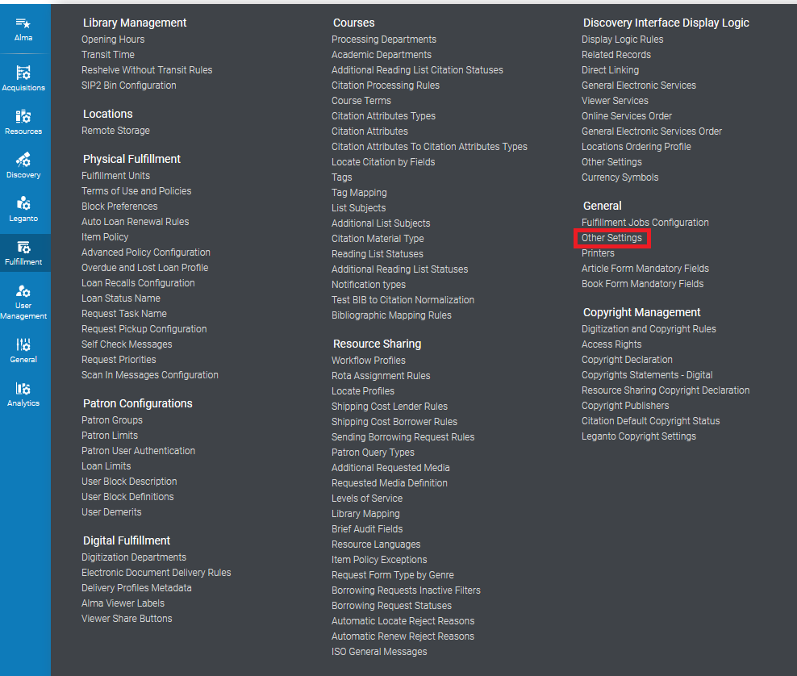

Step 2: Change the close_paid_lost_loan Parameter to true

In the mapping table, scroll down to find the close_paid_lost_loan parameter. To change the setting, click the ellipses on the right side of the screen and select customize. After changing the setting, select Save.
