Alma Reserves Processing – Instructor Owned

Outline
- Create the Course
  - Add an instructor
    - 1 course per instructor if the instructor uses unique materials
    - All instructors added on the same course if all instructors share materials
- Add a Reading List to the Course
- Add Citations to the Reading List
  - Create a brief record for each Citation
- Temporarily Move Citations to the appropriate Reserve Desk
- Check your work in Primo

Add a Course
From the Alma homepage navigate to Fulfillment > Courses.
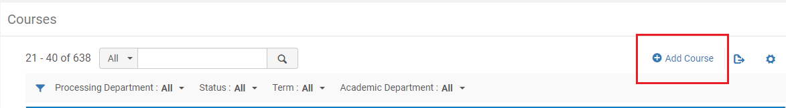
Once you are on the “Manage Course Information” page, begin filling out the required fields.
- Code – Follow the format “HIST101 – Reeves”.
- Name – The course name should match the course name in the catalog.
- Processing Department – Choose the appropriate department for your campus.
- Start Date – Should be today’s date.
- End Date – Choose an appropriately long end-date to the course. The end-date determines when the course is removed from Primo.
- Searchable IDs – Insert additional search parameters for the course. This should include variations of the Course ID. 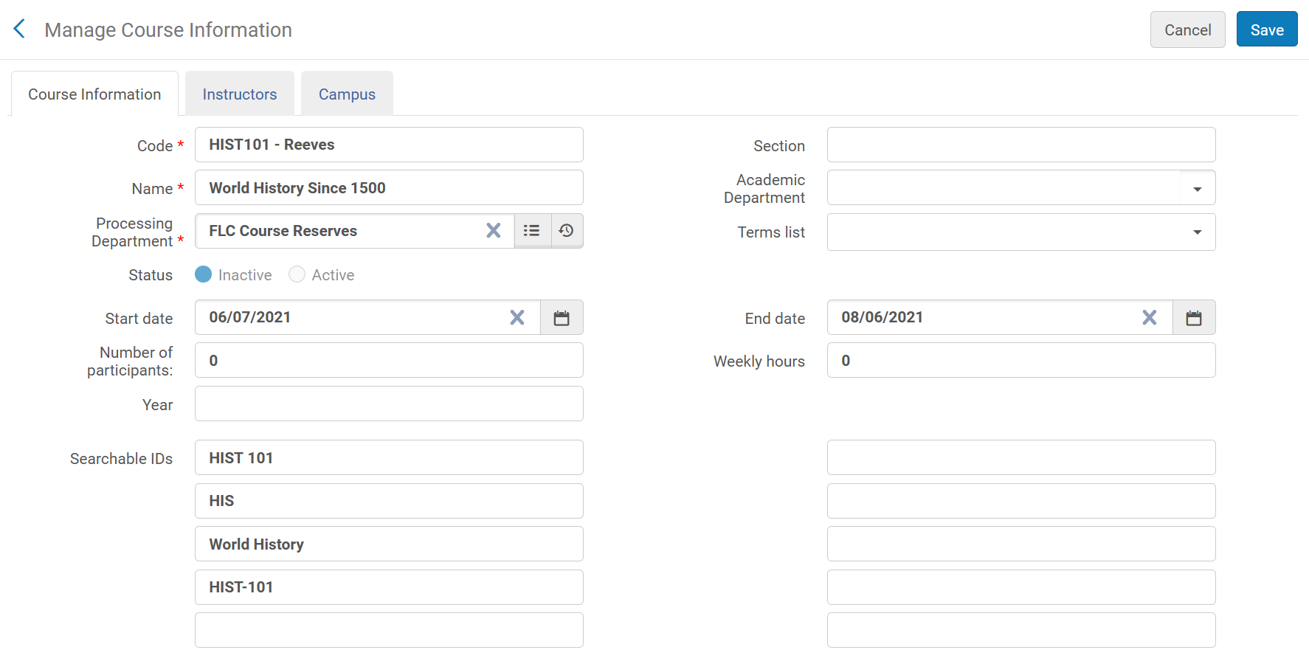
Once you have filled out the “Course Information” tab, select the “Instructors” tab at the top of the page. On the “Instructors” tab select the “Add Instructor” button. In the field that appears, type the instructor’s last name, wait until a dropdown with user records is populated, then select the appropriate record. Once the record is entered, click “Add Instructor”.
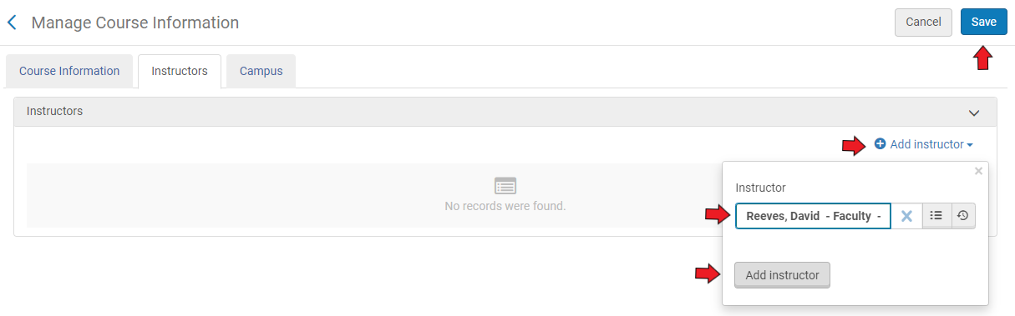
When you are done adding an instructor, select “Save” at the top right of the screen.

Adding a Reading List to Your Course
Navigate to Fulfillment > Courses
In the “Courses” screen, type the course code for the course you just created (HIST) and hit enter. Navigate to the course that you created, and click the ellipses on the right side of the screen and select “Reading List”.
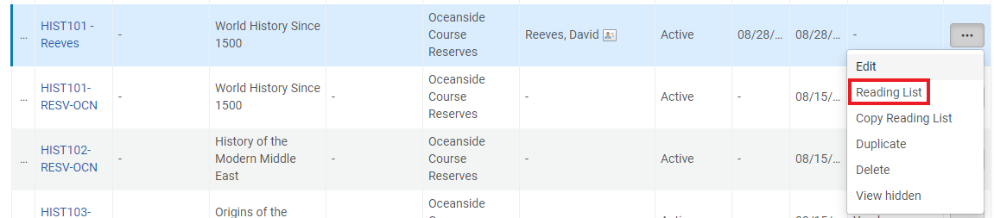

Once on the “Courses Reading List” page for the course you created, select “Add Reading List” on the right side of the window.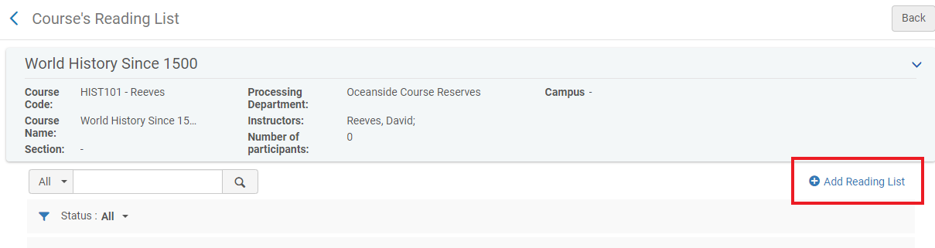
In the “Add Reading List” window that pops up, fill out all fields. Once all fields have been filled out, click “Add and Close”.
- Code – Follow the same format as the Course Code (HIST101 – Reeves).
- Name – Type in the name for the course.
- Status – Set to “Complete” so that citations are published to Primo as they are added
- Due Back Date – This is inherited from the Course end-date
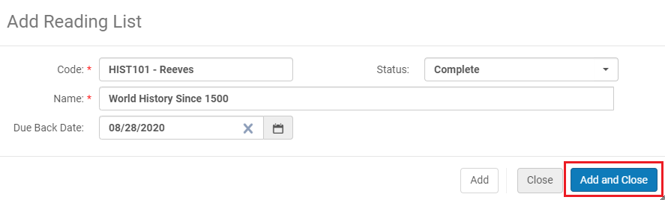
Once you have added the reading list to the course it should appear in the window. Click on the Reading List’s Code to be brought to the configuration window for that reading list.
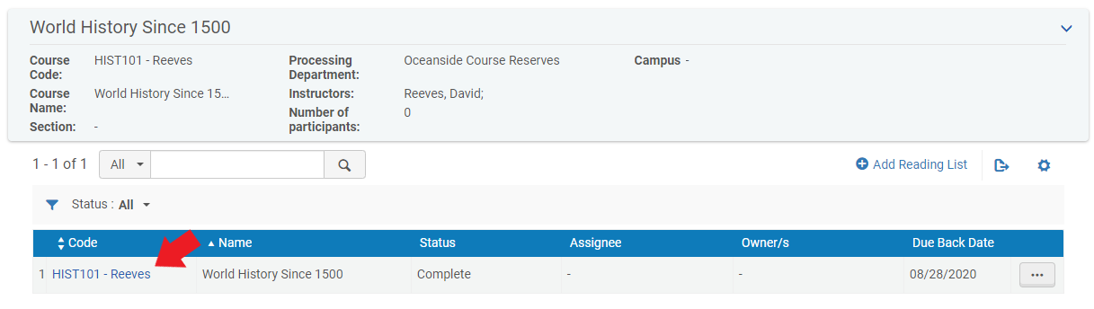

Adding Citations to Your Reading List
Click on the “…” button to the right of Due Back Date, and select “Work On.” Once you are on the “Edit Reading List” screen you can begin to add citations to the list.
Begin by selecting “Add Citation”, then choose “Add Brief”
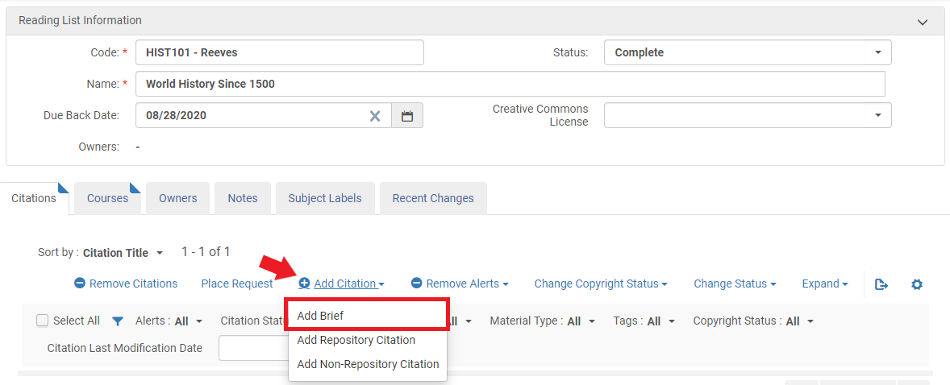
At the pop-up screen, select “Physical Book” and click “Choose”
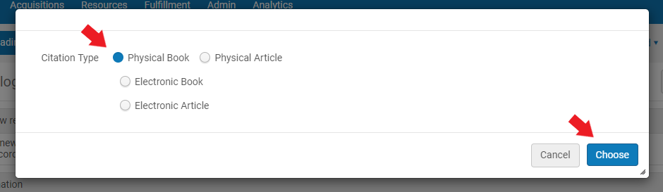
You will be brought to the “Quick Cataloging” screen. Choose “Institution” as the placement of the new record, then begin to fill out the necessary fields for a brief record. Refer to the Bibliographic Formatting for Brief Title Creation for Reserves document on the shared drive.
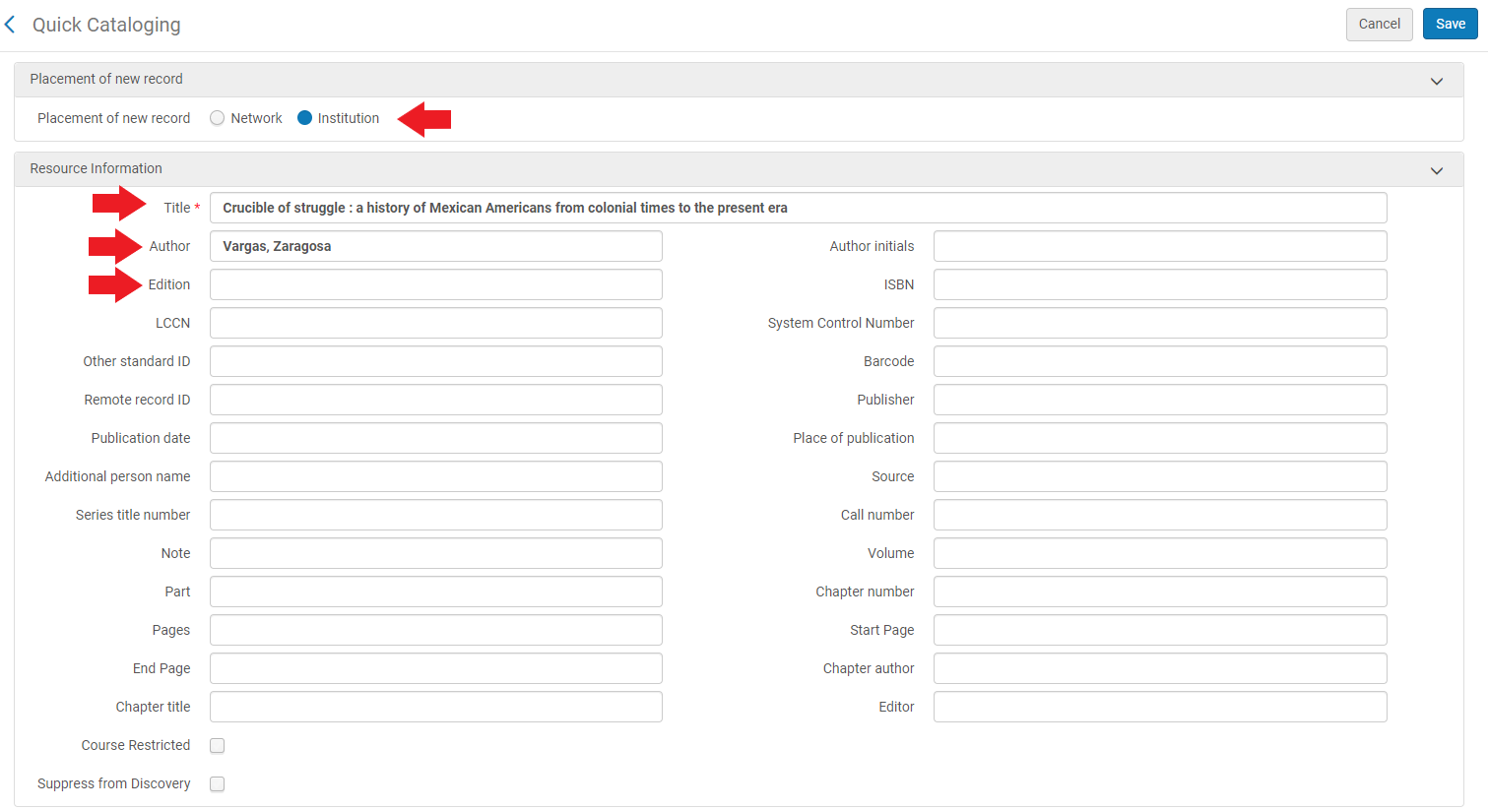
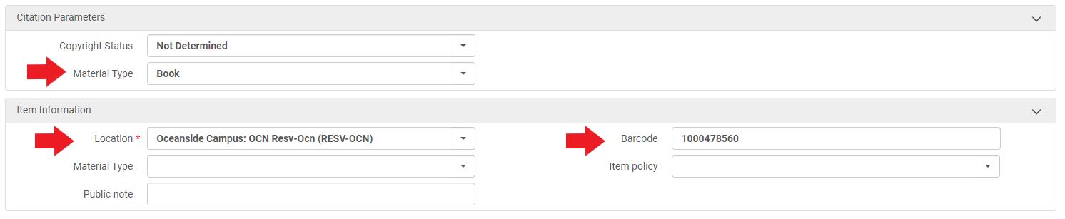
After you have entered all field, click “Save” at the top-right of the screen. Once you return to the “Edit Reading List” page, your citation should be added to the reading list. Select “Save” again at the top-right of the screen.
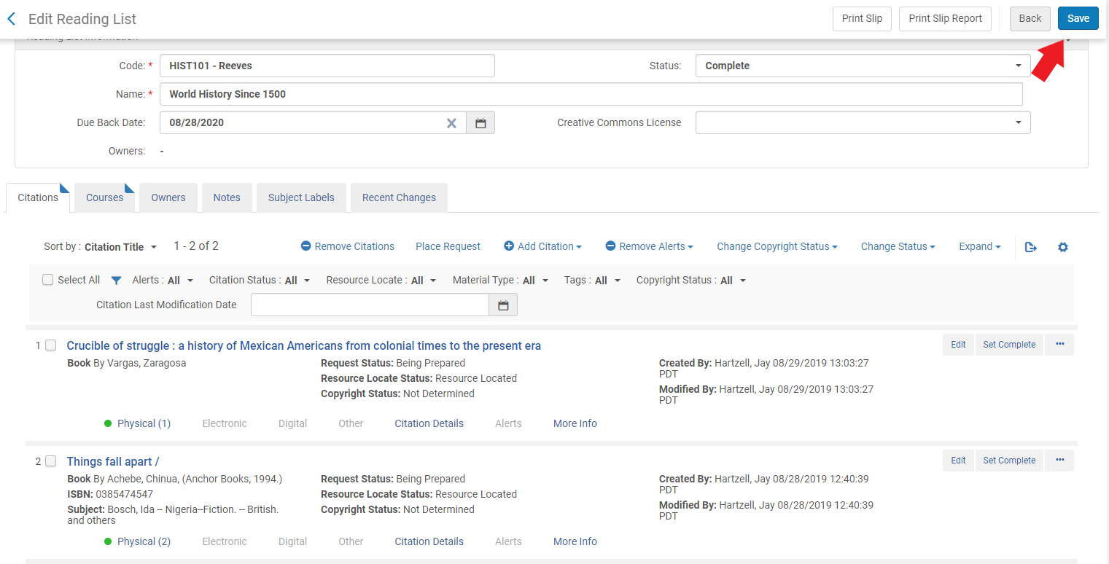

Change the Item’s Temporary Location
The last step is to change the instructor-owned item’s temporary location. This step isn’t used to change the location of the item, but rather to add a temporary call number to the record. This temporary call number then displays in Primo.
Begin by navigating to Fulfillment > Scan in Items. On the “Scan in Items” page, choose the second tab titled “Change Item Information”
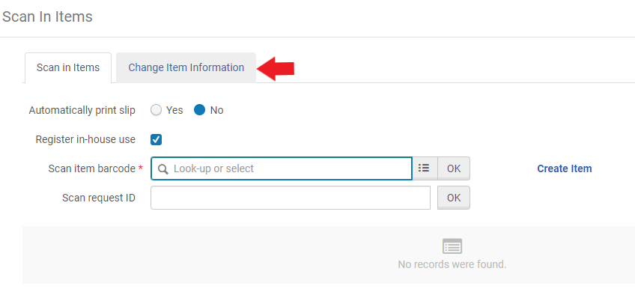
- Change Type – Remains “Temporary”
- Location – Choose Open or Closed for your location
- Reading List – Choose “Select from a list” on the right side of the field, then search for the list you just created (HIST101 – Reeves). Once selected it should populate that field with the reading list name.
- Call Number – Type in the same information as the reading list / course code (HIST101 – Reeves)
- Item Policy – Choose the appropriate item policy (3-day, 7-day etc) if your item is not for 2-hour in-library use. If your item is for in-library use only, choosing the appropriate location (OCN Closed_Res) will default to a 2-hour circulation period and no item policy needs to be selected. Since a location must be chosen anyways, any exceptions to this policy such as a 3 or 7 day checkout must utilize a selection in the Item Policy dropdown.
- Scan item barcode – Enter the item’s barcode and hit enter. Do this step last.
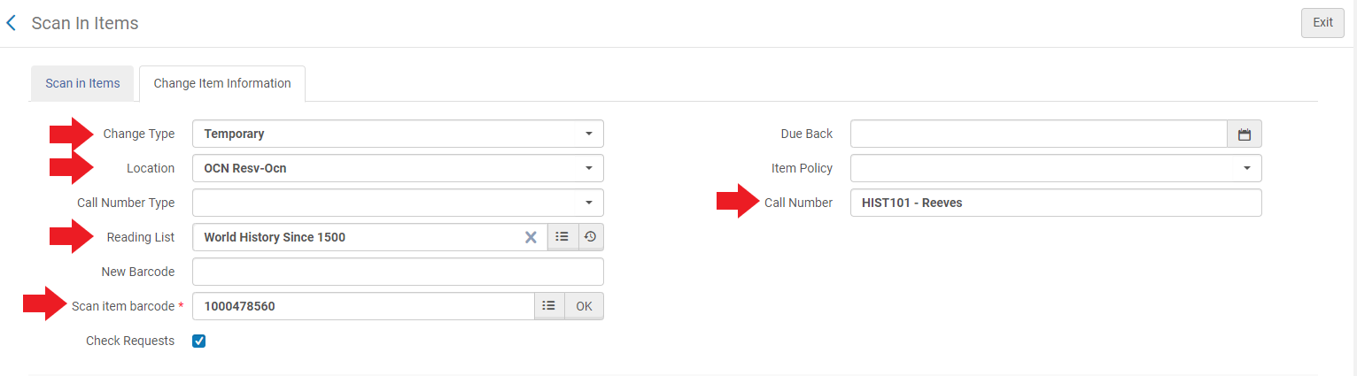
Checking Primo
Once you have finished changing the item’s location, it is now on reserve.
- It will take between 10 – 30 minutes before the reserve information is published to Primo.
Wait roughly 30 minutes, then check Primo. We check Primo to confirm that the item has been correctly placed on reserve and that the information was entered accurately. Here are a few things to look for when searching for your reserve in Primo:
- Confirm that the citations are listed under the correct course, campus, and reserve desk.
- Confirm that the information you put in the temporary call number field (HIST101 – Reeves) is displaying from the main search results page. You shouldn’t have to click through to an item record to see this information.
- Try searching using the different Searchable ID’s that you entered to confirm that these are working properly.
- Try a search for the instructor’s last name in the “Everything” search. Your reserve items should be at the top of the list.
- Try using both the “Everything” and “Course Reserves” search scope to confirm that you can find your reserves under either.

Version 2.0, March 2021

