ALMA QUICK TIP: Free Text Communication with Patrons

- From the persistent search bar, search for the patron

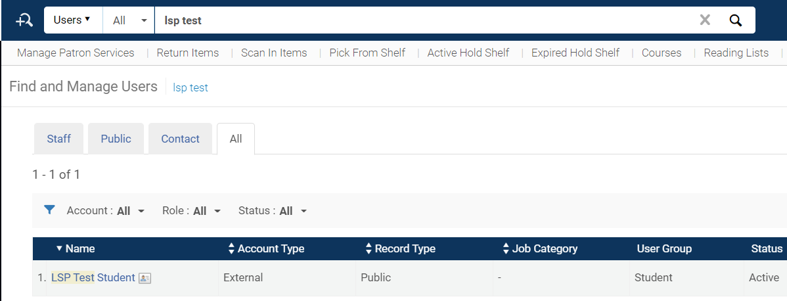

- Using the 3-dot menu on the right, choose Edit

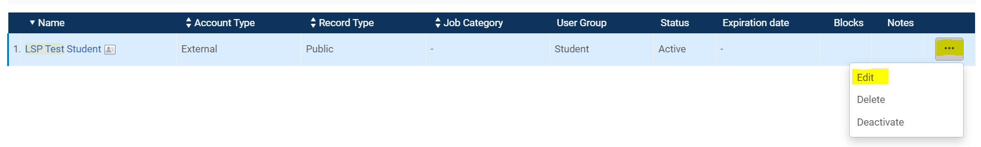

- This will take you to the User Details screen. Look for “Send Message” on the bottom right and choose “General Email” and “Compose.”

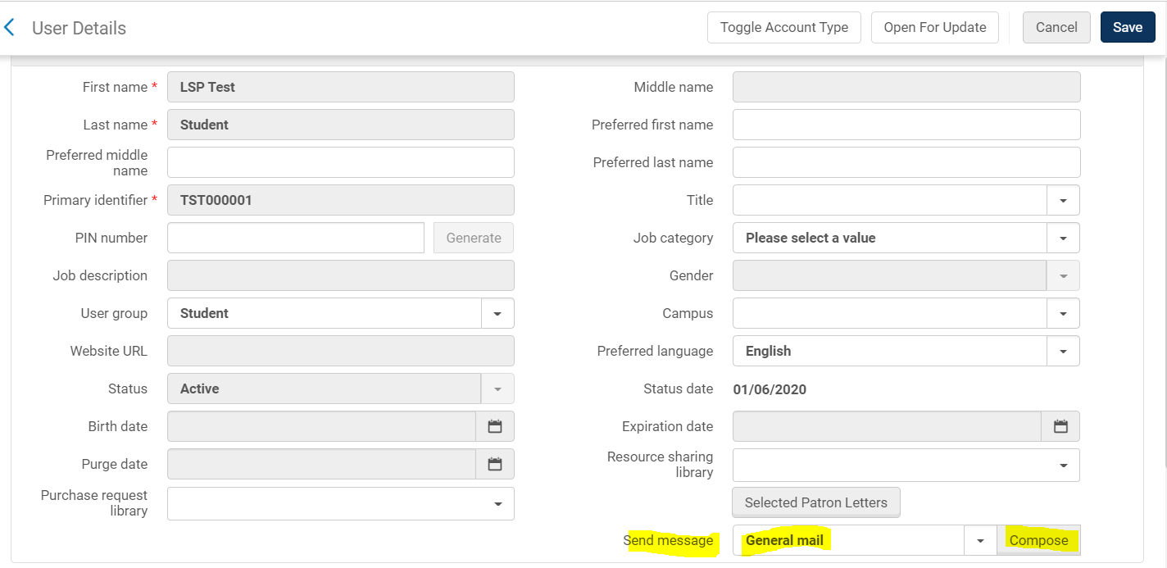

- Compose your email message. When finished, “Send Mail.”

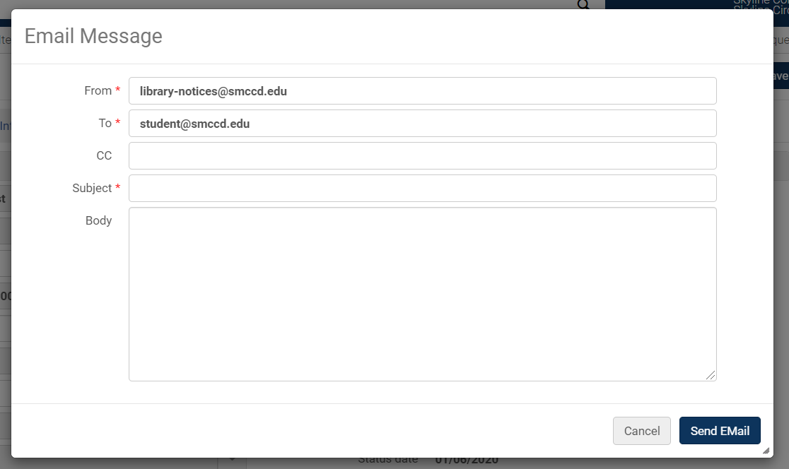

- The message will be saved in the patron’s account under attachments.

