ALMA QUICK TIPS: Adding Patrons on the Fly
- In the Fulfillment menu, click Manage Patron Services
- Scan the patron’s library card or enter the patron’s barcode or name; click Go
- If the patron’s record is not found, click Register New User
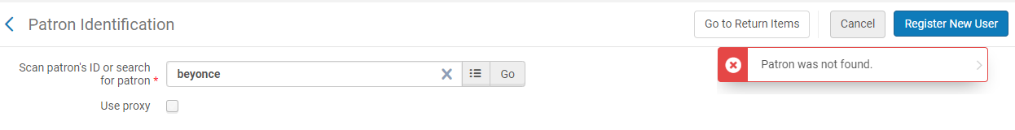
- Upon presentation of a valid photo ID, complete all required fields on the Quick User Management page with the new patron’s information. Required fields are marked with a .
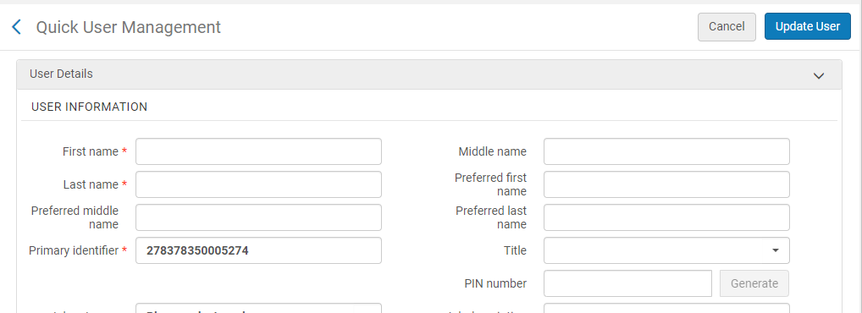

Note #1: The Primary Identifier field will auto-populate according to your institution’s configuration settings. Modify this number as needed in accordance with your institution’s protocols.

Note #2: Your institution’s configuration settings will determine what format of phone numbers are accepted when registering new users. See the parameter phone_regex in User Management > Other Settings. If you are getting a “Field phone number must be numeric” error message, enter the following syntax in the phone_regex configuration field: ^([0-9\(\)\/\+ \-]*)$

- If the user you are registering is an external user, such as a new student, select “Yes” in the Patron has institutional record area. If the user is internal, such as a community patron, select “No”.
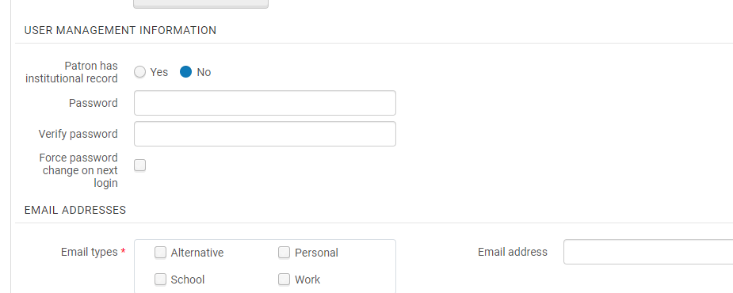
- Click on Update User to save.

- The user record will appear as confirmation that they have successfully been added to the system. You may then proceed to check out items to the patron in the Scan Item Barcode field.
