ALMA QUICK TIPS: WORKING AT THE CIRCULATION DESK

CHECK-OUT
To check out physical items to a patron
- Log in to Alma (Username _______) (Password ________)
- Look to the top right on the blue menu bar - verify that your current location is the circulation desk where you want to work.
If not, click the location icon and select the desired location.
- 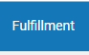 In the Fulfillment menu, click Manage Patron Services

- Scan the patron’s library card or enter the patron’s barcode or name; click Go
- The patron’s record opens to the Loans tab.
- Scan the item barcode or enter the item’s barcode and click Ok
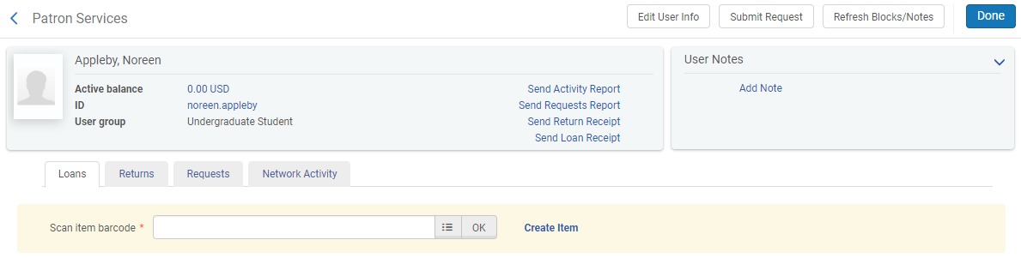
The item is checked out to the patron. That’s the basic check out procedure: swipe the patron’s card, scan the item barcode. Click “Done.”

CHECK-IN
Check-in loans of a given patron:
- Navigate to the Returns tab of the patron’s record
- Scan each item to be checked in, the returned item will show up in a list.

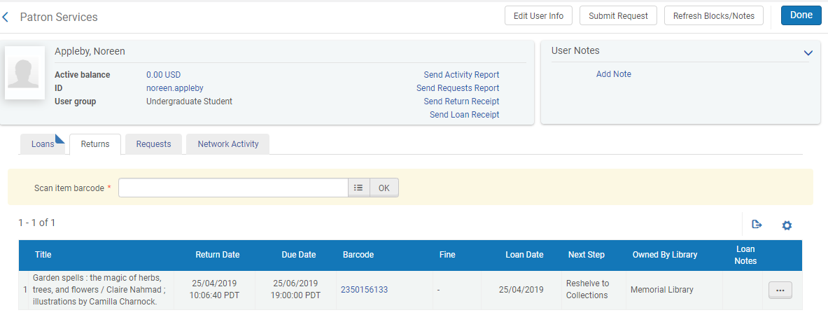

To check-in a stack of books returned by different patrons:
- Navigate to the Returns workbench via Fulfillment menu > Return Items
- Scan the items in one at a time.

