

|  |
| --- |
| **2015** |
| Submission Calculation Service |
| Residency Algorithm & Other Logic |

Submission Calculation Service

Residency Algorithm &   
Other Logic

Technical Support & Online FAQs

Technical support for the CCCApply applications is available for colleges online and by email.

College Support Email:   
Email: cccapply@  
openccc.zendesk.com

New!   
Community Support Site  
for the CCC Technology Center

New! 24/7, online,   
on-demand, community-powered support site for the California Community Colleges is now available at [*ccctechnology.info*](http://www.ccctechnology.info)   
  
Featuring FAQs, system alerts, release notes, maintenance windows, and more, the new ccctechnology.info will serve as the primary support site for all CCC Technology Center system-wide applications, including CCCApply.

The complete specification for the *CCCApply Standard Online Application for Admission* has the following three parts:

* Part 1: Data Element Dictionary
* Part 2: Application Form Specifications
* Part 3: Submission Calculations Service

## 

## Scope of This Document

This document describes the calculations that are made once the user has submitted an application for admission and the requirements for the service that performs these calculations.

## 

Online User Guides:   
Configuring the Administrator, Setting Up Downloads, & Using the CCC Report Center

Visit the Documents section of the CCCApply Project site to find installation and user guides for the CCCApply staff tools, including:

* Setting up terms, majors, rules & supplemental questions in   
  the Administrator;
* Adding authorized Users and resetting downloads;
* Setting up download files & database tables;
* Looking up applications and running reports in the   
  CCC Report Center

Contents

Scope of This Document 1

Overview of Submission Calculations 4

Receiving Data from CCCApply 4

Returning Calculations to CCCApply 4

Receiving Data from Other Sources and Returning Calculations to Them 4

Residency Algorithm (Preliminary Residency Calculation) 5

Areas of Residency Qualification 5

Citizenship (Area A): 5

Stay and Intent (Area B): 5

Military Exemption (Area C): 6

Other Exemptions (Area D): 6

Area Criteria 6

Residence Determination Date (RDD) 6

Residency Integrity Flags 7

Identification of Data Elements 7

Table A. Outline of Area A (Citizenship) Criteria in Residency Algorithm 8

Table B. Outline of Area B (Stay and Intent) Criteria in Residency Algorithm 9

Table C. Outline of Area C (Military Exemption) Criteria in Residency Algorithm 11

Table D. Outline of Area D (Other Exemptions) Criteria in Residency Algorithm 12

Table E. Residency Integrity Flags 13

Residency Status Calculation 19

Residency Status 1 (Resident): 19

Residency Status 2 (Possible Resident) 19

Residency Status 3 (Non-Resident): 19

Residency Status Change Information 19

Residency Determination Details Report 21

Table F: Visa Types 22

Financial Aid Algorithm 27

Financial Aid Referral Flag: Identifying Students for Financial Assistance 27

AB540 Waiver Algorithm 28

AB540 Notification to Students 28

Non-Immigrant Visa Types (Table no longer used) 29

Table G. Non-Immigrant Visa Types 29

Ineligibility Flag 31

Highest Education Level 32

Change Log 33

# Overview of Submission Calculations

Once an applicant submits an application and it is validated by the software, it is finalized from the applicant’s point of view. The applicant’s responses cannot be changed. At this point, there are several calculations to be performed before the application is ready for completion and downloading. These include:

* Residency calculations
* Preliminary residency status
* Residency change information
* Residency integrity flags
* Financial aid flag
* AB540 eligibility flag
* Ineligibility-for-admission flag

## Receiving Data from CCCApply

Initially, the Submission Calculation Service will operate only on submitted CCCApply applications. This document identifies all of the data elements that are needed for the various submission calculations. How the Submission Calculation Service will receive these data elements is beyond the scope of this document.

## Returning Calculations to CCCApply

The Submission Calculation Service must respond to the CCCApply Service promptly with the results of its calculations, since those results will be used to determine some of the contents of the Links and Opportunities page.

## Receiving Data from Other Sources and Returning Calculations to Them

There has been discussion about the Submission Calculation Service having the ability to receive data from other sources (such as Xap or a college that has its own online application) and to provide calculated data to those sources. The design of the Submission Calculation Service should allow this future possibility, but details of the communication with other sources/services are TBD.

# Residency Algorithm (Preliminary Residency Calculation)

The residency calculation provided by CCCApply is a*preliminary* residency calculation only, not an actual or final residency determination. CCCApply does not ask the applicant for proofs of residency in any form. Actual residency determination remains the responsibility of the college to which the student applies.

CCCApply does not reveal any indication of residency determination to the applicant. It is up to the colleges to communicate with the applicants about their residency status.

## Areas of Residency Qualification

The CCCApply preliminary residency calculation is based upon four areas or categories of evaluation: citizenship, stay and intent, military exemptions, and other exemptions. The student is evaluated in each area separately. The area classifications (referred to as ‘classes’) are then processed to make the overall preliminary residency calculation.

### Citizenship (Area A):

Area A indicates whether the applicant is a U.S. Citizen or an eligible non-U.S. Citizen. An applicant who indicates either U.S. citizenship or a status of Permanent Resident, Temporary Resident/Amnesty, or Refugee/Asylee (along with an unexpired alien registration number) is classified as A1. An applicant indicating an unexpired visa type that is eligible for residency is classified as A2. An applicant not qualifying either as A1 or A2 is classified as A0.

### Stay and Intent (Area B):

Area B indicates whether the applicant meets the minimum requirements for duration of stay in California and activities consistent with residency in California. An applicant who meets requirements for residency with no contrary data is classified as B1. An applicant who meets requirements for residency but has some data that needs to be explained or documented is classified as B2. An applicant who does not meet requirements for residency is classified as B0.

### Military Exemption (Area C):

Area C indicates whether the applicant is either an eligible active or discharged U.S. Military person or a dependent of such. Active military persons and their dependents are classified as C1. Recently discharged military persons are classified as C2. All others are classified as C0.

### Other Exemptions (Area D):

Area D indicates whether the applicant qualifies for a special residency exemption. A state college or university employee or dependent, a public school employee, or an eligible seasonal agricultural worker or dependent (not precluded by INS) is classified as D1. All others are classified as D0.

## Area Criteria

The criteria and logic for evaluating each area of the residency algorithm are shown in *Tables A* through *D* and *Figures 1* through *5*. Evaluations are based on data elements reflecting the applicant’s answers to residency-related questions.

***Note:*** Answers supplied in Areas B and D are in reference to the parent/guardian if the applicant is under age 19 and not independent (i.e., not married, in the military, or emancipated). “Evidence of Intent” rules in the Student Attending Accounting Manual (Chapter 2), based on Title 5 section 54024, specify “under 19 years” as the age criterion, superseding the definition of a “Minor” in general law as under age 18.

## Residence Determination Date (RDD)

Residency determination is defined to be ‘as of the day before the term start date’. The day before the term start date is called the Residence Determination Date, or RDD. The RDD is used at several points in the area determination logic specified in *Tables A* through *D*.

## Residency Integrity Flags

In addition to the preliminary residency determination (Residency Status), the area determination logic produces Residency Integrity Flags that provide additional information to help the colleges in their final residency determinations. Some Integrity Flags indicate why a Residency Status of 2 was assigned; others indicate applicant responses that did not affect the Residency Status but may warrant investigation or documentation.

Integrity flags are two-digit numeric codes, as defined in *Table E*. They are stored and downloaded in data element ‘residency: res_int_flags’, a string that can contain up to 26 flags. Refer to the *CCCApply Data Dictionary* for more information about this data element.

In addition to their basic function alerting A&R staff to specific information about an applicant’s responses related to residency, Integrity Flags may be used to automate electronic responses back to the applicant with further instructions.

## Identification of Data Elements

In *Tables A* through *E*, the data elements are in the Residency Table unless a different table is identified (e.g., ‘education: element_name’ is in the Education Table).

### Table A. Outline of Area A (Citizenship) Criteria in Residency Algorithm

### 

| **Step** | **Evaluation Statement** | **Data Elements & Logic** | **if Yes** | **if No** |
| --- | --- | --- | --- | --- |
| **1** | Is the student a US citizen? | citizenship_status = 1 | **Class A1** | Go to step 2 |
| **2** | Is the student’s visa/alien registration active? | alien_reg_no_expire = 1 **OR**  alien_reg_expire_date > RDD | Go to step 3 | **Class A0** |
| **3** | Does the student have Permanent Resident, Temporary Resident/ Amnesty, or Refugee/Asylee citizenship status? | citizenship_status = 2 **OR** citizenship_status = 3 **OR** citizenship_status = 4 | Go to step 4 | Go to step 6 |
| **4** | Does the student have an Alien Registration number? | alien_reg_number ≠ null | Go to step 5 | **Class A2** set flag 50 |
| **5** | Is issue date more than 1 year before RDD? | RDD *minus* alien_reg_issue_date > 365 (days) | **Class A1** | **Class A2** set flag 60 |
| **6** | Does the student have a visa that allows residency to be established? | visa_type has YES in ‘Residency?’ column of *Table F*. | **Class A2** set flag 51 | **Class A0** set flag 48 if visaType=B, B1, *or* B2 |
| Class A1 indicates that no further proof of citizenship is needed. Class A2 indicates that the admissions office must obtain proof of citizenship status before residency can be determined. | | | | |

### Table B. Outline of Area B (Stay and Intent) Criteria in Residency Algorithm

| **Step** | **Evaluation Statement** | **Data Elements & Logic** | **if Yes** | **if No** |
| --- | --- | --- | --- | --- |
| **1** | Do out-of-state indicators support intent? | ca_outside_tax = 0 **AND** ca_outside_voted = 0 **AND** ca_outside_college = 0 **AND** ca_outside_lawsuit = 0 | Go to step 2 | **Class B0** (go to step 2) |
| **2** | Has the applicant lived in California for two years prior to RDD? | ca_res_2_years = 1 | Go to step 5 | Go to step 3 |
| **3** | Has the applicant been resident in CA for over a year prior to RDD? | ca_date_current ≠ null **AND** ca_date_current < RDD minus 1 year | **Class B2** (flag 59) go to step 5 | Go to step 4 |
| **4** | Is the applicant a current or former Foster Youth, under age 20, and now residing in California? | ca_foster_youth = Yes | **Class B2** go to step 5 (flag 70) | **Class B0** end |
| **5** | Has the applicant completed HS outside CA in last 2 years? | education: hs_state’ ≠ CA **AND** education: hs_comp_date ≥ RDD minus 2 years | **Class B2** (flag 61) go to step 6 | Go to step 6 |
| **6** | Is the applicant in military with non-CA home of record? | military_status = 2 **AND**  **(** military_home_state ≠ CA **OR** military_legal_residence ≠ CA **)** | **Class B2** flag 62) go to step 7 | Go to step 7 |
| **7** | Is the applicant under the care and control of a guardian, under 19 and unmarried? | ‘over19OrMarried’ = 0 AND ‘guardianOrParentRelation’ = G | **Class B2** (flag 58) go to step 8 | Go to step 8 |
| **8** | Is the applicant’s current address outside of California? | ‘Mailing address – state’ ≠ CA | **Class B2** (flag 01) go to step 9 | Go to step 9 |
| **9** | Is the applicant’s permanent address outside of California? | ‘Permanent address – state’ ≠ CA | **Class B2** (flag 02) go to step 10 | Go to step 10 |
| **10** | Is the applicant under 19 as of RDD with last high school out-of-state? | RDD *minus* 19 years > personal_info: birthdate **AND** education: hs_state ≠ CA | **Class B2** (flag 03) go to step 11 | Go to step 11 |
| **11** | Was the applicant enrolled in an out-of-state college with a ‘To Date’ within the year previous to the term start date? | In any row of colleges_attended table: If state ≠ CA AND to_date is greater than the term start date minus 1 year. | **Class B2** (flag 04) go to step 12 | Go to step 12 |
| **12** | Has Class B2 been set? |  | **Class B2** | **Class B1** |

Table C. Outline of Area C (Military Exemption) Criteria in Residency Algorithm

|  |  |  |  |  |
| --- | --- | --- | --- | --- |
| **Step** | **Evaluation Statement** | **Data Elements & Logic** | **if Yes** | **if No** |
| **1** | Is the student (or the student’s parent/guardian) currently an active military member, a dependent of a currently active military member, or a member discharged from the military in the past year? | military_status = 2 **OR** military_status =3 **OR** military_status =4 | Go to step 2 | **Class C0** |
| **2** | Is the military member currently active? | military_status = 2 **OR** military_status =3 | Go to step 3 | **Class C2** (flag 52) |
| **3** | Is California the home of record for the military member? | military_home_state = CA | **Class C1** (flag 53) go to step 4 | Go to step 4 |
| **4** | Is the active military member currently stationed in California? | military_ca_stationed = 1 | **Class C1** (flag 54) go to step 5 | Go to step 5 |
| **5** | Is the active military member (or spouse/parent/dependent) stationed/assigned to California for educational purposes? | military_stationed_ca_ed =1 | **Class C1** (Set flag 65) Go to step 6 | Go to step 6 |
| **6** | Is California the state of legal residence for the military member? | military_legal_residence = CA | **Class C1** (flag 63) go to step 7 | Go to step 7 |
| **7** | Is Class C1 set in any step? |  | **Class C1** | **Class C0** |

### Table D. Outline of Area D (Other Exemptions) Criteria in Residency Algorithm

|  |  |  |  |  |
| --- | --- | --- | --- | --- |
| **Step** | **Evaluation Statement** | **Data Elements & Logic** | **if Yes** | **if No** |
| **1** | Is the residency claimant a state college/university employee? | ca_college_employee = 1 | **Class D1** (flag 55) | Go to step 2 |
| **2** | Is the applicant a California public school employee? | ca_school_employee = 1 | **Class D1** (flag 56) | Go to step 3 |
| **3** | Is the residency claimant a qualified agricultural worker? | ca_seasonal_ag = 1 | Go to step 4 | **Class D0** |
| **4** | Is the residency claimant a U.S. Citizen or INS-eligible alien? | Area A = A1 **OR** Area A = A2 | **Class D1** (flag 57) | **Class D0** |

### Table E. Residency Integrity Flags

| **Flag** | **Meaning** | **Logic** |
| --- | --- | --- |
| 01 | Current address state is not California | *See Residency Area B logic* |
| 02 | Permanent address state is not California | *See Residency Area B logic* |
| 03 | State of last high school attended is not California and student is under 19 | *See Residency Area B logic* |
| 04 | State of most recent college attended is not California and ‘To Date’ is within one year of term start date | *See Residency Area B logic* |
| 11 | Claiming California high school completion but last high school not in California | education: cahs_graduated = 1 **AND** education: hs_state ≠ CA |
| 47 | Eligible with documentation: high school graduate or equivalent but under 18 | adm_ineligible = 2 |
| 48 | Ineligible to enroll; B-visa holder | *See Residency Area A logic* |
| 49 | Ineligible to enroll; minor in high school | adm_ineligible= 1 |
| 50 | Missing valid Alien Registration Number | *See Residency Area A logic* |
| 51 | Has visa type that may establish residency. Documentation required. | *See Residency Area A logic* |
| 52 | Recently discharged U.S. military member | *See Residency Area C logic* |
| 53 | U.S. military member or dependent spouse/child of military member with California as home of record | *See Residency Area C logic* |
| 54 | U.S. military member or dependent spouse/child of military member currently stationed in California | *See Residency Area C logic* |
| 55 | State college/university employee | *See Residency Area D logic* |
| 56 | California public school employee | *See Residency Area D logic* |
| 57 | Qualified seasonal agriculture worker | *See Residency Area D logic* |
| 58 | Two years care and control proof for guardian required | *See Residency Area B logic* |
| 59 | Applicant has resided in California for over one year but less than two years | *See Residency Area B logic* |
| 60 | Date of Alien Registration not more than one year before term start date | *See Residency Area A logic* |
| 61 | State of last high school attended is not California and high school completion date is within last 2 years | *See Residency Area B logic* |
| 62 | Currently in military with home of record other than CA | *See Residency Area B logic* |
| 63 | U.S. military member or dependent spouse/child of military member with California as military state of legal residence | **(**military_status = 2 **OR** military_status = 3**)** **AND** military_legal_residence =CA |
| 65 | U.S. military member or dependent/ spouse/child of military member stationed in California for educational purposes only. Verify that dates of assignment are for 30 days or more. | *See Residency Area C logic* |
| 70 | Applicant is a current or former Foster Youth in California and under 20 years of age | ca_foster_youth = 1 |
| 80 | Applicant is an independent minor | *data element and logic tbd (dependency=Yes)* |

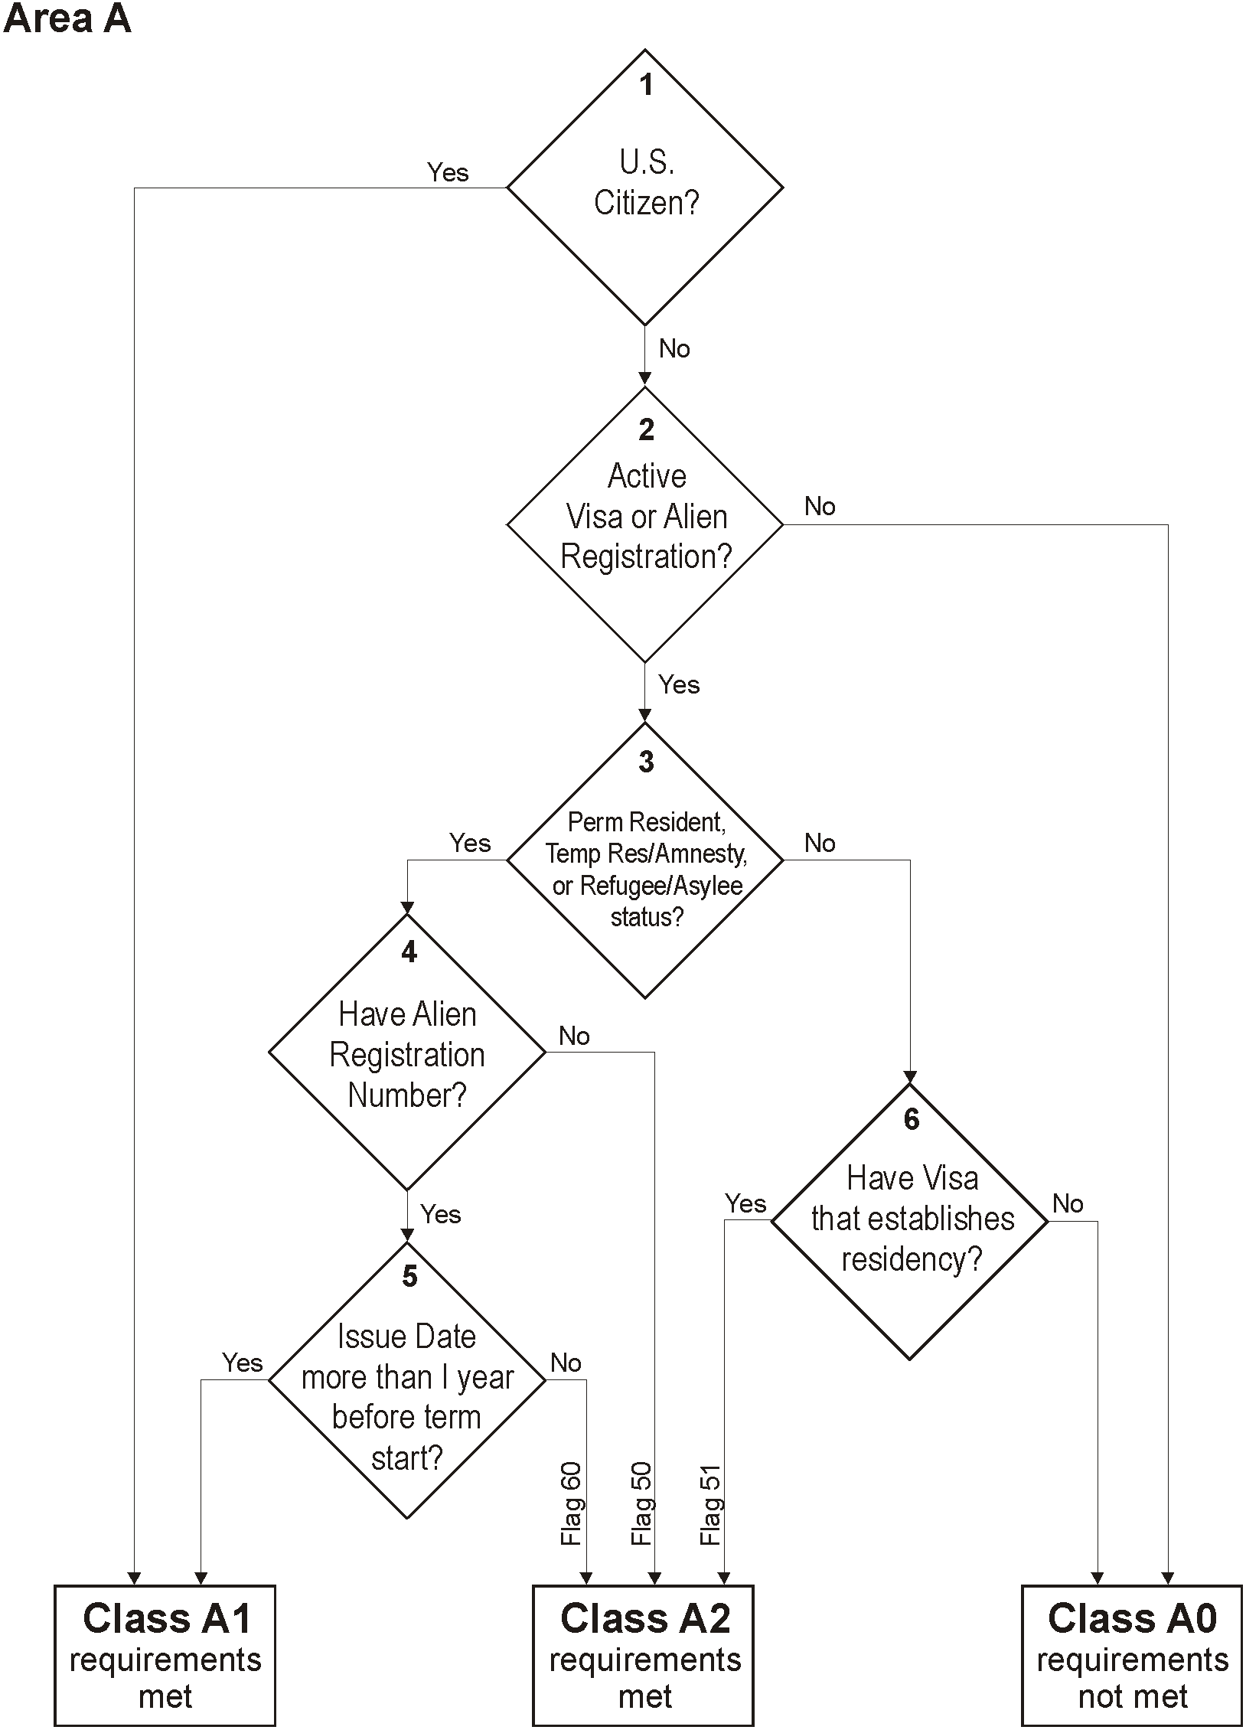

###### Figure 1. Flowchart for Residency Area A Logic

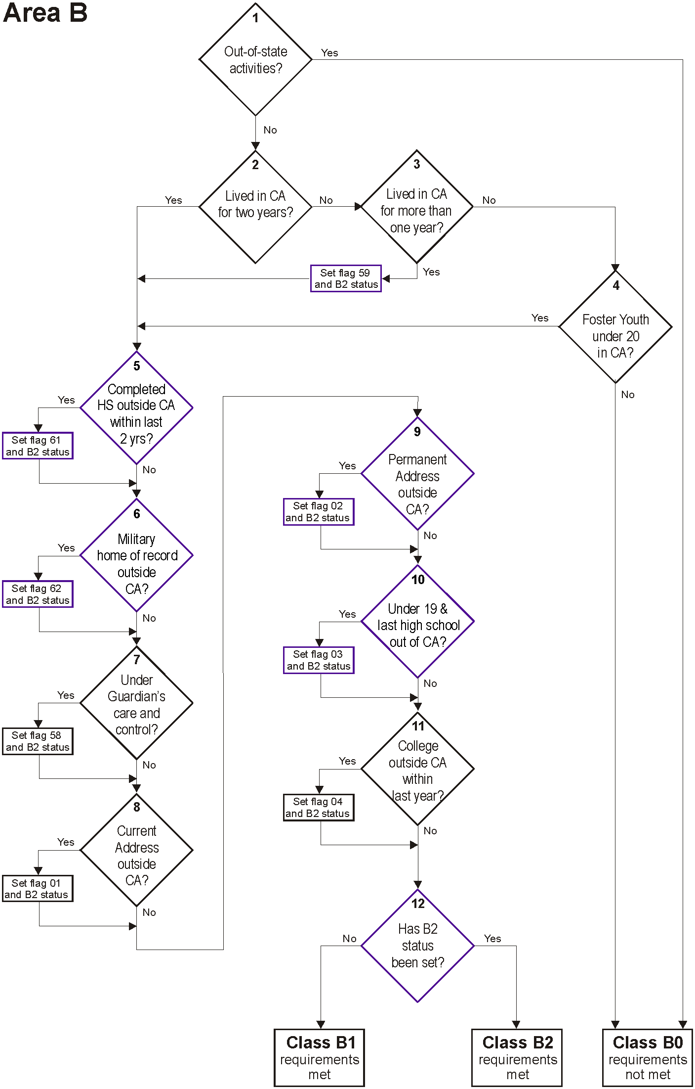

###### Figure 2. Flowchart for Residency Area B Logic

###### Figure 3. Flowchart for Residency Area C Logic

For education for   
30 days or more?   
If Yes, Set flag 65

**1**

Active military

member/dependent,

or discharged in

past year?

Currently

active military

member or

dependent?

**2**

Is CA the

military home

of record?

**3**

Currently

stationed in

CA?

**4**

**Class C2**

requirements

met

**Class**

**C1**

requirements

met

Yes

No

Is CA the

State of Legal

Residence?

set?

**5**

Yes

No

Flag 52

No

**Class**

**C0**

requirements

not met

**Area C**

No

No

Is C1

status

**6**

Yes

Set flag 53

and C1 status

Yes

Yes

Set flag 54

and C1 status

Yes

Set flag 63

and C1 status

No

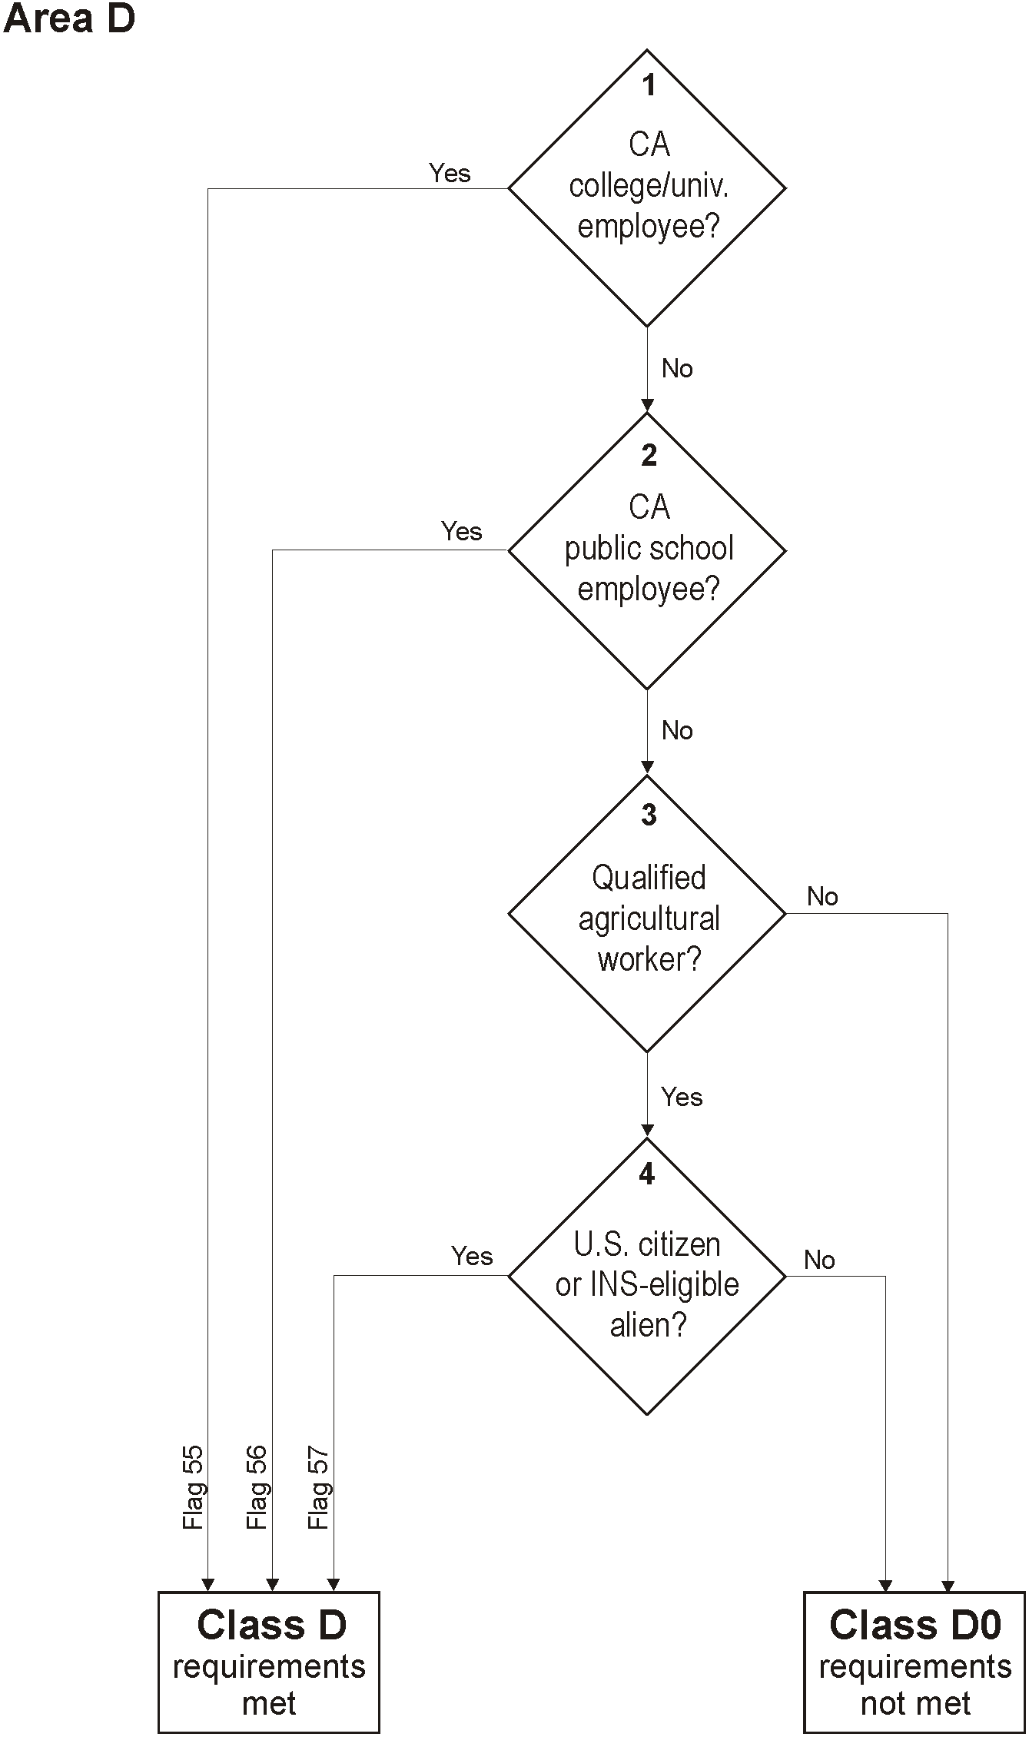

###### Figure 4. Flowchart for Residency Area D Logic

### Residency Status Calculation

The residency determination algorithm looks at each area of qualification to determine whether the student meets the residency classification criteria for the purposes of assessing tuition. This *preliminary* Residency Status calculation is stored in data element ‘residency: res_status’ as either 1, 2, or 3. Figure 5 (p. 18) shows the preliminary residency determination logic.

Residency Status 1 (Resident): An applicant considered eligible for California residency classification without further proof. The applicant must have the following Area calculations:

* A1 and B1

Residency Status 2 (Possible Resident) ***- Documentation Required:*** Any applicant considered eligible for California residency classification provided they can show proof. The applicant must have the following Area calculations:

* A1 and B2
* A2 and (B1 or B2)
* C1
* C2 and (B1 or B2)
* D1

Residency Status 3 (Non-Resident): An applicant failing to meet any of the above criteria.

## Residency Status Change Information

The Residency Algorithm also compares the Residency Status for the current application with the Residency Status determination for the immediately previous application by the same applicant (i.e., user account). If there has been a residency status change, it sets a Residency Status Change flag (data element ‘residency: res_status_change’) and also stores the date of the different residency status determination (data element ‘residency: res_prev_date’).

The residency status change information needs to persist in all applications for a particular account until there is another residency status change. Therefore, the ‘res_status_change’ and ‘res_prev_date’ values will default to the values in the most recent application submitted by the account, and will be overwritten only if the Residency Status for the current application is different than the Residency Status determination for the immediately previous application.

Documentation Required

**A1**

**Met?**

**B1**

**Met?**

**B2**

**Met?**

**Status 1**

Resident

**Status 2**

**Status 3**

**C1**

**Met?**

**D**

**Met?**

**A2**

**Met?**

**B1**

**Met?**

**B2**

**Met?**

**C2**

**Met?**

Yes

Yes

Yes

Yes

Yes

Yes

Yes

Yes

Yes

No

No

No

No

No

No

No

No

Possible Resident

Non-resident

###### Figure 5. Preliminary Residency Determination Flowchart

## Residency Determination Details Report

For each submitted application, CCCApply will include the functionality for displaying a Residency Determination Details Report. This report records the results of each logical step in the four residency areas, the calculation of the Residency Status, any integrity flags that have been set, and AB540 eligibility. The top of the report indicates the application by Student Name and Application Confirmation Number. At the bottom of the report is a link to Integrity Flag Definitions, which will appear in a separate tab or pop-up.

*Figure 6* shows an example of a Residency Determination Details Report from Xap CCCApply.

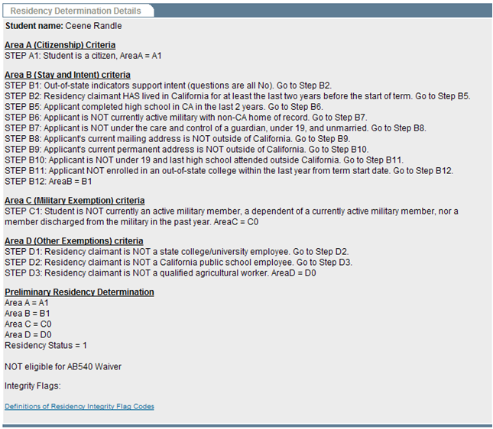

*Figure 6.* *Example of Residency Determination Details Report*

### Table F: Visa Types

| **Database Value** | **Visa Type Menu Listing** | **Residency?** | **Visa and Description** |
| --- | --- | --- | --- |
| A1 | A-1 | YES | **A-1** Ambassador, Public Minister, Career Diplomat, Consular Officer, Head of State, and immediate family members |
| A2 | A-2 | YES | **A-2** Other foreign government officials or employees coming to the United States and immediate family members. Includes technical and support staff of A-1 |
| A3 | A-3 | YES | **A-3** Attendants, Servants and Personal employees of A-1 and A-2 and immediate family members |
| B1 | B-1 | no | **B-1** Temporary visitor for business |
| B2 | B-2 | no | **B-2** Temporary visitor for pleasure |
| BCC | BCC | no | **BCC** Border Crossing Card: Mexico |
| BE | BE | no | **BE** Bering Straits agreement entrants |
| C1 | C-1 | no | **C-1** Alien in transit (direct and continuous travel through the United States) |
| C1D | C-1D | no | **C-1D** Combined transit and crewman visa |
| C2 | C-2 | no | **C-2** Alien in transit to the U.N. headquarters |
| C3 | C-3 | no | **C-3** Foreign government official, members of immediate family, attendants, servants or other personal employee of official in transit through the United States |
| C4 | C-4 | no | **C-4** Transit without Visa, see TWOV |
| D1 | D-1 | no | **D-1** Crewmen departing on same vessel of arrival, crewmen departing on same aircraft or same airline |
| D2 | D-2 | no | **D-2** Crewmen departing on vessel other than one of arrival. Airmen departing on different airline that one of arrival |
| E1 | E-1 | YES | **E-1** Treaty trader, spouse, and children |
| E2 | E-2 | YES | **E-2** Treaty investor, spouse, and children coming to develop and direct a bon fide enterprise in which he/she has invested a substantial amount of capital |
| E3 | E-3 | YES | **E-3** Australian nationals working in specialty occupations |
| E3D | E-3D | YES | **E-3D** Spouse or child of E-3 |
| E3R | E-3R | YES | **E-3R** Returning E-3 |
| F1 | F-1 (Student Visa) | no | **F-1** Academic student |
| F2 | F-2 | no | **F-2** Spouse or child of student |
| F3 | F-3 | no | **F-3** Canadian and Mexican Academic Students who commute across the US land border to school. |
| G1 | G-1 | YES | **G-1** Principal resident representative of recognized foreign member government to international organization, staff, and immediate family members |
| G2 | G-2 | YES | **G-2** Other temporary representative of recognized foreign member government to international organization and immediate family members |
| G3 | G-3 | YES | **G-3** Representative of non-recognized or nonmember foreign government to international organization and immediate family members |
| G4 | G-4 | YES | **G-4** International organization officer or employee and immediate family members |
| G5 | G-5 | YES | **G-5** Attendant, servant, or personal employee of G-1 through G-4 and immediate family members |
| GB | GB | **NO** | **GB** Temporary visitor for business, Guam |
| GT | GT | **NO** | **GT** Temporary visitor for pleasure, Guam |
| H1 | H-1 | NO | **H-1** Temporary worker of distinguished merit and ability (Note: This VISA type no longer exists. Per CCCCO, leave in list for historical reasons; eligibility: NO.) |
| H1A | H-1A | NO | **H-1A** Temporary worker performing services as a registered nurse (Note: This VISA type no longer exists. Per CCCCO, leave in list for historical reasons; eligibility: NO.) |
| H1B | H-1B | YES | **H-1B** Specialty occupation (professionals), DOD workers, fashion models |
| H1B1 | H-1B1 | **NO** | **H-1B1** Specialty occupation, entering under free trade agreements with Chile and Singapore |
| H1C | H-1C | NO | **H-1C** Nurses going to work for up to 3 years in health professional shortage areas (Note: This VISA type no longer exists. Per CCCCO, leave in list for historical reasons; eligibility: NO.) |
| H2A | H-2A | no | **H-2A** Temporary or seasonal agriculture workers |
| H2B | H-2B | no | **H-2B** Nonagricultural temporary or seasonal workers |
| H2R | H-2R | no | **H-2R** Returning H-2B worker |
| H3 | H-3 | no | **H-3** Trainee or participant in special education exchange visitor program |
| H4 | H-4 | YES | **H-4** Spouse or child of H-1, H-2, H-3 (parent/spouse visa type determines whether holder may or may not establish residency)  Yes *if* parent or spouse has a H1A, H1B or H1C. Valid dates required for H4 only. |
| I | I | YES | **I** Representative of foreign information media, spouse, and children |
| J1 | J-1 | no | **J-1** Exchange visitor |
| J2 | J-2 | no | **J-2** Spouse or minor child of exchange visitor |
| K1 | K-1 | YES | **K-1** Fiancé or fiancée of U.S. Citizen |
| K2 | K-2 | YES | **K-2** Minor child of K-1 |
| K3 | K-3 | YES | **K-3** Spouse of U.S. Citizen (under LIFE Act provisions) |
| K4 | K-4 | YES | **K-4** Child of K-3 |
| L1A | L-1A | YES | **L-1A** Intra company transferee (executive, managerial and specialized personnel) entering to continue employment with the same employer or a subsidiary or affiliate thereof |
| L1B | L-1B | YES | **L-1B** Executive, manager or has specialized skill of international firm |
| L2 | L-2 | YES | **L-2** Spouse or child of L-1 |
| M1 | M-1 | no | **M-1** Vocational or non-academic student |
| M2 | M-2 | no | **M-2** Spouse or child of M-2 |
| M3 | M-3 | no | **M-3** Border commuter student |
| N8 | N-8 | YES | **N-8** Parent of alien classified SK-3 “special immigrant” |
| N9 | N-9 | YES | **N-9** Child of N-8, SK-1, SK-2, or SK-4 “special immigrant” |
| NATO1 | NATO-1 | YES | **NATO-1** Principal permanent representative of member state to NATO and resident members of official staff or immediate family |
| NATO2 | NATO-2 | YES | **NATO-2** Other representatives of member state; dependents of member of a force entering in accordance with the provisions of NATO Status-of-Forces agreement; members of such force if issued visas |
| NATO3 | NATO-3 | YES | **NATO-3** Official clerical staff accompanying representative of member state to NATO or immediate family |
| NATO4 | NATO-4 | YES | **NATO-4** Official of NATO other than those qualified under NATO-4, employed on behalf of NATO and immediate family |
| NATO5 | NATO-5 | YES | **NATO-5** Expert other than NATO officials qualified under NATO-4, employed on behalf of NATO and immediate family |
| NATO6 | NATO-6 | YES | **NATO-6** Member of civilian component who is either accompanying a Force entering in accordance with the provision of the NATO Status-of-Forces agreement; attached to an Allied headquarters under the protocol on the Status of International Military headquarters set up pursuant to the North Atlantic Treaty; and their dependents |
| NATO7 | NATO-7 | YES | **NATO-7** Servant or personal employee of NATO-1 through NATO-6, or immediate family |
| O1 | O-1 | YES | **O-1** Aliens of extraordinary ability |
| O2 | O-2 | no | **O-2** Accompanying alien who is coming solely to assist in the artistic or athletic performance by an O-1 |
| O3 | O-3 | **YES** | **O-3** Spouse and/or child of O-1 only (Type 0-2_is not eligible. Yes *if* parent or spouse has an O-1 only. Valid dates for O-3 required. |
| P1 | P-1 | no | **P-1** Internationally recognized professional artists, athletes, entertainers, and “essential support personnel” |
| P2 | P-2 | no | **P-2** Artist or entertainer in reciprocal exchange programs |
| P3 | P-3 | no | **P-3** Artists and entertainers coming to perform, teach, or coach a culturally unique program. |
| P4 | P-4 | no | **P-4** Spouses and/or children of P-1, P-2, P-3 |
| Q1 | Q-1 | no | **Q-1** International cultural exchange visitor |
| Q2 | Q-2 | no | **Q-2** Irish Peace Process cultural and training program (Walsh Visas) |
| Q3 | Q-3 | no | **Q-3** Spouse or child of Q-2 |
| R1 | R-1 | YES | **R-1** Religious workers |
| R2 | R-2 | YES | **R-2** Spouse or child of R-1 |
| S5 | S-5 | no | **S-5** Alien witness or informant possessing critical, reliable information concerning a criminal organization or enterprise whose presence in the United States is required for the successful investigation or prosecution of the criminal organization |
| S6 | S-6 | no | **S-6** Alien witness or informant possessing critical reliable information about terrorist organization, enterprise, or operation, who will be placed in danger as a result of supplying that information; and is eligible to receive a reward under separate U.S. State Department legislation |
| S7 | S-7 | no | **S-7** Spouse, unmarried sons and daughters, and parents of witness or informant |
| T1 | T-1 | YES | **T-1** Victim of a severe form of trafficking in persons (eligible for benefits of AB540 ) |
| T2 | T-2 | YES | **T-2** Spouse of a victim of a severe form of trafficking in persons (eligible for benefits of AB540 ) |
| T3 | T-3 | YES | **T-3** Child of victim of a severe form of trafficking in persons (eligible for benefits of AB540 ) |
| T4 | T-4 | YES | **T-4** Parent of a victim of a severe form of trafficking in persons (if T-1 victim is under21) (eligible for benefits of AB540 ) |
| T5 | T-5 | YES | **T-5** Sibling under 18 years of age of T-1 under 21 years of age (eligible for benefits of AB540 ) |
| TN1 | TN1 | no | **TN1** Canadian professionals under NAFTA |
| TN2 | TN2 | no | **TN2** Mexican professionals under NAFTA |
| TD | TD | no | **TD** Spouse or child of TN |
| TPS | TPS | YES | **TPS** Temporary Protected Status |
| TWOV | TWOV | no | **TWOV** Transit without a Visa |
| U1 | U-1 | YES | **U-1** Victim of certain criminal activity (eligible for benefits of AB540 ) |
| U2 | U-2 | YES | **U-2** Spouse of U- (eligible for benefits of AB540 ) |
| U3 | U-3 | YES | **U-3** Child of U- (eligible for benefits of AB540 ) |
| U4 | U-4 | YES | **U-4** Parent of U-1, if U-1 is under 21 (eligible for benefits of AB540 ) |
| U5 | U-5 | YES | **U-5** Unmarried sibling of U-1 under 18 (eligible for benefits of AB540) |
| V1 | V-1 | YES | **V-1** Spouse of an LPR who is the principal beneficiary of a family-based petition which was filed prior to December 21, 2000, and has been pending for at least 3 years |
| V2 | V-2 | YES | **V-2** Child of an LPR who is the principal beneficiary of a family-based visa petition that was filed prior to December 21, 2000, and has been pending for at least 3 years |
| V3 | V-3 | YES | **V-3** The derivative child of a V-1 or V-2 |
| WB | WB | no | **WB** Temporary visitor for business, visa waiver |
| WT | WT | no | **WT** Temporary visitor for pleasure, visa waiver |
| OTHR | Other | NO | Depending on the specific other visa type, visa holder may or may not be allowed to establish residency. Requires documentation (proof beyond self-reported data). |

# Financial Aid Algorithm

CCCApply facilitates early awareness of financial assistance in two directions. The application process asks questions about the Needs & Interests of the applicant to alert them to the possibility of financial assistance, and offer links to the online BOG Fee Waiver application and FAFSA federal aid application form. Based on responses to the Needs & Interests questions, CCCAppy can send notification to financial aid departments at the same time as the application is downloaded by the college so that financial aid departments can begin their processes of contacting and assisting the applicants.

The process of identifying the student and the information required in the notification to the financial aid departments are outlined below.

## Financial Aid Referral Flag: Identifying Students for Financial Assistance

If a student answers “yes” to any of the following questions from the Needs & Interests section of the application, the Financial Aid Referral Flag (fin_aid_ref) will be set:

* Financial help to attend college
* Receiving TANF, SSI, or General Assistance
* CalWorks
* EOPS - Extended Opportunity Programs and Services
* Scholarship information
* Veteran’s services

# AB540 Waiver Algorithm

After the Preliminary Residency Determination is set, the AB540 Eligibility Flag is set according to the following logic:

1. The response to **both** of the following questions on the Education Page is “Yes”:
   * “I have graduated from a California high school or have attained the equivalent thereof, such as a High School Equivalency Certificate, issued by the California State GED Office or a Certificate of Proficiency, resulting from the California High School Proficiency Examination.”
   * “I have attended high school in California for three or more years.”
2. AND the Preliminary Residency Determination is NOT “1 (Resident)”
3. AND the “Visa Type is null” OR “Visa Type is T1, T2, T3, T4, T5, U1, U2, U3, U4, U5”.
4. *THEN* the AB540 Eligibility flag is “Yes”; otherwise it is “No”.

All data items referred to above, as well as the eligibility flag, are available in the standard download file for all colleges.

AB540 Notification to Students  
  
If the AB540 Eligibility flag is “Yes”, then the following links are automatically generated on the Special Links and Opportunities page:

You may be eligible for a special tuition waiver.  
For more information see the Explanation of AB540 Tuition Exemption  
*Para imformacion en Español, lea AB540 Tuition Exemption en Español*  
Print and mail the AB540 Tuition Exemption Request Form:

* PDF version of the AB540 Tuition Exemption Request Form



* HTML version of the AB540 Tuition Exemption Request Form

(Note: All documents must by ADA-compliant. The High Technology Center concludes that PDF is not yet generally acceptable, so HTML is the better choice of format for compliance. The forms will be available in both HTML and PDF).

### Non-Immigrant Visa Types (Table no longer used)

Education Code section 68130.5 excludes “a nonimmigrant alien within the meaning of paragraph (15) of subsection (a) of Section 1101 of Title 8 of the United States Code.” *8 U.S.C. §1101(a)(15)* defines an "immigrant" as every alien ***except*** non-immigrant aliens holding the visas identified in the table below. Therefore, per part **C** in the AB540 algorithm described above, holders of visa types listed in *Table G* are not eligible for AB540.

### Table G. Non-Immigrant Visa Types

|  |  |
| --- | --- |
| **Visa Class** | **Non-Immigrant Visa Types** |
| A | *Diplomatic and other foreign governmental officials, and their families and employees*: A-1, A-2, A-3. |
| B | *Temporary visitors for business and pleasure*: B-1 and B-2. |
| C | *Alien in transit through the U.S.:* C-1, C-1D, and C-2.  *[Although C-3 and C-4 visas are also issued, they are not issued under section 1101(b)(15) which is referenced in EC 68130.5.]* |
| D | *Crewmen*: D-1 and D-2. |
| E | *International Traders and Investors:* E-1, E-2. |
| F | *Academic students and their families:* F-1, F-2. |
| G | *Representatives to international organizations and their families and employees:* G-1, G-2, G-3, G-4, G-5. |
| H | *Temporary workers:* H-1B, H-1C, H-2A, H-2B, H-3, H-4. |
| I | *Representatives of foreign media and their families:* I. |
| J | *Exchange visitors and their families:* J-1, J-2. |
| K | *Fiancé (e) or spouse of a U.S. citizen or dependent of a fiancé(e) or spouse:* K-1, K-2, K-3, K-4. |
| L | *Intercompany transferees:* L-1A, L-1B, L-2. |
| M | *Vocational and language students and their families:* M-1, M-2. |
| N | *Parents and children of the people who have been granted special immigrant status because their parents were employed by an international organization in the United States:* N-8, N-9. |
| O | *Aliens of extraordinary ability:* O-1, O-2, O-3. |
| P | *Entertainers and athletes:* P-1, P-2, P-3, P-4. |
| Q | *Participants in international cultural exchange programs:* Q-1, Q-2, Q-3. |
| R | *Religious workers:* R-1, R-2. |
| S | *Informants or witnesses (and accompanying family) on terrorism or organized crime:* S-5 and S-6. |
| ~~T~~ | *~~Victims of severe form of trafficking in persons:~~* ~~T-1, T-2, T-3, T-4.~~ Removed 12/5/14 |
| ~~U~~ | *~~Crime victims:~~* ~~U-1, U-2, U-3, U-4.~~ Removed 12/5/14 |
| V | *Second preference beneficiaries:* V-1, V-2, V-3. |

# Ineligibility Flag

The ineligibility flag (residency:adm_ineligible) is set based on the following:

Set flag to 1 (**ineligible for admission**) and set integrity flag 49 on if all of these conditions are true:

1. Applicant will be under 18 on <RDD>
2. hs_edu_level = 0 (Not a graduate of, and no longer enrolled in high school).
3. Enrollment status is NOT “Enrolled in college and K-12 at the same time”.

Set flag to 2 (**eligible with documentation**) and set integrity flag 47 on if all of these conditions are true:

1. Applicant will be under 18 on <RDD>.
2. hs_edu_level indicates high school graduation or equivalent (3 - Received high school diploma; 4 - Passed the GED, or received a High School Certificate of Equivalency; 5 - Received a certificate California High School Proficiency; or 6 - Foreign secondary school diploma/certificate of graduation).

Set flag to 1 (**ineligible for admission**) and set integrity flag 48 on if all of these conditions are true:

1. Applicant has a B-1 or B-2 Visa type.

Otherwise, set the flag to 0 (**eligible for admission**).

# Highest Education Level

Set the highest_edu_level as follows:

1. If higher_edu_level = 7 or = 8, then set the first character = higher_edu_level

else set the first character = hs_edu_level

1. If higher_edu_level = 7 or = 8, then set the final four characters = yyyy from higher_comp_date

else set the final four characters = yyyy from hs_comp_date (0000 if null)

This element is in the education table: highest_edu_level, but it needs to be 5 char, not 1.

Note: Correlates to MIS SB11

# Change Log

|  |  |  |  |
| --- | --- | --- | --- |
| **Rev.** | **By** | **Date** | **Changes** |
| 0.1 |  | 6/11 | First draft. |
| 0.2 |  | 7/11/11 | Added CCCApply data element names to Residency Algorithm section. |
| 1.0 | T. McCune | 10/5/2011 | Added logic for ineligible flag and rewrote the highest_edu_level section to remove the copied in data dictionary section. |
| 1.1 | T. McCune | 8/27/2012 | Changed AB540 logic to match change request 2013-14. |
| 1.2 | T. McCune | 5/1/2013 | Clarified step 11 of Area B. Also created a JIRA to fix this. It’s not working exactly right in production. |
| 1.3 | T. McCune | 8/2/2013 | Corrected Area B, step 4 to set Integrity Flag 70. Also simplified the condition to remove the check for contact state = CA since that is already one of the conditions for setting ca_foster_youth. |
| 1.4 | T. McCune | 9/11/2013 | Corrected reference of B1 to B2 in the Area B determination. |
| 1.5 | T. McCune | 9/26/2013 | Filled in the information for the field name fin_aid_ref iin the financial aid calculation. |
| 1.6 | T. McCune | 04/21/2014 | Corrected logic for adm-ineligible to use hs_edu_level rather than highest_edu_level. The field is not getting set correctly. This will be fixed with **JIRA OpenApply-1974.** |
| 1.7 | P. Donohue | 7/22/14 | Revised definition for “Residency Status 2”:  *Possible Resident. Documentation Required.* |
| 1.8 | P. Donohue | 12/5/14 | Revised logic in residency Area C (step 5) to set Integrity flag 65 based on response to [military_stationed_ca_ed] field. Added new Flag 65 to Residency Integrity Flags table (Table E.). |
| 1.9 | P. Donohue | 12/5/14 | Updated Visa Types (Table F.) with 2014 changes. |
| 1.10 | P. Donohue | 12/5/14 | Revised AB540 algorithm to include VISA types (T1-T5) and (U1-U5) as eligibile for establishing residency. (AB8133). Removed Visa Types T and U from Table G. |
| 1.10 | P. Donohue | 12/5/14 | Fixed error in residency logic (Area B) that was by-passing potentially eligible, non-resident Foster Youths from residency determination. AB669 at |
| 1.10 | P.Donohue | 12/5/14 | Area A residency logic was corrected to compare VISA expiration date to the RDD instead of the current date. |
| 1.11 | P. Donohue OPENAPPLY-2240 | 3/27/15 | Corrected residency eligibility for Visa type “Other” to NO; but the logic continues to set B2 and sets flag 70. |
| 1.12 | P. Donohue OPENAPPLY-2281 | 3/27/15 | Fixed bug in Area B logic (step 1) where the logic was classifying B0 and ending, instead of continuing to the next step. New logic: If out-of-state indicators are present (“No” column), set B0 (and go to step 2). |
| 1.13 | P. Donohue | 3/27/15 | Fixed error in Area B logic (step 4) where the logic was not ending if answer to Foster Youth in California = “No”. New Logic: If applicant reaches step 4, and ca_foster_youth = “Yes”, then set B2, set flag 70; if ca_foster_youth = “No” then, set B0 and End. |