STATE OF CALIFORNIA | ELOY ORTIZ OAKLEY, CHANCELLOR
California Community Colleges  Chancellor’s Office  1102 Q street, Suite 4400  Sacramento, Ca 95811-6549  (916) 322-4005  http://www.cccco.edu | 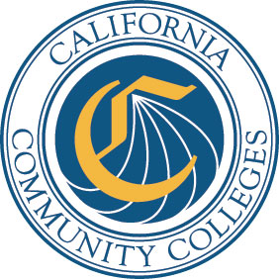

DATE: September 29, 2017 AA 17-55
VIA E-MAIL

TO: Chief Executive Officers
Chief Instructional Officers
Academic Senate for California Community Colleges
Curriculum Specialists

FROM: Laura L. Hope
Executive Vice Chancellor, Educational Services and Support

SUBJECT: CHANCELLOR’S OFFICE CURRICULUM INVENTORY RELEASE OF 1.5.0 UPDATE
The Chancellor’s Office continues to work closely with the California Community College (CCC) Technology Center regarding the technical issues with the Chancellor’s Office Curriculum Inventory (COCI).

With the input received from the colleges, Chancellor’s Office staff, California Community Colleges Curriculum Committee (5C) COCI Workgroup, and the CCC Technology Center, a strong focus has been committed to addressing current issues. In this regard, the CCC Technology Center released the COCI 1.5.0 Update on September 28, 2017. Technical fixes are listed in the release notes.

The CCC Technology Center will now focus on COCI 1.6.0 Update, which will address additional areas of concern. With the two updates, it is the hope to have the system at the desired functionality that allows for more of a seamless effort for both the submitters and reviewers.

The Chancellor’s Office again would like to thank the colleges for their continued patience during the transition to the new curriculum inventory system. The next planned release, designated as COCI 1.6.0,
is targeted for late October.

Please continue to report COCI issues to cociappsupport@openccc.zendesk.com. For questions, contact David Garcia at dgarcia@cccco.edu or at 916-322-4192.

