  - OpenCCC 2.0

Account System
  - General Specification & Data Dictionary

Table of Contents
Account Creation System 5
Part 1. General Specifications 5
Terminology Used in This Document 5
Basic Design Principles 5
General Requirements for Account Creation System 6
Account Creation Fields 7
Account Profile & Editing 12
Duplicate Account Prevention 13
User Flow Screens 15
Flowchart of Account Creation Page Sequences 16
Account Recovery, Matching, & Verification Functions 21
Part 1. Overview of Functions 21
Terminology Used in This Section 21
Basic Design Principles 22
Interrelationships between Functions 22
Account Recovery Function 24
The Account Recovery Process 24
Failure to Find A Match 25
If Account Recovery Is Canceled 25
Use of Account Matching Flags 25
Account Matching Function 25
Principles & Features of Account Matching 26
The Account Matching Process 27
Account Data Provided to the Calling Function 31
Account Verification 31
Security Question Retries 31
If Account Verification Is Canceled 31
ReCaptcha 31
Account Creation: Additional Requirements 32
Notes on Handling Definitive Matches 32
Failure Responses 32
Part 2. Account Recovery & Verification Screens 34
Flowchart of Page Sequences 35
Account Recovery Screens 36
Account Verification Screens 38
Appendices 40
Appendix A. Change Log 40
Appendix B. Name Matching 41
Account Profile Display/Edit Service 42
Part 1. Overview of Account Profile Display & Edit Service 42
Terminology Used in This Section 42
Basic Design Principles 42
Displaying the Account Profile 43
Editing Data in the Account Profile 43
Providing PIN & Answering Security Questions 43
General Requirements 44
Account Name Check & Suggestions 44
Hover Help and Language Switching 45
Stored Values 45
Auto-Population 45
Account System Data Dictionary 46
Legal Name: First 46
Legal Name: Middle 47
Legal Name: Last 47
Legal Name: Suffix 48
Other/Previous First Name 49
Other/Previous Name: Middle 50
Other/Previous Name: Last 51
Preferred First Name 52
Preferred Middle Name 53
Preferred Last Name 54
Date of Birth 55
Social Security Number Type 57
Social Security Number/Taxpayer Identification Number 59
Social Security Number: None 62
Social Security Number: Other Exception 64
Social Security Number Last Four Digits 65
Social Security Number Hash 66
Social Security Number Hash - HMAC 66
Email Address 67
Main Phone Number 68
Main Phone: Extension 69
Main Phone: Text Permission 70
Second Phone Number 71
Second Phone: Extension 72
Second Phone: Text Permission 73
Permanent Address: Street1 and Street2 73
Permanent Address: City 75
Permanent Address: State 75
Permanent Address: Non-U.S. State/Province 76
Permanent Address: ZIP Code or Postal Code 77
Zip Code - Four Character 78
Permanent Address: Country 79
Permanent Address Validation 79
Username 80
Password 81
California Community College ID 82
User ID 83
matchtype 83
Public Key 84
Private Key 84
Cryptokeyid 85
Create Time 85
Update Time 86
Password Update Time 86
Salt 87

Account Creation System

Part 1. General Specifications

Terminology Used in This Document

Basic Design Principles
The first screen of the System-Wide Logon service is the System-Wide Logon Options screen, which allows the user to select from several options, including:
Log on to existing OpenCCC account.
Recover existing OpenCCC account.
Log on to Federated system using WAYF process (Phase II).
Create new OpenCCC account.
The System-Wide Logon service can be called by any OpenCCC service (including the OpenCCC Portal itself) that requires a user to log on using an OpenCCC account. Therefore, the System-Wide Logon service, including Account Creation, will be generic in design, allowing screen branding and general instructions to be controlled by the OpenCCC service that calls it.
OpenCCC services such as System-Wide Logon will run as portlets within either a college’s portal or the OpenCCC portal. Generally, branding will be controlled by the portal in which the service is running. The portlet will have either no branding, or an unobtrusive logo for the specific service or OpenCCC.
Note: If the college has a website rather than a portal, OpenCCC will provide a simple, college-branded portal in which OpenCCC portlets can run.
Explanation of OpenCCC accounts and general instructions about the need for and use of an account will be left to the service calling the System-Wide Logon service. Within the System-Wide Logon service, any text will be specific to the fields and choices presented on the portlet screens.
Thus, for example, if a user accesses CCCApply by clicking an ‘Apply’ link on a college’s portal, the OpenCCC 2.0 service (including called services such as System-Wide Logon) will appear to the user to be part of the college portal. CCCApply can also provide different instructional text and different process flows, depending on whether or not the user has accessed the service via a college website (in which case, selecting a college is not part of the flow) or via the OpenCCC Portal (in which case, selecting a college is a crucial part of the flow).

General Requirements for Account Creation System

Legal Approvals
The CCCCO Legal Department and the Office of Civil Rights need to approve the way we ask for, store, and transmit certain sensitive information. For account creation, that includes:
- Social Security Number
- Date of Birth (Age)
We have approved language where we ask for this information within the CCCApply application, but that language is generally not appropriate for use in the account creation process. Therefore, the ‘legal’ language included in this specification is preliminary, and we will need to get approval for the final language.
Legal approval might also be needed regarding other elements of account creation, such as:
- Text message authorization
- Links to email account providers
Account Name Check And Suggestions
In association with the Username field, there will be a function that checks whether a particular Username is already in use. This function will operate similarly to the button providing this function on the Xap CCCApply Account Creation screen. When the username has been entered, the value entered in the Username field will be checked against all existing Usernames, and a message will be displayed telling the user either:
The Username you entered is available.
The Username you entered is already in use. Please enter a different Username. (You might try adding a number to the end of the name entered.)
‘Account Created’ Message
When an account has been created, a message will inform the user. This is included as Screen 5 in the sequence of Account Creation screens in Part 2 of this document.
After creating a new account, the user is automatically logged on.
Live User Verification: reCaptcha
A ‘reCAPTCHA’ function will verify that account creation is performed by a live person rather than a programmed machine. The user will be required to select the "I'm not a robot" check box in response to the reCaptcha field to pass reCaptcha verification.
The reCaptcha function will include a Screen Reader solution to meet accessibility needs.

Account Creation Process

Account Creation Fields
Table A identifies all of the fields that may be included in the Account Creation process. Some fields will be available or not based on other fields. Most of the fields in the Account Creation process will be stored in the Account Profile; a few are used in the process but not stored.
For each field in the Account Creation process, Table A indicate the type of entry field it is, whether or not a response is required, and other significant information related to the field.

- A field type in which the user types an entry is indicated by the type of entry allowed: Text (including special/ extended characters); Alphanumeric; Alpha; or Numeric.
- In some Numeric fields, hyphens or other separators are optional. The field type for these is specified as Numeric +.
- A field will be defined as required if an entry is required whenever the field is present. For example, the Country field is present only when the address is outside the U.S., and in those cases a Country selection must be made, so Country is defined as required.
- Complete details of the Account Creations fields, including data formats and limits, are provided in Part 3 of this document, the Account Creation Data Dictionary.
- XOR indicates exclusive-OR logic.
Part 2 of this document shows how the data fields appear on the Account Creation screens, including all prompts and explanatory text. Table A follows the order of fields shown in Part 2.
For more complete information about each field for which data is stored, see Part 3 of this document, the Account Creation Data Dictionary.

Address Validation
CASS (or equivalent) Address Validation will occur only on the server side (when clicking ‘Continue’ causes the page of data to be saved). Address Validation will try to match the address entered with an address in its database.
- If a match cannot be found, the Account Creation service will display a message showing the address entered, stating that no match was found, and asking the user to either correct the address entry or confirm that the address is correct.
- If a match is found, the Account Creation service will ‘normalize’ the address to the exact form used by CASS. The user will not see this occur because ‘Continue’ will bring up the next page, but the normalized form of the address will appear whenever address fields are displayed thereafter.
Detailed specifications for Address Validation are TBD.

Table A. Account Creation Data Fields
Field | Type | Required? | Comments
Page 1 - Personal Information
First Name | Text | YES | First Name not null XOR box checked.  Display error message but do not change either entry.
No First Name | Checkbox
Middle Name | Text | YES | Middle Name not null XOR box checked. Display error message but do not change either entry.
No Middle Name | Checkbox
Last/Family Name | Text | YES | Text
Name Suffix | Menu | no | Options: I, II, III, IV, JR, SR
Previous First Name | Text | YES | Previous First Name must be null if ‘No First Name’ is checked.  If Previous Last Name is not null, Previous First Name cannot be null unless ‘No First Name’ is checked.
No First Name | Checkbox
Previous Middle Name | Text | YES | Previous Middle Name not null XOR box checked. Display error message but do not change either entry.
No Middle Name | Checkbox
Previous Last Name | Text | YES | If Previous First Name is not null or ‘No First Name’ box is checked, Previous Last Name cannot be null.
Date of Birth | Numeric+ |  | CCCCO Legal/OCR must approve language and usage.
SSN Type | Radial | YES | New download field; Required if SSN/TIN are not empty; Error/ validity checks matching type with constraints; Store one value for download.
SSN | Numeric+ | YES | Required fields: SSN/TIN fields must match OR ‘SSN_No’ box must bechecked, else error message.  Store only one value for download (with hyphens).  SSN encouragement occurs if ‘SSN_No’ is checked for any reason
SSN Repeat | Numeric+
No SSN | Checkbox

Page 2 - Contact Information
Email Address | Text | YES | Must match; cannot be null.  Store only one value.
Email Address Repeat | Text | YES
Main Phone Number | Numeric+ | no | Validate as far as possible (at least area code format).
Extension | Numeric | no | Error message if non-numeric character entered: e.g., x123
Text message permission  (Main) | Checkbox | no | User can give permission for text messages to be sent to this phone.

Field | Type | Required? | Comments
Second Phone Number | Numeric+ | no | Validate as far as possible (at least area code format).
Extension | Numeric | no | Error message if non-numeric character entered: e.g., x123
Text message permission  (Second) | Checkbox | no | User can give permission for text messages to be sent to this phone.
Address Type | Checkbox | YES | ‘Check here if address not in U.S.’ – determines which address fields are displayed.  No need to make this a data element or store in database.
Address 1 | Text | YES | CASS validation and normalization will be employed. If CASS cannot find address, user will be prompted to fix errors or affirm that entered address is correct.
Address 2 | Text
City |  | Varies | Required for all addresses
State | Menu | YES | Available only if Address Type = In U.S.  Use ISO state list: full name in menu; store 2char abbreviation
State/Province | Text | no | Available only if Address Type = Outside U.S.
ZIP Code | Numeric+ | YES | Available only if Address Type = In U.S.  Must be ‘nnnnn’ or ‘nnnnn-nnnn’
Postal Code | Text | no | Available only if Address Type = Outside U.S.
Country | Menu | YES | Available only if Address Type = Outside U.S.  Store ‘US’ of Address Type = In U.S.  Use ISO country list: full name in menu; store 2-char abbreviation
Page 3 – Logon and Security
Username | Text | YES | Explain username requirements and purpose on screen.  Include availability-check function.
Password | Alphanumeric | YES | Explain password requirements and purpose on screen.  Two password entries must match (caseinsensitive).
Password Repeat | Alphanumeric | YES
PIN | Numeric | YES | Must match; else error message.
PIN Repeat | Numeric | YES | Include text explaining requirements and purpose.
Security Question 1 | Menu | YES | Explain requirements and purpose on screen.  Use same menu for each, with error message if same question is selected twice?
SQ1 Answer | Text | YES
Security Question 2 | Menu | YES
SQ2 Answer | Text | YES
Security Question 3 | Menu | YES
SQ3 Answer | Text | YES
Image Verification  (reCAPTCHA) | Alpha | YES | User must select the "I'm not a robot" check box in response to the reCAPTCHA field.  Client side and Server side validation should read: "You must indicate if you are not a robot. For security reasons, please enter your password and security PIN again before completing the "I'm not a robot" field."  This is not a stored data element.

First Name Validation
A database will be used to determine when a First Name entry might be a nickname. If the First Name appears to be a nickname, the user will be prompted to enter the full legal First Name or to confirm that the apparent nickname is the full legal name.

Hover Help
Most fields in Account Creation process include basic help text that will be displayed when the mouse hovers over the field. This ‘hover help’ text is included in Part 3 of this document, the Account Creation Data Dictionary.

Language Switching
All Account Creation pages which include hover help will also include a button to switch the language used in hover help. Initially the button will switch between English and Spanish, but other languages may be supported in the future.
If possible, the language toggle should also affect the language used in drop-down menus and in pop-up help. (This is less important for Account Creation than for CCCApply.)
The button should say something like (in Spanish) “Switch Help Text to Spanish” and (in English) “Switch Help Text to English”. Hover help will provide additional information on what is affected by the language switching.

Stored Values
For all fields in which the user types in a response, the stored value will be exactly what the user types, with the following exceptions:
- Addresses will be ‘normalized’ by CASS or similar software.
- Some numeric fields will be stored in defined formats (such as ‘nnn-nn-nnnn’ for SSN), even if the user is allowed to type in a different format (such as ‘nnnnnnnnn’ for SSN). Exactly how forgiving the specific fields will be is to be determined.
- Answers to security questions will be ‘normalized’ so that answers will match even if entered with different capitalization or spacing (e.g., “TOPHAT” and “Top hat” could be matches). Exact details of this normalization are to be determined.
For all fields in which the user types in a response, the stored value will be a coded value (sometimes numeric, sometimes alpha). The Data Dictionary in Part 3 of this document defines the coded values for each menu option, checkbox, and radio button.

Non-Form Information Stored
When an account is created, a CCCID is created and stored. The CCCID serves as the account key in the database, and is an essential element in OpenCCC Federated Identity.
The data and time of account creation will also be stored as part of the account data.
As indicated in the Duplicate Account Prevention section, Account Matching may provide flags relating to account matching situations. These flags will need to be saved in the account database.
Are there any other data elements that will be save when the account is created?
- Flags of any kind?
- Entry Point (i.e., URL of previous page)?
Attention: Is this a question from Mark Howell? Find out if flags are stored. If not, remove this.

Auto-Population
Data entered during Account Creation will be used to populate the user’s Account Profile. In addition, via the Account Profile, it will auto-populate the appropriate fields in the CCCApply application form.

Account Verification Process

Account Confirmation

Account Profile & Editing
The Account Profile service will display the Personal Information and Contact Information fields from Account Creation with their current values. It will provide options for changing Personal Information and Contact Information values, as well as options for changing the username, password, PIN, and security questions/answers. Some level of security verification (e.g., PIN entry) will be required before any security values can be displayed or changed.
Details of the Account Profile service are provided in Specification: Account Profile Display/Edit Service.

Duplicate Account Prevention
Duplicate accounts for the same individuals will significantly degrade the functionality of OpenCCC and CCCApply. Therefore, before a new account is created, Account Creation will call the Account Matching service to determine whether there is an existing account that might belong to the person creating a new account. Specific logic used for Account Matching is provided in Specification: Account Recovery, Account Matching, and Account Verification Functions.
Account Matching will be called when the Personal Information page is saved and again when the Contact
Information page is saved. If a single matching account is found, Account Matching will identify the account to Account Creation, and may also include one or more flags indicating various matching conditions. Account Creation will inform the user that a possible matching account has been found, and will call Account Verification to attempt to verify (by asking Security Questions) that the user is the owner of the matching account. Details of Account
Verification are provided in Specification: Account Recovery, Account Matching, and Account Verification Functions.
If the user fails to recover the matching account by answering the Security Questions, he will be encouraged to contact User Support if he believes the matching account is his, but he will also have the option of continuing with Account Creation. All data entered in Account Creation will be retained, so if the Account Verification fails, the user can continue with Account Creation without having to re-enter any data.
There is one exception to the preceding paragraph: If the SSN and Date of Birth match an existing account, and the user fails to answer the Security Questions correctly, the user will not be allowed to continue with Account Creation. The user will be told to contact User Support (or to contact the college A&R office, if the user is creating an account in order to begin an application for admission) to resolve the issue.
In rare instances, Account Matching may find matches to more than one existing account. If there are multiple matches when the Personal Information page is saved, the matches will be ignored. If there are multiple matches when the Contact Information page is saved, the user will be informed, and encouraged to contact User Support if he believes he may already have an account.
If a matching account is found when the Personal Information page is saved, but the user fails to recover the account, Account Matching will not be called when the Contact Information page is saved, since that would result in a repeat of the attempt to recover the same matching account.
Message For Matching Account Found
If a single matching account is found by Account Matching, the following message will be displayed. The user will be required to answer the security questions and click Access Account, which will take the user to the password reset page.
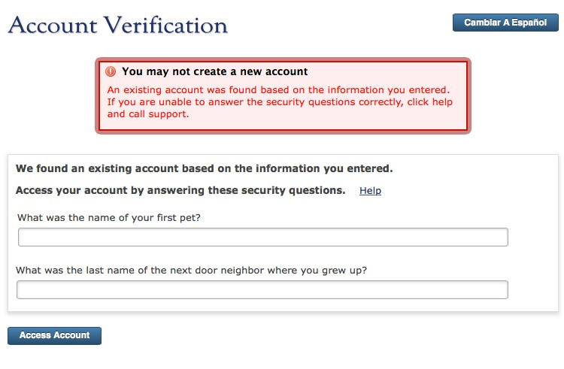
Account Verification Messages
Account Verification is a separate service/function called by Account Creation. Account Verification functionality and screens are detailed in Specification: Account Recovery, Account Matching, and Account Verification Functions.
If the user fails to verify ownership of the matching account (i.e., if the user cannot correctly answer the security questions presented by Account Verification), and the matching account does not include matches on the SSN and Date of Birth, cancelling Account Verification will bring the user back to Account Creation at the same place he left off, with the following message:
We were unable to verify your ownership of the matching account. It may be that this account is not yours, though there is a close match to the data you entered. If you believe it is your account but were unable to answer the security questions, please contact User Support for assistance in recovering the account. Otherwise, click ‘Continue’ to proceed with creating your new account.
[ Contact User Support ] [ Continue ]
If the user fails to verify ownership of the matching account and the matching account includes matches on the SSN and Date of Birth, cancelling Account Verification will bring the user back to Account Creation at the same place he left off, with the following message.
There is already an account with the same key data that you have entered for your new account, including Date of Birth and Social Security Number. This situation must be resolved before you can proceed with creating a new account. Please review the data you entered to make sure that it is correct. If it is, please contact User Support by telephone or email—or, if you are creating a new account in order to submit an application for admission to a college, please contact the college’s Admissions and Records office. Click ‘Review My Data’ to proceed.
Cancel [ Review My Data ]
Clicking ‘Review My Data’ will take the user back to the Personal Information screen (data entered on the Contact
Information screen, if any, should not be lost, so that if the user corrects the Date of Birth or SSN and proceeds to Contact Information, no re-entry of data will be required). Clicking ‘Cancel’ will take the user back to wherever he was before Account Creation was initiated.
Saving Account Matching Flags
As indicated in Specification: Account Recovery, Account Matching, and Account Verification Functions, there are several possible flags related to account matches that may be passed by Account Matching to Account Creation. If Account Creation is completed, these flags need to be saved in the account database. These flags will also need to be saved in the database for the matching account involved.
For example, if Account Matching provides a flag that says an existing account has the same SSN as the account to be created, the flag will need to be saved with the existing account and the new account. CCCApply may then pass along this flag whenever an application is submitted from one of these accounts, and the colleges will be alerted to verify the student’s SSN if appropriate.
Note: Currently, Account Matching will not pass flags if multiple matches are found. This may need to be revisited.

User Flow Screens
This part of the document shows, in a rudimentary way, how the data fields and supporting text will appear on the Account Creation screens. The intent is to show the order of the data fields and the exact language to be used. Details of layout and aesthetic elements are not addressed.

Flowchart of Account Creation Page Sequences
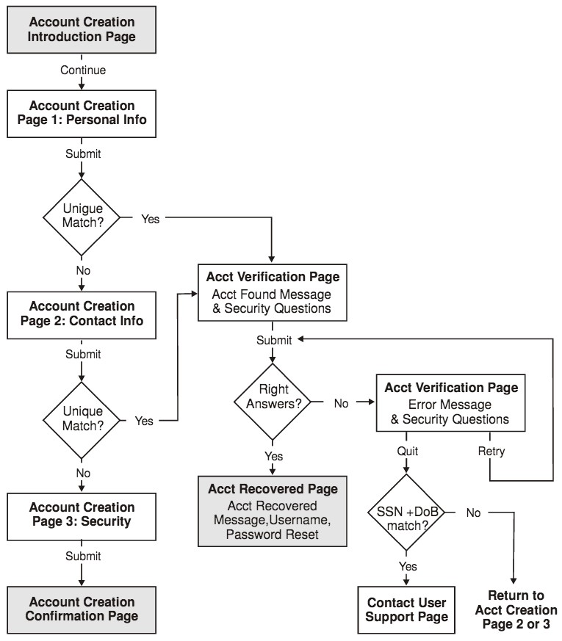

Screen 1: Create Your OpenCCC Account
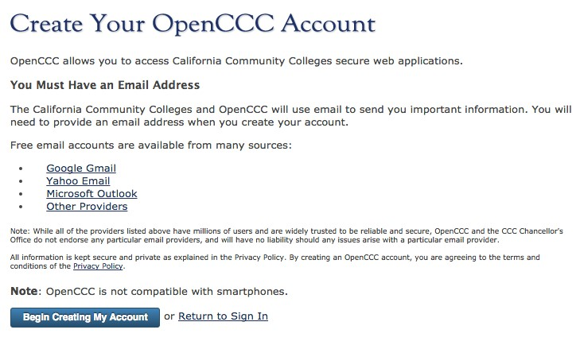

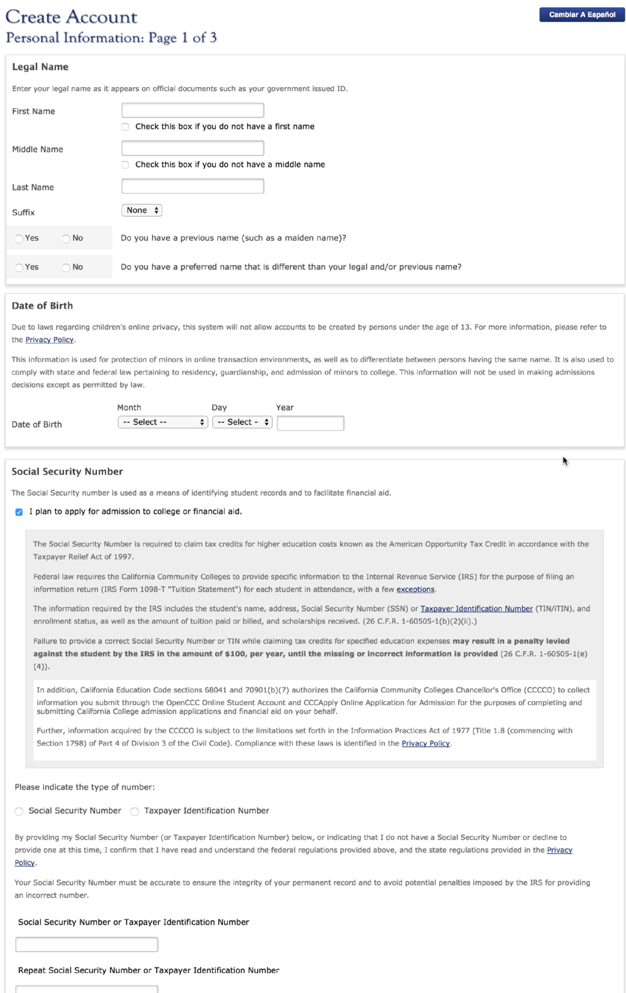
Screen 2: Create Your Account: Personal Information

Screen 3: Create Your Account: Contact Information
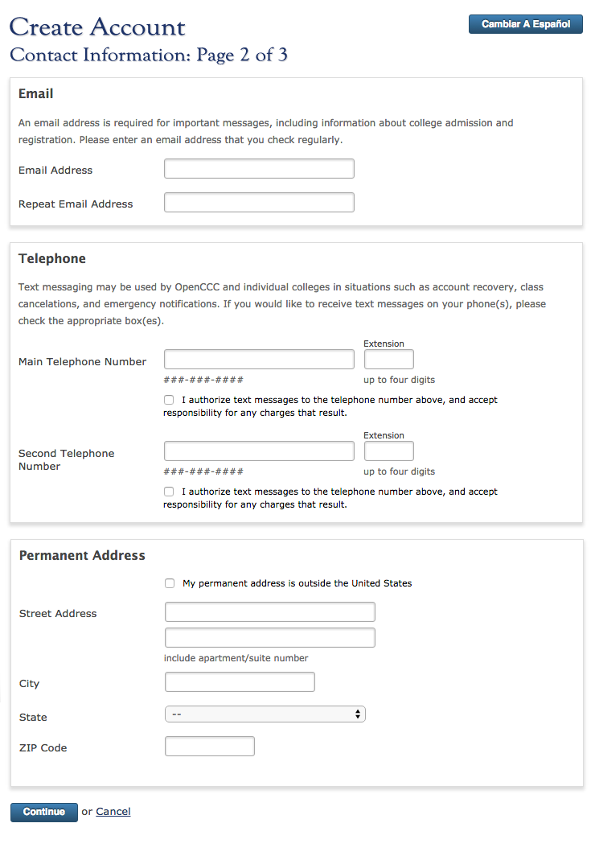
Note: A Confirmation dialog box displays when the User selects the "My permanent address is outside the United States" check box, to confirm they have correctly selected this option. The Country drop-down list, which displays when this check box is selected, is used in determining the User's U.S. or non-U.S. residency. When the check box is not selected, the hidden Country drop-down list defaults to U.S.

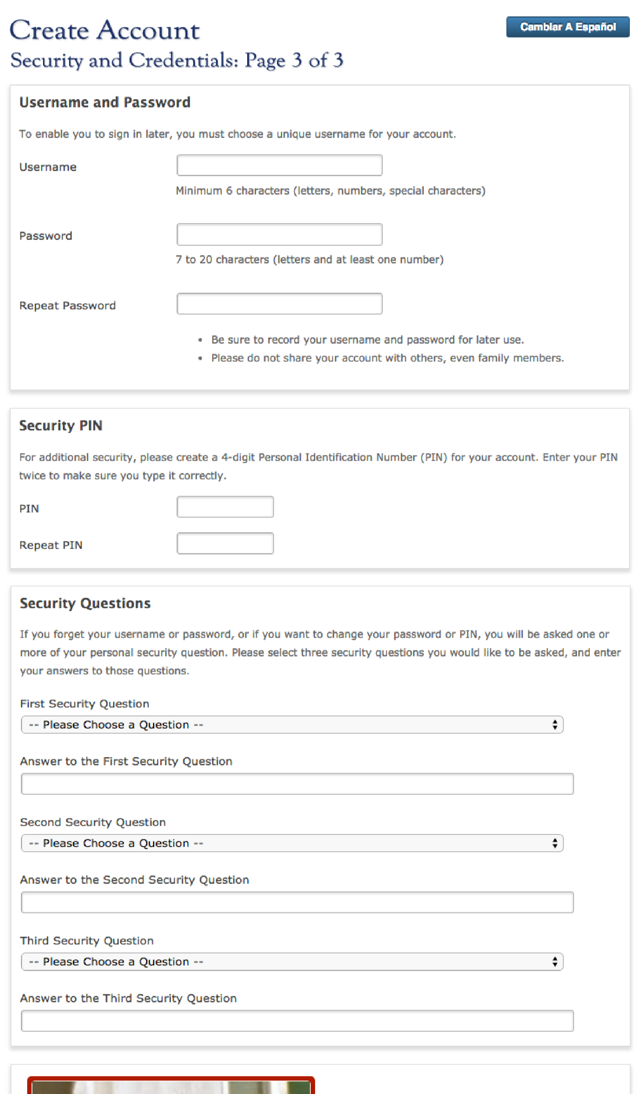
Screen 4: Create Your Account: Logon and Security

Screen 5: Account Created
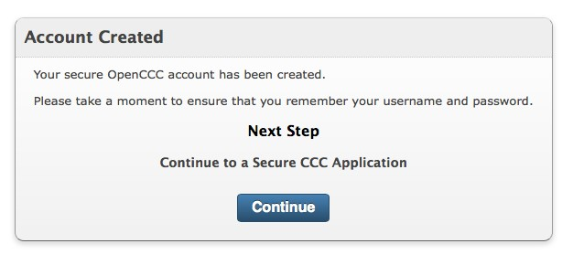

Account Recovery, Matching, & Verification Functions

Part 1. Overview of Functions

Terminology Used in This Section
Account | A user account for OpenCCC.
Account Duplication | The existence of two or more OpenCCC user accounts for the same person.
Account Matching | The function that takes data input by a user and attempts to match it to an existing OpenCCC account.
Account Profile | The set of personal data directly associated with an account (as opposed to data stored by a particular service, such as CCCApply data). Basically, it includes all of the data fields populated during Account Creation, but values may have been updated since account creation.
Account Recovery | The process of regaining access to an account for which the Username has been forgotten.
Account Verification | Ensuring, through the use of Security Questions or other techniques other than logon, that an online user is the owner of a particular existing account.
Calling Function | The function that initiates another function. When Account Creation sends data to Account Matching to see if a matching account already exists, it is the ‘calling function’.
Definitive Match | When user-provided account data matches an Account Profile in a way that ensures a near-100% probability of either a True Match or some sort of identity fraud.
Match Type Flags | Indicators provided by Account Matching to identify types of matches that might lead to some sort of special handling by another function or service, by OpenCCC administration, or by colleges.
Multiple Match | Where Account Matching finds two or more accounts matching a particular set of user data.
Probable Match | When user-provided account data matches an Account Profile in a way that makes it probable but not definitive that that the user is the owner of the account. A probable match is the threshold for asking Account Verification.
True Match | When the user providing account data is truly the same person as the holder of an existing account. This is a real-world status that the system can never determine with a non-zero chance of error, but it is the goal of Account Matching and Account Verification.
Multiple Match | Where Account Matching finds exactly one account matching a particular set of user data.
Verified Match | When a user has verified ownership of an account by answering Security Questions (or through another verification process).

Basic Design Principles
This document specifies the requirements for three interrelated functions:
- Account Recovery, which enables a user to regain access to an account when the username and/or password have been forgotten.
- Account Matching, which determines whether a set of user information is a probable match or definitive match to an existing account.
- Account Verification, which uses Security Questions to verify that the online user is the owner of a particular account, allows the user to reset the password, and logs the user into the account.
These functions might be implemented as separate services, or parts of other services. The choice should be consistent with overall SOA philosophy.

Interrelationships between Functions
Sign In, Account Creation, Account Verification, Account Recovery, and Edit Account functions have various linkages, as indicated in Figure 1.
Note: Figure 1 provides a fairly detailed overview of the functions and their interrelationships; however, it is not meant to illustrate all of the logic for the functions.
- The Logon function has not yet been specified in any detail, but its basic functionality has been decided. It will present to the user a single screen with various Account and Logon options: Log On; Recover Username; Recover Password; Create Account; Log On Using WAYF (Federated ID).
- The Forgot Username option in the Logon function will initiate the Account Recovery function. The Forgot Password option will go straight to Account Verification if the user enters a valid Username.
- Account Recovery will gather user information and then call the Account Matching function.
- Before creating a new account, Account Creation will call the Account Matching function to determine whether the user might already have an account. This will be transparent to the user unless a match is found. If a match is found, Account Creation will call Account Verification to verify the match.
- Duplicate account detection will be part of the Account Matching function, and will return an indication of whether there is a definitive match—i.e., a match with near-zero likelihood of belonging to a different person. Account Creation might use this information to disallow creation of a new account.
Note: The tech team is in disagreement about whether the user will always have the option to go ahead and create a new account, or will in certain situations be barred from creating a new account and forced into Account Recovery and/or User Support. The Steering Committee will discuss this issue in January 2011. CCCCO legal will be asked for approval of whatever is decided.
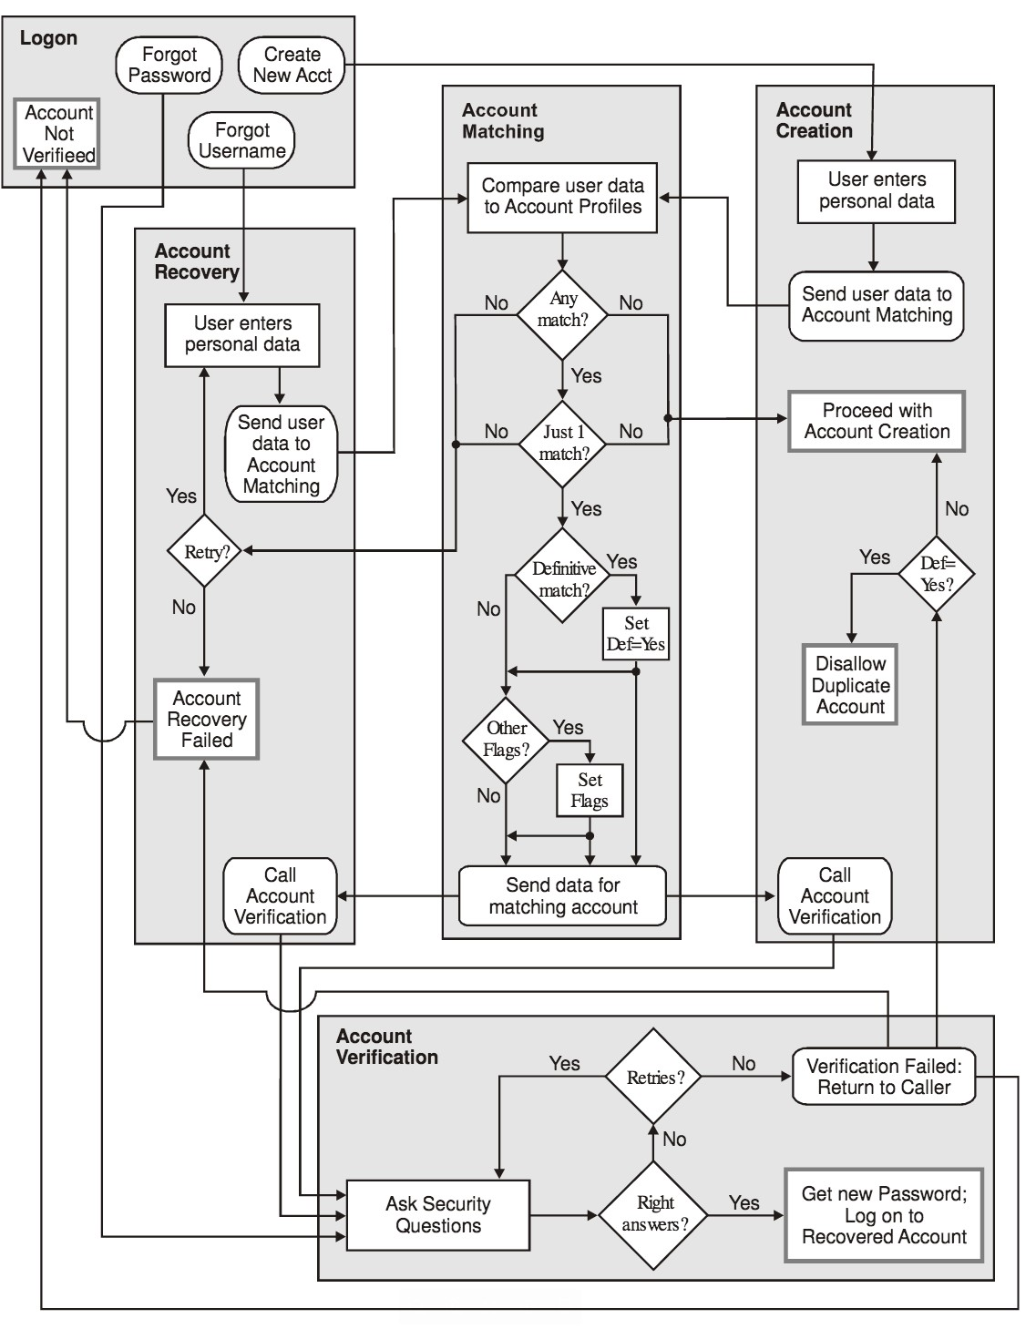
Figure 1: Simplified Flow Chart of Functions and Their Interrelationships

Account Recovery Function
The Account Recovery function interacts with users, allowing them to ‘recover’ their accounts when they have forgotten the Username for the account. It is called by the Logon function when the user clicks a button to indicate “I forgot my Username”.
The Account Recovery function gathers information from the user and passes it to Account Matching, which compares the user’s entries with the Accounts database and responds with its findings.
If Account Matching indicates a unique match, the Account Recovery function calls the Account Verification function, which employs Security Questions to verify that the user is truly the owner of the account.
Users always have the option to cancel the Account Recovery process. Doing so will take them back to the Logon function.

The Account Recovery Process
User Recovery employs one screen, headed Account Finder, on which the user is asked to supply personal information. The fields on this screen correspond to the fields of the Account Profile. Content and layout of this screen are shown in Part 2. Fields included on this screen are identified in Table A.

Table 1: Table A. Account Recovery Fields
Field | Required? | Comments
Date of Birth | YES | Legal language is not required
Social Security Number (SSN) | YES | Legal language is not required
Legal First Name | YES | Including ‘no first name’ checkbox
Legal Middle Name | YES | Including ‘no middle name’ checkbox
Legal Last Name | YES
Suffix | no | Asked, but not used in matching
Previous First Name | no | Including ‘no first name’ checkbox
Previous Middle Name | no | Including ‘no middle name’ checkbox
Previous Last Name | no
Email Address | no | Optional
Main Telephone | no | No field for extension
Second Telephone | no | No field for extension
Street Address | no | With CASS, as in Account Creation
City | no | U.S. and Non U.S.
U.S. State | no | U.S. addresses only
ZIP Code | no | U.S. addresses only
Non-U.S. State/Province | no | Non-U.S. addresses only
Non-U.S. Postal Code | no | Non-U.S. addresses only
Non-U.S. Country | no | Non-U.S. addresses only

Failure to Find A Match
If the first attempt at account recovery does not result in a match, the user will be prompted to retry, adding more information and/or providing older information. After a second failure to find a match, the user will be prompted to retry, contact User Support, or Create a New Account. Error messages for these two cases are provided in Part 2.

If Account Recovery Is Canceled
If the user clicks Cancel on an Account Recovery screen, the user will be returned to the Logon function. Any data entered for Account Recovery will be stored so it can be used to auto-populate Account Creation fields if the user opts to create a new account.

Use of Account Matching Flags
As described later in this document, Account Matching will provide various flags identifying types of matches (such as a definitive match). Currently, Account Recovery will not use any of these flags, it is possible that in the future we will refine Account Recovery so that it provides different messages and/or operates differently based on the flags from Account Matching. Similarly, Account Verification does not currently use the flags but might in the future, so Account Recovery should pass the flags to Account Verification—and, if Account Verification fails, to the Logon function.

Account Matching Function
The Account Matching function does not have a user interface. It is called by other functions to compare user data with existing accounts. It will accept whatever set of user data the calling function provides, and will attempt to identify a unique account based on that data. (For example, Account Recovery might provide only the required fields, Legal Name and Date of Birth.)
Once the Accounts database has been searched for matches, Account Matching will:
- identify a single matching account to the calling function, provide flags to indicate match type (such as whether the match is definitive or not) as appropriate; or
- tell the calling function that there was no matching account; or
- tell the calling function that there were two or more matching accounts.
It is not the job of Account Matching to determine that a unique account found by Account Matching is a true match—in other words, that it does indeed belong to a particular online user. That task is performed by Account Verification, which will employ security questions to verify that the online user is the actual owner of the account. (Account Verification will never ensure a true match with absolute certainty, but a verified match must provide sufficient assurance to meet current and evolving security standards.)

Principles & Features of Account Matching
Basic Goal: Account Matching looks for at least a probable match so that Account Verification can be invoked. Increasing the amount of data required for a probable match increases the probability of a true match, but it also increases the probability of missing a true match. Account Matching should strike a balance between being so loose that many of the declared probable matches are not true, and being so tight that many true matches are not detected.
Important Edge Cases: Matching logic needs to take into account: a) that two people may share a lot of the same information; and b) that over time one person’s information might almost completely change. Therefore, the following two cases should be kept in when considering matching logic. These are unusual cases, but could occur many times in the large population OpenCCC will serve:
- Twins who share an address and perhaps share phones and email as well. The only differentiating info might be First Name and SSNs.
- A parent and child with the same name who share an address and perhaps share phones and email as well. The only differentiating info might be Date of Birth.
- A woman who has changed her name through marriage, moved, and gotten a new email address and phone. Only her Date of Birth, SSN, and (probably) First Name would be the same.
Match Searching: The first version of Account Matching will look for matches in current Account Profiles only. Later, Account Matching may also ask for and compare additional data as appropriate. There are several reasons for initially limiting the account searches to current Account Profiles:
- Account Profile history is unlikely to be useful, since users are unlikely to enter data older than what is in the Profile, though they may enter newer data.
- If application data auto-updates the Profile as expected, there will be no need to check application data unless non-Profile data (e.g., confirmation #, schools attended) is added to the data possibly sent to Account Matching.
- We don’t know yet exactly how and when historical applications from the Xap system will be added to the database; or how and when Xap accounts will be merged into our Federated ID system. Possible account merging and/or attachment of submitted apps not linked to an account will be addressed later, probably by other functions or services.
- We don’t know what useful account-identifying data might be available from other OpenCCC services.
- If we ask for additional data to resolve multiple matches (for example, last high school attended), we need to decide whether to ask programmatically or only when the user calls User Support.
Date of Birth and SSN: These are the only profile data elements that are essentially unchangeable. A matching account must include a match on at least one of these fields.
An SSN match by itself cannot be considered definitive because of the possibility that an incorrect SSN has been entered, either accidentally or on purpose.
Name Matching: Names provided by the calling functions will be compared for matches with both the Current and Previous Names in the Account Profile. However, matching elements must come from one name in the calling function and one name in the Account Profile. For example, if the Legal Name from the calling function is Mary Jones, that is not First Name + Last Name match for an account that has a Legal Name of Mary Contrary and a Previous Name of Janet Jones. For a more detailed explanation, see Appendix B.
Later, a data base might be used to match different forms of a first name. For example, ‘Anthony Benedetto’ and ‘Tony Benedetto’ would be considered matches. Null First Names and/or Middle Names will be a match only if the corresponding Last Name is a match.
Suffix has no value for Account Matching, since we have Date of Birth, and therefore will not be used in account matching. However, because users have been known to add a suffix in the Last Name field, we will include a Suffix field when asking for the Legal Name in order to protect the accuracy of the Last Name field.
Email Address Matching: When comparing email addresses, the domain will be ignored.
Telephone Matching: When comparing telephone numbers, extensions will be ignored.
Both Telephone Numbers provided by the calling functions will be compared with both Telephone Numbers in the Account Profile, and any match will be accepted (i.e., a Main Telephone can match a Second Telephone).
Address Matching: Lines 1 and 2 of the Street Address will be concatenated. CASS or equivalent address validation/normalization will be used when feasible. For example, “100 E. Bluebird” and “100 East Bluebird Lane” should be recognized as matching.
Only the Street Address and State values need to match for U.S. addresses; for non-U.S. addresses, only the Street Address and Country values need to match. (This will eliminate false non-matches due to mistakes in other address elements such as City and ZIP Code.)
Note: CASS or equivalent address validation/normalization may not be implemented in the earliest release(s). In that case, address matching might need to rely more on weaker City and Postal Code matches, since matching of non-normalized addresses will be unreliable. Temporarily implementing a simple normalization algorithm for Street Address might be worthwhile; otherwise, the matching algorithm would probably need to be adjusted for the weakened address matching.
Blank Fields: Blank values in optional fields will not be considered matches (except for name fields, where a blank is equal to “no first name” or “no middle name”).

The Account Matching Process
Account Recovery will employ a stepped process that first determines if there any matches, then resolves any multiple matches, then determines whether a unique match is definitive or probable and sets other flags for certain matches. Figure 1 illustrates the basic process.
Step 1
In order for Account Matching to declare a match, it must find one of the sets of data matches shown in Table B, in which each row indicates a possible way in which accounts can match. (Blank gray cells in the body of Table B indicate fields that may or may not match.) The Account Matching algorithm will query the database for matches in the order specified. Querying will stop whenever a completed query finds at least one matching account.
Note: Table B represents the CCC Team’s best effort at defining match criteria and search order. However, we recognize that programming considerations and further analysis are likely to lead to modifications of the matching algorithm.
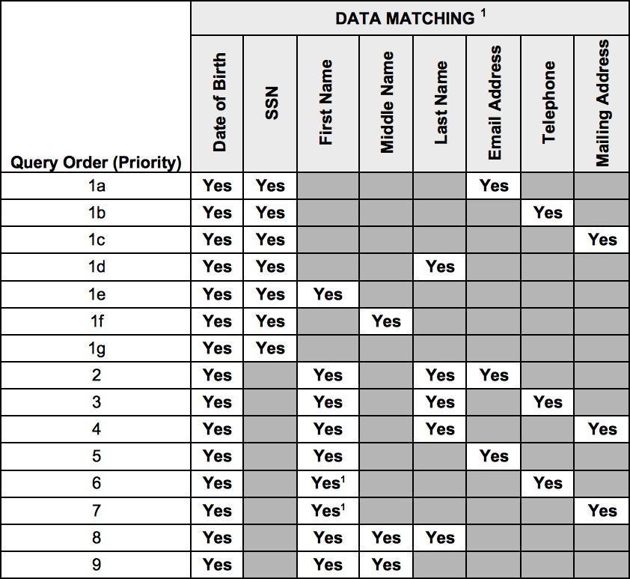
Figure 2: Table B. Account Matching Logic and Query Order
Note: See the section headed Principles and Features of Account Matching for details about normalization, name matching, email address matching, telephone matching, and mailing address matching.
If multiple matches are found in the first query that finds at least one match, Account Matching proceeds to Step 2.
Example: There are no matching accounts found in queries 1a through 5. In query 6, two accounts are found that have matches on DoB + FirstName + Telephone.
If a unique match is found in the first query that finds at least one match, Account Matching identifies the account and skips to Step 3.
Example: There are no matching accounts found in queries 1a through 5. In query 6, one account is found that has matches on DoB + FirstName + Telephone.
If no match is found by any of the queries in Table B, Account Matching is finished; Account Matching tells the calling function that there is no match on the data provided.
Step 2
If Account Matching finds multiple matches in the first query that finds at least one match, it will use any additional data available to attempt to find a single match.
For the input data and the matching accounts, compare any data fields that have not already been compared. If only one account has any matches when the additional data is compared, that account will be chosen as a unique match.
If two or more accounts have different matches when the additional data is compared, the one with the higherpriority match will be chosen as a unique match. The priority of additional data matches will be (from highest to lowest): Email Address, Telephone, Mailing Address, Last Name, First Name, Middle Name.
If neither account has additional matches, or both have the same matches, the multiple match cannot be resolved with the available data.
Example: If there are two accounts that have matched the query for Date of Birth + First Name + Email Address,
Account Matching will look at Telephone, Mailing Address, and Middle Name to try to resolve the multiple match (previous queries will have ruled out a match on SSN or Last Name). If one account has a match on Telephone and the other has a match on Middle Name, the account with the Telephone match is chosen.
If multiple matches have been resolved to a unique match, Account Matching identifies the account and goes to Step 3.
If multiple matches cannot be resolved, Account Matching is finished; Account Matching tells the calling function that there are multiple matches for the data provided.
Step 3
After Account Matching finds a unique match, it will compare all of the data provided by the calling function to the identified account and set flags as indicated in Table C. Account Matching will provide these flags to the calling function so the calling function can make procedural decisions and/or store the flags in the database for other uses.
Figure 3: Table C. Account Matching: Setting Match Type Flags
There are many different ways that these flags might be used.
Flag A, which indicates a definitive match, might be used by Account Creation to block creation of a new account and require the user to contact User Support; or it might be used simply to set a flag in the database.
Flag B, which indicates a match on both SSN and Date of Birth, might be used by Account Creation to set a flag in the database that could trigger emails indicating possible identity fraud.
Note: The flags defined in Table C represent our current best judgment of what is necessary or useful. The possibility of additional flags, as well as appropriate use of the flags, will be determined in discussion with the CCCApply Steering Committee. Implementation of flags should make it easy to add and remove flags.
What the calling functions do with the flags provided by Account Matching will be specified in the specifications for those functions (e.g., Account Creation).

Account Data Provided to the Calling Function
If Account Matching finds a unique match, it must provide information about the matching account to the calling function (see Figure 1). At a minimum, it must provide an account ID and any flags set. In addition, it might provide additional information that might be needed by a calling function. For example, it might provide Security Questions and Answers so they can be passed to Account Verification. The most efficient approach should be used.

Account Verification
It is the job of Account Verification to verify with an acceptable level of certainty that a unique existing account identified during Account Recovery or Account Creation does indeed belong to the online user. It does this by randomly selecting two of the account’s three Security Questions, and requiring the user to answer those questions.
If the user answers the Security Questions correctly, Account Verification will display the account’s Username and provide fields for resetting the account’s Password.
Once the password has been reset, the user will be admitted to the account, just as if he had logged on. (For example, if Account Recovery or Account Creation has been entered as part of the flow from a college website to the CCCApply online application, the user will be taken from the password reset screen to the Introduction page of the college’s online application.)
Layout of the Account Verification pages is shown in Part 2.

Security Question Retries
The user will be allowed six tries at answering the Security Questions; after six failed attempts, there will be a 30 minute lockout. User sent to User Support page. When a lockout ends, six more tries will be allowed before another lockout. For each successive lockout, the lockout period doubles.
The lockout period will be reset after a legitimate logon or customer service intervention.

If Account Verification Is Canceled
If the user clicks Cancel on an Account Verification screen, the user will be returned to the calling function: Logon or Account Matching. It will be up to the calling function to proceed appropriately.

ReCaptcha
Because it is unlikely that an automated attacker could successfully answer the Security Questions in a small number of tries, ReCaptcha normally will not be included in Account Verification.
However, if there are six incorrect attempts to answer the Security Questions, there will be a 30-minute lockout as described above. After this lockout, the screen on which the Security Questions are asked will also include the same Captcha function that is used for Account Creation. Captcha will continue to be used for the Security Questions for this account until the lockout period is reset.

Account Creation: Additional Requirements
Currently, the Account Creation Specification does not address in any detail the requirements for the use of Account Matching and Account Verification in the prevention of duplicate accounts. The Account Creation Specification will need to be updated to fully address these requirements.
Changes to the Account Creation Specification will include the following:
Account Matching will be called when the first page is saved. A unique match at that point will cause Account Verification to be called. If there are no matches or multiple matches, Account Creation will continue.
Account Matching will be called again when the second page is saved. A unique match at that point will cause Account Verification to be called. If there are no matches, Account Creation will continue. If there are multiple matches, the user will be prompted to consider calling User Support; the user might or might not have the option of creating the new account.
Based on the flags provided by Account Matching, Account Creation will set database flags if it creates a new account. In addition, it might (if the Steering Committee so decides) disallow Account Creation in the case of definitive matches.
In addition, the Gender field will be deleted from Account Creation, and a field for Previous Middle Name will be added.

Notes on Handling Definitive Matches
No match is absolutely definitive. For example, identity fraud could lead to one person creating an account with another person’s data. Also, an extremely unlikely situation or set of coincidences could lead to a false ‘definitive match’. The larger our account database becomes, the higher the probability will be that some of these very unlikely situations will occur. Therefore, we need to make sure that our software and our user support processes ensure that false ‘definitive matches’ can be resolved effectively and efficiently.
For example, simply blocking the creation of a new account when there is a definitive match with an existing account might be too extreme. The person attempting to create an account may be providing completely accurate data, and the existing account may match because of a highly unlikely situation or because of identity fraud by the person who created the earlier account. In such a situation, it might not be acceptable that the person attempting to create an account is either unable to do so or is required to wait until the situation can be investigated.
One option that has been discussed is for Account Creation to have a hidden ‘override code’ field that can be activated by a secret keyboard sequence. When a user is blocked from creating an account because of a definitive match, the user can call User Support and, if no other solution is available, User Support can tell the user how to activate the hidden field and use it to override the block on Account Creation.

Failure Responses
Sometimes the Account Creation, Account Matching, Account Recovery, and Account Verification functions will fail to reach the desired results. The following are possible failures, and the required responses:
Account Recovery and Matching Failure: Data provided by Account Recovery does not match any existing account.
- Possible Reasons: a) User has not provided sufficient or ‘correct’ information; b) User does not have an existing account.
- Response: User will be prompted to enter more or different information. The user will also have the option to Cancel the process and return to Logon, or to contact User Support (in case the user continues to believe there is an existing account).
Account Recovery and Matching Failure: Data provided by Account Recovery matches multiple accounts.
- Possible Reasons: a) User has not provided sufficient or ‘correct’ information; b) User has two accounts; c) There are two or more accounts with exactly the same matching values (for example, two accounts for a John James Smith born on the same day but having no other matches), so the Account Matching logic cannot choose one over the other(s) as most likely.
- Response: User will be prompted to enter more or different information. The user will also have the option to Cancel the process and return to Logon, or to contact User Support.
Account Creation and Matching Failure: Data provided by Account Creation matches multiple accounts.
- Possible Reasons: a) User has not provided sufficient or ‘correct’ information; b) User has two accounts; c) There are two or more accounts with exactly the same matching values (for example, two accounts for a John Smith born on the same day but having no other matches).
- Response: User will be prompted to call User Support. Otherwise, assuming that the two matches are not definitive, Account Creation must be allowed to proceed, since there is a good chance no ‘matching’ account actually belongs to the user, and (at this time, anyway) we have no way to use an online dialog to get more possible matching info from the user.
Account Verification Failure: User cannot answer security questions.
- Possible Reasons: a) Account does not belong to user; b) User has forgotten the answers.
- Response: Six retries allowed before lockout “tarpit” is initiated. User will be informed of User Support option. Cancel will take user back to calling service; data fields should be populated as they were when Account Verification was called.

Part 2. Account Recovery & Verification Screens

All data fields used in the Account Recovery and Account Verification screens are defined in the Account Creation Specification and Data Dictionary. Hover help, validation of entries, and error messages for invalid entries on the Account Recovery and Account Verification screens will be the same as defined in the Account Creation Specification and Data Dictionary, except as regards required fields. In Account Recovery, the only required fields are Date of Birth, First Name, Middle Name, and Last Name. In Account Verification, all input fields are required.
Error messages for Account Recovery or Account Verification processes (i.e., a failure to identify a unique user account or a failure to verify ownership of an account) are defined and illustrated on the following pages.

Flowchart of Page Sequences
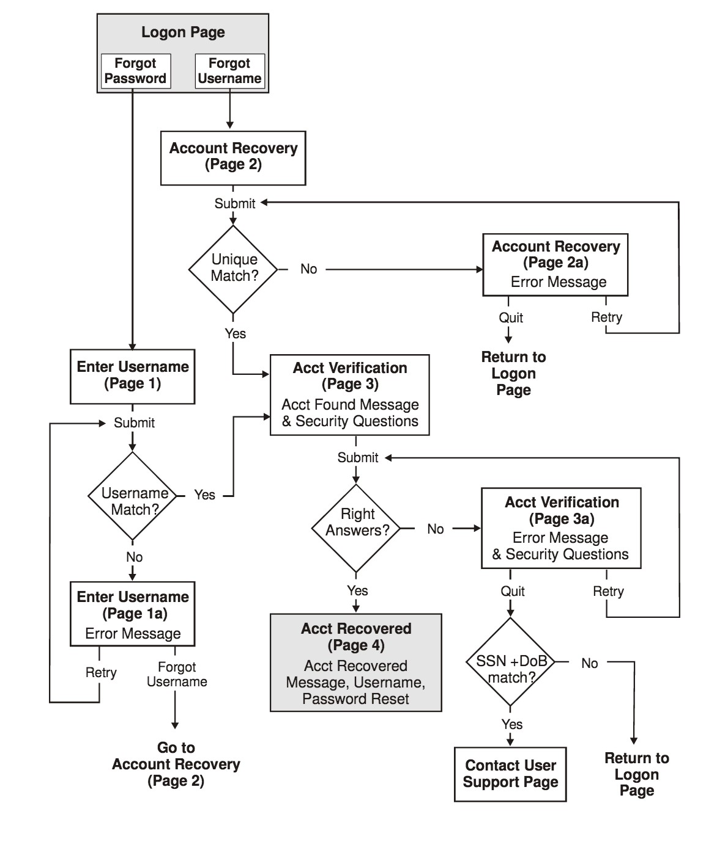
Figure 4: Table D. Flow Chart of Page Sequences

Account Recovery Screens
Account Finder
* required fields
Social Security Number [________] Usually this is the best way to find your account
Date of Birth * [ ] mm/dd/yyyy
Legal First Name * [ ]
□ Check this box if you do not have a first name
Legal Middle Name * [ ]
□ Check this box if you do not have a middle name
Legal Last/Family Name * [ ]
Suffix [_MENU_]
Previous First Name [____________________________________]
□ Check this box if you did not have a first name
Previous Middle Name [____________________________________]
□ Check this box if you did not have a middle name
Previous Last/Family Name [____________________________________]
Previous Suffix [_MENU_]
Email Address [ ]
Main Telephone Number [____________] (###) ###-####
Second Telephone Number [____________]
□ My address is outside the United States
Street Address [____________________________________________]
[____________________________________________]
(include apartment/suite number)
City [____________________________________]
State [_MENU_]
ZIP Code [__________]
{OR, if non-U.S. box is checked, replace State and ZIP Code fields with the following}
State/Province [_______________________________________]
Postal Code [__________________________]
Country [_MENU_]
Cancel[ Find My Account ]
____________________________________________________________________________________
<Screen after one failed matching attempt>
Account Finder
We could not identify an account based on the information you entered. Please double-check the information you entered, and provide as much additional information as you can. Keep in mind that some of your information may have changed since you last used your account, so try to provide the information that would have been correct then, such as a previous name or older email address.
required fields
Social Security Number [________] Usually this is the best way to find your account
Date of Birth * [ 11/11/1980 ] mm/dd/yyyy
[_MENU_] [_MENU_] [_YYYY Text_]
Legal First Name * [ James ]
□ Check this box if you do not have a first name
..
..
..
Cancel[ Find My Account ]
____________________________________________________________________________________
<Screen after two or more failed matching attempts>
Account Finder
We still could not identify an account based on the information you entered. Please double-check the information you entered, provide any additional information you can, and retry. Keep in mind that some of your information may have changed since you last used your account, so try to provide the information that would have been correct then. If you have provided all of the information you can, contact User Support if you would like further help, click Create New Account, or click Cancel to exit from the Account Finder.
required fields
Social Security Number [________] Usually this is the best way to find your account
Date of Birth * [ 11/11/1980 ] mm/dd/yyyy
Legal First Name * [ James ]
□ Check this box if you do not have a first name
..
.. ..
Cancel[ Find My Account ] Create New Account
____________________________________________________________________________________

Account Verification Screens
Account Verification
Username thowell3<Read-only. Line is displayed only for I Forgot My Password>
Thank you, <FirstName>. Please answer your Security Questions to verify your identity.
What was the name of your first pet?
Answer: [ ]
What is your oldest cousin’s first and last name?
Answer: [ ]
Cancel[ Continue ]
____________________________________________________________________________________
<Screen 1: after erroneous entry>
Account Verification
You have not answered your Security Questions correctly. Please try again. If you cannot answer your Security Questions, contact User Support for help in finding or verifying your account, or click Cancel to exit from Account Verification.
Username thowell3
What was the name of your first pet?
Answer: [ Acidophilus ]
What is your oldest cousin’s first and last name?
Answer: [ Zane Gray ]
Cancel[ Continue ]
____________________________________________________________________________________
<Screen 2, displayed if user provides correct answers on Screen 1>
Account Finder
Username thowell3
Please enter a new Password for your account, then click Continue to log on. Your Password must be between 7 and 20 characters long, must include at least one letter and at least one number, and may not include characters other than letters and numbers. New Password [ ]
Repeat New Password [ ]
Cancel[ Continue ]
____________________________________________________________________________________
<Screen 2: after erroneous password entry>
Account Finder
Username thowell3
Please enter a new Password for your account, then click Continue to log on. Your Password must be between 7 and 20 characters long, must include at least one letter and at least one number, and may not include characters other than letters and numbers.
Your two Password entries were not the same. Please enter your new Password again in both Password fields.
New Password [ ]
Repeat New Password [ ]
Cancel[ Continue ]
____________________________________________________________________________________
Note: If password entries match but do not meet requirements, the error message would be:
Your Password must be between 7 and 20 characters long, must include at least one letter and at least one number, and may not include characters other than letters and numbers.

Appendices

Appendix A. Change Log

Appendix B. Name Matching
This appendix provides a more detailed explanation of the name matching rules described under Principles and Features of Account Matching. The table below shows how two different names entered by a user are compared with two different names in a database account.
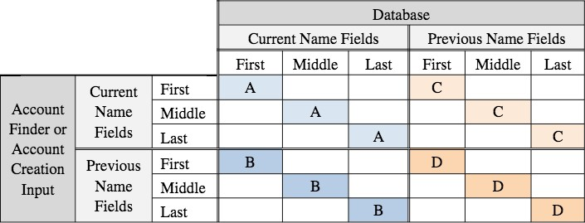
Valid matches are those that occur within corresponding fields of only one group (A,B,C,D). For example, any name fields from Account Finder:Previous Name must match their corresponding fields within Database:Current Name fields or Database:Previous Name fields.
Example of a valid FirstName + LastName match:
AccountFinder:PreviousFirstName = Database:CurrentFirstName
AND
AccountFinder:PreviousLastName = Database:CurrentLastName
Example of an invalid FirstName + LastName match:
AccountFinder:CurrentFirstName = Database:PreviousFirstName
AND
AccountFinder:PreviousLastName = Database:PreviousLastName

Account Profile Display/Edit Service

Part 1. Overview of Account Profile Display & Edit Service

Terminology Used in This Section
CCC | A California Community College.
CCCApply.org | The ‘portal’ for Xap CCCApply. It is a relatively uncommon way for users to select a college and begin an application. Most users access a particular college’s CCCApply application from the college website.
College | One of the California Community Colleges.
OpenCCC | A new, integrated system of services for prospective, current, and past students of California Community Colleges. These systems will share a federated logon service and a database of user information.
OpenCCC Portal | The new Portal we are building for services related to the CCCs.
OpenCCCApply | The new version of CCCApply we are building.
System-wide Logon | The service that provides logon, account creation, account recovery, and duplicate account checking for OpenCCC.
Xap CCCApply | The existing version of CCCApply, which is used by most of the California Community Colleges.

Basic Design Principles
This document specifies the features and functions of the Account Profile Display/Edit service. The Account Profile Display/Edit service allows a user to display his/her current Account Profile information, and to update it if desired.
The Account Profile Display/Edit service will run as a portlet within either the OpenCCC portal or, in situations yet to be determined, within a college’s portal. Generally, branding will be controlled by the portal in which the service is running. The portlet will have either no branding, or an unobtrusive logo for the specific service or OpenCCC.
The fields that can be displayed and modified in the Account Profile Display/Edit service are all fields populated by the Account Creation service. Detailed information about the fields is provided in the Account Creation Specification and Data Dictionary, and will not be repeated in this document.
The Account Profile Display/Edit service will be available only when a user is logged on.

Displaying the Account Profile
When the Account Profile Display/Edit service is first called, it will display a single Account Profile screen with all of the current Personal Information and Contact Information that is included in Account Creation and the Account Profile. This information will be in a read-only form. In association with the Personal Information will be a button to ‘Edit’ Personal Information. In association with the Contact Information will be a button to ‘Edit’ Contact Information.

Editing Data in the Account Profile
Clicking any of the Edit or Change hyperlinks on the Account Profile screen will provide editable fields in much the same format as they are presented in the Account Creation service. One significant difference is that there will be Cancel and Save buttons at the bottom of each screen.
When the user clicks the Save button at the bottom of any of the Edit Profile pages, the service saves any changed values and then returns the user to the Account Profile screen. If any values have been changed, the Account Profile screen displays the new values along with a general message indicating that information has been changed.
Clicking the Cancel button at the bottom of any of the Edit Profile pages returns the user to the Account Profile display screen. If any fields have been changed before Cancel is clicked, the service returns to the Account Profile screen and displays a message stating “Your changes have been cancelled.”:
Content and general layouts of the screens of the Account Profile Display/Edit service are provided in Part 2 of this specification.

Providing PIN & Answering Security Questions
To change the values for security fields, users will be required first to provide other security information. Specifically:
- To change the Password, the user must answer one of their Security Questions and provide their old Password.
- To change the Security PIN, the user must answer one Security Question, randomly chosen.
- To change any of the Security Questions and/or Answers, the user must provide the Security PIN.
These instances of asking for security information will follow general rules established for OpenCCC, including the following:
- OpenCCC will enforce a maximum of six failed entries before a temporary lockout of 30 minutes.
- Throughout a single browser session, OpenCCC will double the length of the temporary lockout for each additional set of six failed entries.
- Once a Security Question has been selected, that Security Question will continue to be asked in the same situation throughout a browser session. In other words, to be asked a different Security Question, the user must end the current browser session and begin a new one.
- The existing Password, Security PIN, and Answers to Security Questions are never displayed; they are always masked.
- When a new Password is being specified, it is masked when it is typed.
- When a new Security PIN is being specified, it is not masked when it is typed.
- When a new Answer to a Security Question is being specified, it is not masked when it is typed.

General Requirements

Error Checking
Error checking of changes to the Account Profile values will be as specified in Part 3 of the Account Creation Specification and Data Dictionary.
In addition, to help prevent against more than one person using a single account, the user will not be allowed to change both the date of birth and any element of the current name within the same session. If both the date of birth and any part of the permanent name are changed when Save is clicked, the following message will be displayed:
You cannot change both your name and your date of birth. If you are sharing someone else’s account to make this application, please create your own account. If you are using your own account and need to change both your name and your birthdate, please contact OpenCCC Support.

Legal Approvals
The CCCCO Legal Department and the Office of Civil Rights need to approve the way we ask for, store, and transmit certain sensitive information. For account profile editing, that includes:
- Social Security Number
- Date of Birth (Age)
We have approved language where we ask for this information within the CCCApply application, but that language is generally not appropriate for use in the account creation process. Therefore, the ‘legal’ language included in this specification is preliminary, and we will need to get approval for the final language.
- Legal approval might also be needed regarding other elements of account creation, such as text message authorization

Account Name Check & Suggestions
In the users opts to change the Username for the account, there will be a function that checks whether the newly chosen Username is already in use. Ideally, this will be a client-side function that will happen automatically, but details are to be determined. When the username has been entered, the value entered in the Username field will be checked against all existing Usernames, and a message will be displayed telling the user either:
- The Username you entered is available.
- The Username you entered is already in use. Please enter a different Username. (You might try adding a number to the end of the name entered.)

Hover Help and Language Switching
If the user elects to edit any of the Account Profile, hover help and language switching will be provided in the same manner as in Account Creation.

Stored Values
When the Account Profile is edited, changed data elements will be stored as described in the Account Creation Specification and Data Dictionary.
In addition, other data associated with the Account Profile will be stored, including change dates and previous values. These additional stored values will be detailed in the appropriate database specification.

Auto-Population
Auto-population from the Account Profile to CCCApply and other OpenCCC services will always use the latest Account Profile values. If feasible, this will include updating the corresponding values in any OpenCCC Applications that have been begun but have not been submitted. (Data in submitted applications is never altered.)
Also, changes to Account Profile data elements that are made in an CCCApply application (or within any other OpenCCC service) will automatically update the user’s Account Profile. Services will notify users when their Account Profile is updated based on data entered into other forms, such as CCCApply.

Account System Data Dictionary
This part of the document provides complete definitions of all of the saved data elements for the Account Creation process. For each data element, the Data Dictionary provides complete data characteristics, information about error checking, legal and other constraints, on-screen language, ‘help’ text, etc.

Legal Name: First
Data Name: | firstname
Description: | User’s legal first name.
Last Revision: | 11/16/15
Data Type/Format, Length: | char, 50  (extended character set, allowing hyphens, letters with diacritical marks or accents, etc.)
Null Allowed: | Yes
Error Checking: | Required unless “I have no legal first name” check box is selected; else error message, “You must enter your legal first name.”  May not be changed at same time as date of birth (i.e., during the same ‘Save’); else error message, “We found some problems with the information you submitted: You cannot change both your name and your date of birth. If you are sharing someone else's account to make this application, please create your own account. If you are using your own account and need to change both your name and your birthdate, please contact OpenCCC Support."
Storage/Usage: | Stored in database for use in auto-population.  Included in Account Profile.
Notes/Constraints: | Length changed to match new CCCCSO MIS field.
Prompt Text: | Legal First Name [text box]
Additional Text: | I have no legal first name [check box]  When this check box is selected the Legal First Name field becomes disabled.
Hover Help: | Enter your full legal first name, as it appears on official documents such as your driver’s license and educational records. If your legal name is a single name, enter that name as your legal last name and select the check boxes indicating that you have no legal first name and no legal middle name.
Pop-Up Help: | When the User clicks the Current Full Legal Name link in the CCCApply Standard, CCCApply International, and CC Promise Grant applications displays the following pop-up text displays:  Use your full legal name as it appears in official documents. Do not use a nickname or informal name.
MIS Correlation: | DED SB31  added for Summer 2011.
Stored Values: | Text string; may be null.

Legal Name: Middle
Data Name: | middlename
Description: | User’s legal middle name.
Last Revision: | 11/16/15
Data Type/Format, Length: | char, 50  (extended character set, allowing hyphens, letters with diacritical marks or accents, etc.)
Error Checking: | Required unless “No legal middle name” is checked; else error message, “You must enter your legal middle name.”
Storage/Usage: | Stored in database for use in auto-population.  Included in Account Profile.
Notes/Constraints: | Length changed to match new CCCCSO MIS first name field.
Prompt Text: | Legal Middle Name [text box]
Additional Text: | I have no legal middle name [check box]  When this check box is selected the Legal Middle Name field becomes disabled.
Hover Help: | Enter your legal middle name, or check the box to indicate that you have no legal middle name.
Pop-Up Help:
XAP Field: | Student name - middle
Stored Values: | Text string; may be null

Legal Name: Last
Data Name: | lastname
Description: | User’s legal last name.
Last Revision: | 2/15/11
Data Type/Format: | char, 50  (extended character set, allowing hyphens, letters with diacritical marks or accents, etc.)
Error Checking: | Response required; else error message, “You must enter your legal last name.”  May not be changed at same time as date of birth (i.e., during the same ‘Save’); else error message, “We found some problems with the information you submitted: You cannot change both your name and your date of birth. If you are sharing someone else's account to make this application, please create your own account. If you are using your own account and need to change both your name and your birthdate, please contact OpenCCC Support.”
Storage/Usage: | Stored in database for use in auto-population.  Included in Account Profile.
Notes/Constraints:
Prompt Text: | Legal Last Name [text box]
Hover Help: | Enter your legal last name.
Pop-Up Help: | When the User clicks the Current Full Legal Name link in the CCCApply Standard, CCCApply International, and CC Promise Grant applications displays the following pop-up text displays:  Use your full legal name as it appears in official documents. Do not use a nickname or informal name.
Values - Labels: | Text string
MIS Correlation: | CO MIS DED SB32, added for Summer 2011.  Length changed to match new CCCCSO MIS field.
XAP Field: | Student name - last

Legal Name: Suffix
Data Name: | suffix  Note: The suffix data element does not populate the CC Promise Grant application.
Description: | Suffix to User’s legal name.
Last Revision: | 11/2/10
Data Type/Format, Length: | char, 3  alphanumeric
Allows Null: | Yes
Error Checking: | Optional user response
Storage/Usage: | Stored in database for use in auto-population.  Included in Account Profile.
Notes/Constraints:
Prompt Text: | Suffix [menu] : (Jr. Sr., I, I, III, IV)
Hover Help:
Pop-Up Help:
Values - Labels: | null  JR  SR  II  III  IV
XAP Field: | nameSuffix
MIS Correlation: | None

Other/Previous First Name
Data Name: | otherfirstname
Description: | User’s previous/other first name.
Last Revision: | 2/15/11
Data Type/Format, Length: | char, 50  (extended character set, allowing hyphens, letters with diacritical marks or accents, etc.)
Error Checking: | If user:  selects Yes radio button in response to "Do you have a previous name (such as a maiden name)?", AND  does not enter any values in either any of the Previous First Name, Previous Middle Name, or Previous Last Name fields, OR  does enter a Previous Middle Name and Previous Last Name value but does not select the "I didn't have a first name" check box",
Client side validation displays the following error message: "You must enter your
Previous First Name (or check the box indicating that you had no first name)."
Storage/Usage: | Stored in database for use in auto-population.  Included in Account Profile.
Notes/Constraints: | Length changed to match new CCCCSO MIS first name field.  Populates CCCApply Standard and CCCApply International applications from the OpenCCC Account database at time of submission.
Prompt Text: | Previous First Name [textbox]
Additional Text: | I didn't have a first name [check box]
Hover Help: | If you previously used a different name than your current legal name, enter your previous first name (even if it is the same as your current first name). If your previous name was a single name, enter that name as your last name and check the box indicating that you had no first name.
Pop-Up Help: | CCCApply Standard Application: on the Account/Mailing Information tab: The "Previous or Alternate Name" link displays the following pop-up help text: "If your name has changed, or you've used an alternate name in school records, enter that name here". The user must click Close to close the pop-up help and then click the Edit Account button to be taken to the OpenCCC Account where they can edit their other/previous first name.  CCCApply International Application: on the Account/Address Information tab: The "Previous or Alternate Name" link displays the following pop-up help text: "If your name has changed, or you've used an alternate name in school records, enter that name here." The user must click Close to close the pop-up help and then click the Edit Account button to be taken to the OpenCCC Account where they can edit their other/previous first name.
Values - Labels: | Text string

Other/Previous Name: Middle
Data Name: | othermiddlename  Note: The othermiddlename field does not populate the CC Promise Grant application data.
Description: | User’s previous/other middle name.
Last Revision: | 2/15/11
Data Type/Format, Length: | char, 50  (extended character set, allowing hyphens, letters with diacritical marks or accents, etc.)
Error Checking: | Optional value, but required value when:  Previous First Name has a value, OR  Previous First Name and Previous Last Name have values, UNLESS User selects the “I didn't have a middle name” check box; else error message, “You must enter your previous middle name.”
Storage/Usage: | Stored in database for use in auto-population.  Included in Account Profile.
Notes/Constraints: | Length changed to match new CCCCSO MIS first name field.  Populates the CCCApply Standard and CCCApply International applications from the OpenCCC Account database at time of submission.
Prompt Text: | Previous Middle Name [textbox]
Additional Text: | I didn't have a middle name [check box]
Hover Help: | If you previously used a different name than your current legal name, enter your previous middle name (even if it is the same as your current middle name)
Pop-Up Help:
Stored Values: | Text string; may be null

Other/Previous Name: Last
Data Name: | otherlastname
Description: | User’s previous/other last name.
Last Revision: | 2/15/11
Data Type/Format, Length: | char, 50  (extended character set, allowing hyphens, letters with diacritical marks or accents, etc.)
Allows Null: | Yes
Default: | None
Error Checking: | Required user response if Previous First Name is entered or “no first name” box is checked; else error message, “You must enter your previous last name.”
Storage/Usage: | Stored in database for use in auto-population.  Included in Account Profile.
Notes/Constraints: | Length changed to match new CCCCSO MIS first name field.
Prompt Text: | Previous Last/Family Name [textbox]
Hover Help: | If you previous used a different name than your current legal name, enter your previous last name.
Pop-Up Help: | CCCApply Standard Application: on the Account/Mailing Information tab: The "Previous or Alternate Name" link displays the following pop-up help text: "If your name has changed, or you've used an alternate name in school records, enter that name here". The user must click Close to close the pop-up help and then click the
Edit Account button to be taken to the OpenCCC Account where they can edit their other/previous first name.
CCCApply International Application: on the Account/Address Information tab: The "Previous or Alternate Name" link displays the following pop-up help text: "If your name has changed, or you've used an alternate name in school records, enter that name here." The user must click Close to close the pop-up help and then click the Edit Account button to be taken to the OpenCCC Account where they can edit their other/previous first name.
Values - Labels: | Text string
XAP Field: | Other name - last name

Preferred First Name
Data Name: | preferred_firstname
Description: | User’s preferred first name.
Last Revision: | 2/19/16
Data Type/Format, Length: | char, 50  (extended character set, allowing hyphens, letters with diacritical marks or accents, etc.)
Allows Null? | Yes
Error Checking: | If user:  selects Yes radio button in response to "Do you have a preferred name that is different than your legal and/or previous name?", AND  does not enter any values in either any of the Preferred First Name, Preferred Middle Name, or Preferred Last Name fields, OR  does enter a Preferred Middle Name and Preferred Last Name value but does not select the "I don't have a preferred first name that is different than my legal and/or previous first name. " check box),  Client-side validation displays the following error message:  "Please enter a preferred first name or check the box indicating you have no preferred first name."
Storage/Usage: | Stored in database for use in auto-population.  Included in Account Profile.
Additional Text: | The additional text displays under the Yes/No radio button question: "Do you have a preferred name that is different than your legal/previous name?":  Note: Not all colleges may allow the use of preferred names for official academic purposes due to legal or technical restrictions.
Notes/Constraints: | Field only displays if the User selected the Yes radio button for the "Do you have a preferred name that is different than your legal and/or previous name?" question.
 | Field is disabled if the user selects the "I don't have a preferred first name that is different than my legal and/or previous first name." check box.
Prompt Text: | Preferred First Name [textbox]
Hover Help: | Enter an optional preferred first name.
Pop-Up Help:
Values - Labels: | Text string

Preferred Middle Name
No longer used since May 2021
Data Name: | preferred_middlename
Description: | DEPRECATED. User’s preferred middle name.
Last Revision: | 05/01/2021
Data Type/Format, Length: | char, 50  (Extended character set, allowing hyphens, letters with diacritical marks or accents, etc.)
Allows Null? | Yes
Error Checking: | If user  selects Yes radio button in response to "Do you have a preferred name that is different than your legal and/or previous name?", AND  does not enter any values in either any of the Preferred First Name, Preferred Middle Name, or Preferred Last Name fields, OR  does enter a Preferred First Name and Preferred Last Name value but does not select the "I don't have a preferred middle name that is different than my legal and/or previous middle name. " check box),  Client-side validation displays the following error message:  "Please enter a preferred middle name or check the box indicating you have no preferred middle name."
Storage/Usage: | Stored in database for use in auto-population.  Included in Account Profile.
Notes/Constraints: | Field only displays if the User selected the Yes radio button for the "Do you have a preferred name that is different than your legal and/or previous name?" question.  Field is disabled if the user selects the "I don't have a preferred middle name that is different than my legal and/or previous middle name." check box.
Prompt Text: | Preferred Middle Name [textbox]
Hover Help: | If you have a preferred middle name that is different from your legal and/or previous middle name, enter it here.
Pop-Up Help:
Values - Labels: | Text string

Preferred Last Name
No longer used since May 2021
Data Name: | preferred_lastname
Description: | DEPRECATED. User’s preferred last name.
Last Revision: | 05/01/2021
Data Type / Format, Length:
Allows Null?
Error Checking:
Storage/Usage: | Stored in database for use in previously submitted applications.
Notes/Constraints:
Prompt Text: | No longer used in OpenCCC 2.0
Hover Help:
Values - Labels:

Date of Birth
Data Element: | birthdate
Description: | User’s Date of Birth
Format, Length: | date, 10  Downloads in this format: yyyy-mm-dd
Values: | Valid date
Allows Null: | No
Default: | None
Storage/Usage: | Birth date is used in the admission application to calculate age, to identify Users who are too young to transact business online per COPPA (Child Online Privacy Protection Act —under age 13), and to identify minors for residency calculation and collection of parent or guardian contact information. OCR acknowledges that collection of birth date is allowed under California State law.  For residency and minor identification, the User’s age is calculated as of the day before the start-of-term date <ResidencyDeterminationDate>.  In OpenCCC Account: Stored in database (with leading zeros as appropriate) for use in auto-population.  Included in Account Profile.
Notes: | Birth date is sensitive information, protected by federal law and the Office of Civil Rights  (with regard to age discrimination). Any change to the text, prompt, access, or transmission of this data item must be approved by the Legal Counsel of the CCC Chancellor’s Office and the Office of Civil Rights.  This information may not be provided to staff in the capacity of making a decision to admit an User until after the User is admitted—that is, uniformly enabled to register for classes.  This is MIS data: CO MIS DED SB03.  OpenCCC Account: Date of birth is needed in account creation to identify Users who are too young to transact business online per COPPA (Child Online Privacy Protection Act--under age 13). OCR acknowledges that collection of date of birth is allowed under California State law.
Error Checking  (OpenCCC  Account Only): | Response required; else error message “Your Date of Birth is invalid or absent. It must be a valid date in mm/dd/yyyy format.”  Date must be validated (‘dd’ must be appropriate for ‘mm’ and ‘yyyy’—for example,  02/29/2009 would not be valid) ; else error message “Your Date of Birth is invalid or absent. It must be a valid date in mm/dd/yyyy format.”  Date may not be less than 13 years before current date; else error message, “You cannot create an account if you are less than 13 years of age.” "Federal privacy laws restrict Users age 13 or younger from creating an online account and applying to college using an online application. Please contact the college's Admissions & Records Office for assistance."  Leading zeros are not required for ‘mm’ or ‘dd’: 02/04/2010 and 2/4/2010 are acceptable and equivalent.  When editing account information from either the Standard, International, or CC PROMISE GRANT applications, if the user attempts to change both their name and their date of birth, the following error displays: "You cannot change both your name and your date of birth. If you are sharing someone else's account to make this application, please create your own account. If you are  using your own account and need to change both your name and your birthdate, please contact OpenCCC Support."
Prompt Text  (OpenCCC  Account Only): | Due to laws regarding children's online privacy, this system will not allow accounts to be created by persons under the age of 13. For more information, please refer to the Privacy Policy.  This information is used for protection of minors in online transaction environments, as well as to differentiate between persons having the same name. It is also used to comply with state and federal law pertaining to residency, guardianship, and admission of minors to college. This information will not be used in making admissions decisions except as permitted by law.  Date of Birth [date textboxcombo boxes] mm/dd/yyyy
Hover Help  (OpenCCC  Account Only): | DOB Year Open Text Box: Enter in the 4 digit year you were born.  Spanish Hover Help:  DOB Month Drop Down Box: Seleccione el mes en que nació en la lista desplegable.  DOB Day Drop Down Box: Seleccione el día en que nació en la lista desplegable.  DOB Year Open Text Box: Introduzca los 4 dígitos del año en que nació.
Input Rules  (OpenCCC  Account Only): | Required user response, else error message “We found some problems with the information you submitted: Your Date of Birth is invalid or absent. It must be a valid date in mm/dd/yyyy format."  Date may not be less than 13 years before current date; else error message, “We found some problems with the information you submitted: Federal privacy laws restrict Users age 13 or younger from creating an online account and applying to college using an online application. Please contact the college's Admissions & Records Office for assistance.  Date of birth may not be changed at the same time (i.e., during the same ‘Save’) as either the first name or the last name; else error message, “We found some problems with the information you submitted: You cannot change both your name and your date of birth. If you are sharing someone else's account to make this application, please create your own account. If you are using your own account and need to change both your name and your birthdate, please contact OpenCCC Support.”
MIS Correlation: | SB03

Email Address
Data Name: | email
Description: | User’s email address.
Last Revision: | 11/2/10
Data Type/Format, Length: | char, 254  Note: Field length for CC PROMISE GRANT Fee Waiver is 128  Two fields; each up to 48 characters, alphanumeric plus ‘@’ and ‘.’
Error Checking: | Required user response. Must contain one ‘@’ symbol (not as the first character) and one ‘.’, and must not begin with “mailto:”; else error message, “Your Email Address is invalid or absent. You must enter a valid Email Address.”  Email address and confirmation must be identical; else error message, “Your Email Address entries do not match. Please make sure you enter exactly the same Email Address in each field.”
Storage/Usage: | Only one field is stored.  Stored in database for use in auto-population.  Included in Account Profile.  Not required to be unique: two or more accounts can have the same Email Address.
Notes/Constraints: | The Steering Committee has affirmed that email addresses must be required, because many colleges use email as the only way to send important information to Users about registration, etc. Users will be required to sign up for an email account if they do not have an email address, and they will be expected to check the email account.  A valid email address is necessary for creating an OpenCCC Account. When a student first lands on the OpenCCC Sign In page, they are notified of the requirement to have a valid email address and are provided links to free email account providers.  Populates CCCApply Standard and International and CC Promise Grant applications from OpenCCC Account database at time of submission.
Prompt Text: | An email address is required for important messages, including information about college admission and registration. Please enter an email address that you check regularly.  Email Address [textbox]  Repeat Email Address [textbox]
Hover Help: | Enter an email address so OpenCCC and colleges that you apply to can communicate with you.
Pop-Up Help:
Values - Labels: | Text string in valid email address format

Main Phone Number
Data Name: | mainphone (OpenCCC Account and CCCApply Standard and CC Promise Grant applications) main_phone_number (CCCApply International Application)
Description: | User’s main telephone number.
Last Revision: | 11/2/10
Data Type/Format, Length: | char, 19 (OpenCCC Account) char, 14 (CCCApply Standard and CC Promise Grant applications) char, 25 (CCCApply International application)  10 to 14 characters, numeric plus: (nnn) nnn-nnnn
Error Checking: | Optional user response.  Must be properly formatted and meet validation tests; else error message, “The  Main Telephone Number you entered is not valid. Please correct it as appropriate.”  123-456-7890 and any number with all digits the same (e.g., 444-444-4444) are not allowed.  Area codes will be validated (against a list or by format?).  Client-side validation: The mainphone field must not be blank if the secondphone field is populated when the user clicks Continue to move to page 3 of 3 in the account set up; else error message, "Please enter your Main Telephone Number before entering a Second Telephone Number." When the user clicks OK to close the error dialog box, focus is placed on the mainphone field.
Storage/Usage: | Stored in database for use in auto-population.  Included in Account Profile.
Notes/Constraints: | Populates CCCApply Standard and CCCApply International and CC Promise Grant applications from OpenCCC Account database at time of submission.
Prompt Text: | Main Telephone [textbox] ###-###-####
Hover Help: | Enter a phone number at which you can be reached.
Pop-Up Help:
Values - Labels: | Null or text string

Main Phone: Extension
Data Name: | mainphone_ext
Description: | Extension for User’s main telephone number.
Last Revision: | 11/2/10
Data Type/Format, Length: | char, 4
Allows Null: | Yes
Error Checking: | Optional user response
Storage/Usage: | Stored in database for use in auto-population.  Included in Account Profile.
Notes/Constraints: | None  Populates CCCApply Standard, CCCApply International from, and CC PROMISE GRANT Fee  Waiver applications from OpenCCC Account database at time of submission.
Prompt Text: | Extension (if any) [textbox] up to four digits
Hover Help: | If your main phone number includes an extension, enter up to four digits here.
Pop-Up Help:
Values - Labels: | Null or numeric string; integer up to 9999
MIS Correlation: | None

Main Phone: Text Permission
Data Name: | mainphone_auth_txt (OpenCCC Account) mainphone_auth_text (CCCApply Standard and CC Promise Grant applications) main_phone_auth_txt (CCCApply International application)
Description: | User’s permission to send text messages to the main telephone number
Last Revision: | 11/2/10
Data Type/Format, Length: | char, 1 (OpenCCC Account)  boolean, 1 (CCCApply Standard and International and CC Promise Grant applications)
Error Checking: | Optional user response; no error checking.
Storage/Usage: | Stored in database for use in auto-population.  Included in Account Profile.
Notes/Constraints:
Prompt Text: | [Checkbox] I authorize text messages to my main telephone number, and accept responsibility for any charges that result.
Hover Help:
Pop-Up Help:
Application Display: | In CCCApply Standard and International applications: If the User did not authorize SMS text messages to their number, then the following text displays below their Main Phone number (and Second Phone number, if provided): "Not authorized for text messages".  If the User did authorize SMS text messages, then the following message displays below their Main Phone number (and Second Phone number, if provided/ opted-in): "Authorized for text messages".
Values - Labels: | 1 = Yes (checked)  0 = No (not checked)

Second Phone Number
Data Name: | secondphone (OpenCCC Account and CCCApply Standard Application)  second_phone_number (CCCApply International application)  Note: The secondphone field does not populate the CC Promise Grant application table.
Description: | User’s second telephone number.
Last Revision: | 11/2/10
Data Type/Format, Length: | char, 19 char, 14 (CCCApply Standard application) char, 25 (CCCApply Standard application)  10 to 14 characters, numeric plus: (nnn) nnn-nnnn
Error Checking: | Optional user response.  Must be properly formatted and meet validation tests; else error message, “The Second Telephone Number you entered is not valid. Please correct it as appropriate.”  123-456-7890 and any number with all digits the same (e.g., 444-444-4444) are not allowed.  Area codes will be validated (against a list or by format?).  Client-side validation: The mainphone field must not be blank if the secondphone field is populated when the user clicks Continue to move to page 3 of 3 in the account set up; else error message, "Please enter your Main Telephone Number before entering a Second Telephone Number." When the user clicks OK to close the error dialog box, focus is placed on the mainphone field.
Storage/Usage: | Stored in database for use in auto-population.  Included in Account Profile.
Notes/Constraints: | Populates CCCApply and International applications from OpenCCC Account database at time of submission.
Prompt Text: | Second Telephone Number [textbox] (###)###-####
Hover Help: | Enter a second phone number at which you can be reached.
Pop-Up Help:
Values - Labels: | Null or text string
XAP Field: | Secondary phone number

Second Phone: Extension
Data Element: | secondphone_ext
Description: | Second telephone extension
Format, Length: | varchar, 4
Values: | Integer up to 9999
Allows Null: | Yes
Error Checking: | Optional user response
Default: | None
Storage/Usage: | Stored in database for use in auto-population.  Included in Account Profile.
Prompt Text: | Extension (if any) [textbox] up to four digits
Hover Help: | If your second phone number includes an extension, enter up to four digits here.
Notes: | Populates from OpenCCC Account database at time of submission.
Xap Field: | Secondary phone - extension
Revision Log: | ~~
MIS Correlation | None
Input Rules | Optional user response

Second Phone: Text Permission
Data Name: | secondphone_auth_txt (OpenCCC Account) secondphone_auth_text (CCCApply Standard Application)  second_phone_auth_txt (CCCApply International Application)  Note: The CC Promise Grant application does not store secondphone_auth_txt data.
Description: | User’s permission to send text messages to the second telephone number
Last Revision: | 11/2/10
Data Type/Format, Length: | char, 1 (OpenCCC Account)  boolean, 1 (CCCApply Standard and International Applications)
Error Checking: | Optional user response; no error checking.
Storage/Usage: | Stored in database for use in auto-population.  Included in Account Profile.
Notes/Constraints:
Prompt Text: | [Checkbox] I authorize text messages to my second telephone number, and accept responsibility for any charges that result.
Hover Help:
Pop-Up Help:
Values - Labels: | 1 = Yes (checked)  0 = No (not checked)

Permanent Address: Street1 and Street2
Data Name: | streetaddress1, streetaddress2 (OpenCCC Account, CC Promise Grant application) perm_streetaddress1, perm_streetaddress2 (CCCApply Standard Application) perm_addr_street_1, perm_addr_street_2 (CCCApply International Application)
Description: | Street portion of User’s permanent address.
Last Revision: | 6/8/15
Data Type/Format: | char, 50  Two fields (extended character set, allowing hyphens, letters with diacritical marks or accents, etc.)
Allows Null: | Yes: streetaddress1, perm_streetaddress1, perm_addr_street_1  No: streetaddress2, perm_streetaddress2, perm_addr_street_2
Error Checking: | Response required; else error message, “You must provide your street address.”  Software will attempt to validate the street address. If the address cannot be validated, the following error message will be displayed:  The address entered appears to be incomplete. If you are sure the address is correct, please check the box below to ignore this warning.  Please note that the verification system might make some changes to the information you entered in an attempt to match its records. Make sure to double check the address you entered below before proceeding.  The following additional text and validation field displays, and the User must select the check box or correct their street address in order to save their OpenCCC Account information:  [check box] I have verified the address entered is correct
Online Display: | Street Address [two text fields]
Additional Text: | Include apartment number or suite  [Displays under the two Street Address text fields]
Storage/Usage: | Stored in database for use in auto-population.  Included in Account Profile.
Notes/Constraints:
Prompt Text: | Street Address [2 textboxes] (please include apartment/suite numbers)
Hover Help: | Enter your street address using one or both lines. Include your apartment or suite number if you have one.
Pop-Up Help: | See Error Checking, above.
XAP Field: | Permanent address – street and Permanent address – street 2
MIS Correlation: | None
Values - Labels: | Two text strings; second may be null

Permanent Address: City
Data Name: | city (OpenCCC Account, CC Promise Grant) perm_city (CCCApply Standard Application) perm_addr_city (CCCApply International Application)
Description: | City portion of User’s permanent address.
Last Revision: | 1/13/11
Data Type/Format, Length: | char, 50  (extended character set, allowing hyphens, letters with diacritical marks or accents, etc.)
Error Checking: | Required user response; else error message, “In your Permanent Address, you must specify the City.”
Storage/Usage: | Stored in database for use in auto-population.  Included in Account Profile.
Notes/Constraints:
Prompt Text: | City [textbox]
Hover Help: | Enter the city where you permanently reside.
Pop-Up Help:
XAP Field: | Permanent address - city
MIS Correlation: | None
Values - Labels: | Text string

Permanent Address: State
Data Name: | state (OpenCCC Account, CC Promise Grant) perm_state (CCCApply Standard application) perm_addr_state (CCCApply International application)
Description: | State portion of User’s permanent address.
Last Revision: | 11/2/10
Data Type/Format, Length: | char, 2
Error Checking: | Required user response if Country = US; else error message, “In your Permanent Address, you must specify the State.”
Allows Null: | Yes, only if Country is not U.S. (in which case the field label displays as State/ Province)
Storage/Usage: | Stored in database for use in auto-population.  Included in Account Profile.
Notes/Constraints:
Prompt Text: | When the "My permanent address is outside the United States." check box is cleared:  State [drop-down list]  When the "My permanent address is outside the United States." check box is selected:  State/Province [text box]
Hover Help: | Enter the U.S. state where you permanently reside.
Pop-Up Help:
Values - Labels: | blank/null or 2-character USPS state code

Permanent Address: Non-U.S. State/Province
Data Name: | nonusaprovince (OpenCCC Account) perm_nonusaprovince (CCCApply Standard application) non_us_permanent_home_non_us_province (CCCApply International application) province (CC Promise Grant application)
Description: | State/province portion of User’s non-U.S. permanent address.
Last Revision: | 1/13/11
Data Type/Format, Length: | OpenCCC Account, Standard Application, CC Promise Grant: char, 30  extended character set, allowing hyphens, letters with diacritical marks or accents, etc.  CCCApply International Application:char, 50
Error Checking: | Optional; no error checking.
Storage/Usage: | Stored in database for use in auto-population.
 | Included in Account Profile.
Online Display: | State/Province  Conditionally displays when the following OpenCCC Account check box is selected: "My permanent address is outside the United States." and the user has clicked through the confirmation pop-up to confirm their address is outside the United States.
Notes/Constraints:
Prompt Text: | State/Province [text box]
Hover Help: | Enter the name of the state or province you live in. Leave blank if your permanent address does not include a state or province.
Pop-Up Help:
XAP Field: | permAddrNonUSState
MIS Correlation: | None
Values - Labels: | Null or text string

Permanent Address: ZIP Code or Postal Code
Data Name: | postalcode (OpenCCC Account and CC Promise Grant application) perm_postalcode (CCCApply Standard application) perm_addr_zip_code (CCCApply International application) perm_addr_non_us_postal_code (CCCApply International application)
Description: | Zip code (for U.S.) or Postal Code (if non-U.S.) portion of User’s permanent address.
Last Revision: | 11/2/10
Data Type/Format, Length: | OpenCCC Account, CCCApply Standard, and CC Promise Grant applications:  char, 20 numeric-plus: nnnnn-nnnn or nnnnn CCCApply International application:  character varying, 30  extended character set, allowing hyphens, symbols, letters with diacritical marks or accents, etc.
Error Checking: | Required user response if Country = US; else error message, “In your Permanent Address, you must specify the ZIP Code. It must be a valid ZIP code in ##### or #####-#### format.”  If the "My permanent address is outside the United States" check box is selected, then the ZIP Code field label displays as Postal Code and the field is not required.
Online Display: | When the "My permanent address is outside the United States." check box is cleared:
ZIP Code [text box]
When the "My permanent address is outside the United States." check box is selected:
Postal Code [text box]
Storage/Usage: | Stored in database for use in auto-population.  Included in Account Profile.
Notes/Constraints:
Prompt Text: | ZIP Code [textbox]  Postal Code [textbox]
Hover Help: | ZIP Code: Enter your ZIP code (5 or 9 digits).  OR  Postal Code: Enter the postal code for your permanent address. Leave blank if your permanent address does not include a postal code.
Pop-Up Help:
Values - Labels: | Null or nnnnn-nnnn or nnnnn
XAP Field: | Permanent address - zip code  permAddrIntlCode
MIS Correlation: | None

Zip Code - Four Character
Data Name: | zip4
Description:
Last Revision:
Data Type/Format, Length: | char, 4
Error Checking:
Storage/Usage:
Notes/Constraints:
Prompt Text:
Hover Help:
Pop-Up Help:
Values - Labels:

Permanent Address: Country
Data Name: | country (OpenCCC Account and CC Promise Grant applications)  perm_country (CCCApply Standard application)  perm_addr_country (CCCApply International application)
Description: | Country portion of User’s permanent address.
Last Revision: | 11/2/10
Data Type/Format, Length: | char, 2
Error Checking: | Required user response when address is not in U.S.; else error message “In your Permanent Address, you must select the Country.”
Storage/Usage: | Stored in database for use in auto-population.  Included in Account Profile.
Notes/Constraints: | Store US unless the address type is non-US.  The Country field value is used in determining the U.S. non-U.S. residency for the User.
Prompt Text: | Country [menu]
Hover Help:
Pop-Up Help:
XAP Field: | Permanent address - country
MIS correlation: | None
Values - Labels: | US or other two-character ISO country code. See https://www.iso.org/obp/ui/ #search.

Permanent Address Validation
Data Name: | perm_address_validation
Description:
Last Revision:
Data Type/Format, Length: | char, 1
Error Checking:
Storage/Usage:
Notes/Constraints:
Prompt Text:
Hover Help:
Pop-Up Help:
Values - Labels:

Username
Data Name: | username
Description: | Username for logging into the account
Last Revision: | 11/2/10
Data Type/Format:, Length | char, 128  6 to 128 keyboard characters (ASCII 33-126: alphanumeric plus punctuation, no spaces).  Normalize for storage and comparison so that Username is case-insensitive.
Error Checking: | Must be unique (i.e., not already in use for another account); else error message:  "The Username you entered is already in use. Please enter a different Username. (You might try adding a number to the end of the name entered.)"  Must not be blank, fewer than six characters, include spaces, or characters other than numbers, letters, or the following special characters: !#%&()*+,-./:; =? @[]^_`{} ~. else error message:  "Your Username must be between 6 and 128 characters long. Your Username cannot include spaces or characters other than letters, numbers, and the following punctuation: !#%&()*+,-./:; =?@[]^_`{}~."
Storage/Usage: | Stored for logon purposes.  Never transmitted except when an account has been successfully recovered or when the user has elected to change the username.  Not masked when typed.
Notes/Constraints: | The $, |, <, and > characters are not allowed in either the user name or password.
Prompt Text: | To enable you to log in later, you must choose a unique username for your account. Your username must be between 6 and 128 characters. Use only letters, numbers, and punctuation you can type on a standard keyboard, with no spaces.  Username [textbox]
Hover Help:
Pop-Up Help: | Whether username that has been entered is already in use.
Values - Labels: | Valid alphanumeric string

Password
Data Name: | password
Description: | Password for logging into the account
Last Revision: | 2/15/11
Data Type/Format, Length: | text  Two fields: each 7 to 20 characters, alphanumeric.  Must include at least one number and one letter.
 | Normalized for storage and comparison so that Password is case-insensitive.
Error Checking: | Two entries must match; else error message, “Your two Password entries were not the same. Please enter your Password again in both Password fields.”  Must meet length and format requirements; else error message, “Your Password must be between 7 and 20 characters long, must include at least one letter and at least one number, and may not include characters other than letters and numbers.”  Cannot include the Username; else error message, “For security reasons, your Password cannot contain your Username. Please choose another Password.”
Storage/Usage: | Stored using OpenCCC’s reversible encryption scheme.  Used for comparison purposes but never transmitted.  Always mask on screen, including when typed.
Notes/Constraints: | Only letters or numbers are allowed in creating a password.
Prompt Text: | You also must choose a password for logging into your account. Your password must be between 7 and 20 characters and must use letters and numbers only, with at least one number and one letter. Enter your password twice to make sure you type it correctly.  Password [textbox]  Repeat Password [textbox]  Be sure to record your username and password for later use. Please do not share your account with others, even family members. All OpenCCC and CCCApply users must have their own individual accounts.
Hover Help:
Pop-Up Help:
Values - Labels: | Valid alphanumeric string

California Community College ID
Data Element: | cccid
Description: | The unique identifier for a single user’s account. This identifier is assigned during account creation in OpenCCC. This field is passed as part of a submitted application to each college and is stored in the college Student Information System (SIS). This field can be used for student authentication when a student signs in at a college. It can be passed as an attribute to student statewide services so the service can verify the student has an OpenCCC account and perform automatic sign in. This field will also be passed as an MIS field.  The user’s unique CCCID for Federated Identity.
Format, Length: | Character varying(8)
Values: | The format of the ccc_id is:  Positions 1 - 3: AAA thru ZZZ (Sequentially assigned beginning with AAA)  Positions 4 – 7: 0001 thru 9999 (Sequentially assigned beginning with 0001 for each value in positions 1-3)  Position 8: For future expansion if all values become exhausted.  Note: In positions 1-3, “I” and “O” are not used to avoid confusion with “0” and “1”.
Allows Null: | No. This is a system assigned field and is not entered by the user.
Default: | System assigned.
Usage: | Used to uniquely identify an OpenCCC user account. This account can be used to apply to any participating college in the new CCCApply. It is also used for any additional student statewide services which use the ccc_id for authentication.  Stored for use in Federated ID.
 | Other possible uses TBD.
Notes/Constraints: | System-generated unique identifier.  System will support expansion of CCCID to 8 characters (XXXXNNNN).  Populates the CCCApply Standard and International applications and the CC Promise Grant applications from the User's OpenCCC Account.
Prompt Text: | None  After account creation, the CCCID displays next to the logged-in user's name for the OpenCCC Account, CCCApply Standard application, CCCApply International application, and CC Promise Grant application.

User ID
Data Name: | uid
Description: | The user’s internal, system-generated user ID.
Last Revision:
Data Type/Format: | integer
Allows Null: | No
Error Checking:
Storage/Usage: | Internal, system-used value.
Notes/Constraints: | System-generated unique identifier. Not a downloadable field for any of the applications (standard, international, or CC Promise Grant).
Prompt Text:
Hover Help:
Pop-Up Help:
Values - Labels:

matchtype
Data Name: | matchtype
Description:
Last Revision:
Data Type/Format, Length: | char, 1
Error Checking:
Storage/Usage:
Notes/Constraints:
Prompt Text:
Hover Help:
Pop-Up Help:
Values - Labels:

Public Key
Data Name: | public_key
Description: | RESERVED
Last Revision:
Data Type/Format, Length: | text
Error Checking:
Storage/Usage:
Notes/Constraints:
Prompt Text:
Hover Help:
Pop-Up Help:
Values - Labels:

Private Key
Data Name: | private_key
Description: | RESERVED
Last Revision:
Data Type/Format, Length: | text
Error Checking:
Storage/Usage:
Notes/Constraints:
Prompt Text:
Hover Help:
Pop-Up Help:
Values - Labels:

Cryptokeyid
Data Name: | cryptokeyid
Description: | RESERVED
Last Revision:
Data Type/Format, Length: | integer
Error Checking:
Storage/Usage:
Notes/Constraints:
Prompt Text:
Hover Help:
Pop-Up Help:
Values - Labels:

Create Time
Data Name: | createtime
Description:
Last Revision:
Data Type/Format, Length: | timestamp with time zone
Error Checking:
Storage/Usage:
Notes/Constraints:
Prompt Text:
Hover Help:
Pop-Up Help:
Values - Labels:

Update Time
Data Name: | updatetime
Description:
Last Revision:
Data Type/Format, Length: | timestamp with time zone
Error Checking:
Storage/Usage:
Notes/Constraints:
Prompt Text:
Hover Help:
Pop-Up Help:
Values - Labels:

Password Update Time
Data Name: | passwordupdatetime
Description:
Last Revision:
Data Type/Format, Length: | timestamp with time zone
Error Checking:
Storage/Usage:
Notes/Constraints:
Prompt Text:
Hover Help:
Pop-Up Help:
Values - Labels:

Salt
Data Name: | salt
Description: | Internal-used database column only.
Last Revision:
Data Type/Format: | text
Allows Null: | No
Error Checking:
Storage/Usage: | Internal, system-used value.
Notes/Constraints: | Not a downloadable field for any of the applications (standard, international, or CC Promise Grant).
Prompt Text:
Hover Help:
Pop-Up Help:
Values - Labels:

