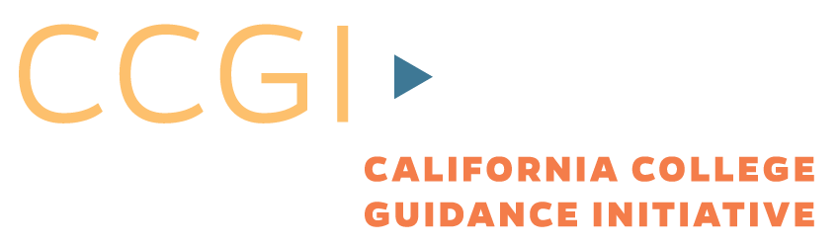
CCCCO-Butte-CCGI
CaliforniaColleges.edu – OpenCCCApply Articulation Brainstorming Meeting
July 21, 2016

Participants:
California Community College Technology Center:
Tim Calhoon, Director
Patricia Donohue, Product Manager, CCCApply

California College Guidance Initiative:
Tessa Carmen De Roy, Executive Director
Benjamin Baird, Director of Data Management

Meeting Objective:
Discuss early scope, brainstorming, timeline, and strategies on how to successfully articulate CaliforniaColleges.edu and OpenCCCApply. This articulation should provide benefit to the student, the high school, and the community college. Success for students in California Community Colleges can be improved through collaboration and articulation with K12 systems.

Proposed Timeline:
Phase 1 “Application web service/listener”
Development begins November 2016, completed by April 2017, ready for Fall 2017 application season
Description:
A student (or HS educator) using a CaliforniaColleges account will be able to track and display the status of all CCC applications for that student.
High Level Process Flow:
Student clicks Community College Application link in CaliforniaColleges.edu account ->
Student checks off consent agreement ->
Student redirected to that college’s OpenCCCApply application (along with uniquely generated non-personally identifiable encrypted key) ->
Student fills out application ->
Student submits application to college ->
Web service at OpenCCCApply securely notifies CaliforniaColleges.edu that the student has completed application to a certain MIS code

Phase 2 “Multiple Measures Transcript Data”
Development begins 2016, completed by Summer 2017, ready for Summer/Fall 2o18 application season
Description:
Using the credentials generated in Phase 1, transcript data from the student’s CaliforniaColleges.edu account could populate a data repository within OpenCCCApply. Such transcript data could be used to inform placement and multiple measures, satisfy college pre-requisites (especially useful for dual enrollment), satisfy AB540 High School requirements, and mark Foster Youth flags.

Phase 3 “Autopopulate Application Fields”
Development begins TBA, completed by TBA, ready for TBA application season
Description:
Data from Phase 2 could be used to autopulate fields as the student completes application, creating a more accurate (and quicker) application process.

Key Questions?
- Are there FERPA or other privacy concerns about notifying the High School that the student has completed a CCC application?
- Does the phased plan and timeline meet the needs of K-12 and CCC stakeholders?

Next Steps:
- CCGI to explore FERPA question about application notification
- Butte Technology Center to discuss design of webservice/listener

