- CCCAppy.org (on the “Money” landing page)
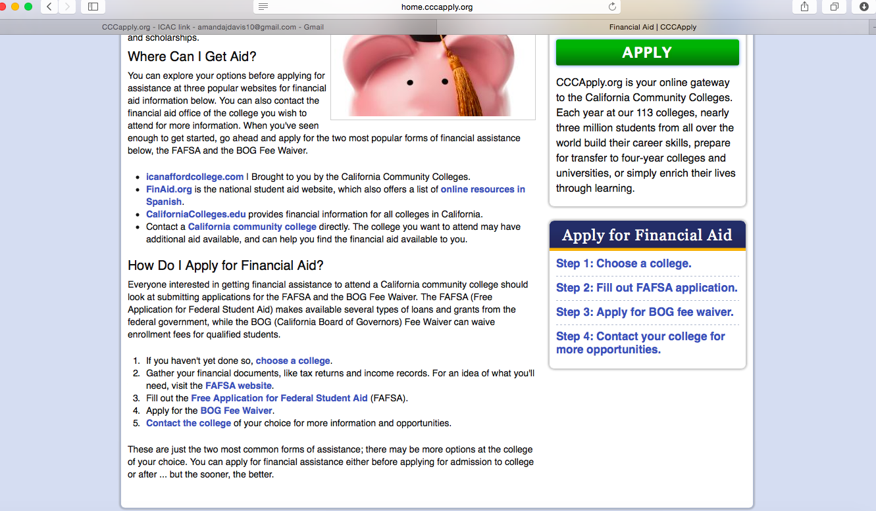

Align the steps in the “How Do I Apply for Financial Aid?” and “Apply for Financial Aid” sections (in the center of the page and the right of the page, respectively) with the steps under “Get Started” on icanaffordcollege.com, per the following screenshot (on the “I Can Afford College” homepage):

2. If this is done, the wording for the “How Do I Apply for Financial Aid?” section in the center of the “Money” landing page will need to be reworded. Below is a suggestion for verbiage, which follows the same five steps pictured in the “I Can Afford College” website screenshot above:

- Are you eligible for federal financial aid? Learn the eligibility requirements.
- Financial aid applications can seem overwhelming, but there are tools and information to help you get organized.
- Ready to start your applications? Apply for the BOG Fee Waiver and complete a FAFSA application.
- If you want to get help right now, or even if you just want to ask a question, use the financial aid office locator to find contact information for the financial aid offices closest to you.
- What can you expect after you’ve filed for financial aid? Find out what’s next.

