Contra Costa College Directions to the Fireside Hall (FH)

To get to the Fireside Hall building at Contra Costa College, please park at Lots 1-7 and walk to the Fireside Hall located in the center of campus. The Entrance to the Lots 1-7 is located on Comet Way. Please consult the attached campus map on how to get to the FH from Lots 1-7.

If you are using GPS device or App, you may try entering this as your destination: 2600 Mission Bell Drive, San Pablo, CA 94806

NORTH DIRECTIONS
Directions from areas NORTH of San Pablo (Sacramento, Vallejo, Concord and Martinez):

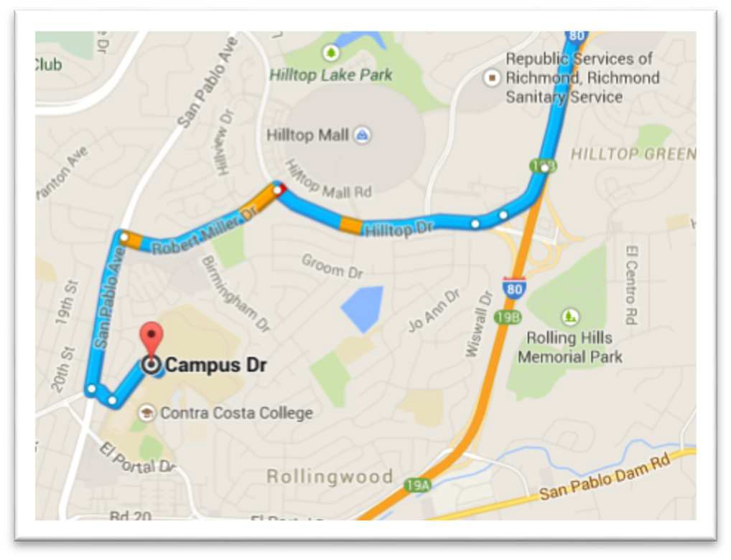
- Take I-80 West towards San Pablo, CA
- Take the Exit at Hilltop Drive-Auto Plaza
- Keep Right at the Fork
- Merge onto Hilltop Drive on your Left
- Turn Left onto Robert Miller Drive
- Turn Left onto San Pablo Ave
- Turn Left onto College Lane
- Turn Left onto Campus Drive
- You’ll see LOT 1 to the Right of the Traffic Circle

After parking, please see the attached campus map for directions to the
SAB on campus.

SOUTH DIRECTIONS
Directions from areas SOUTH of San Pablo (Berkeley, Oakland, San Francisco and San Jose):
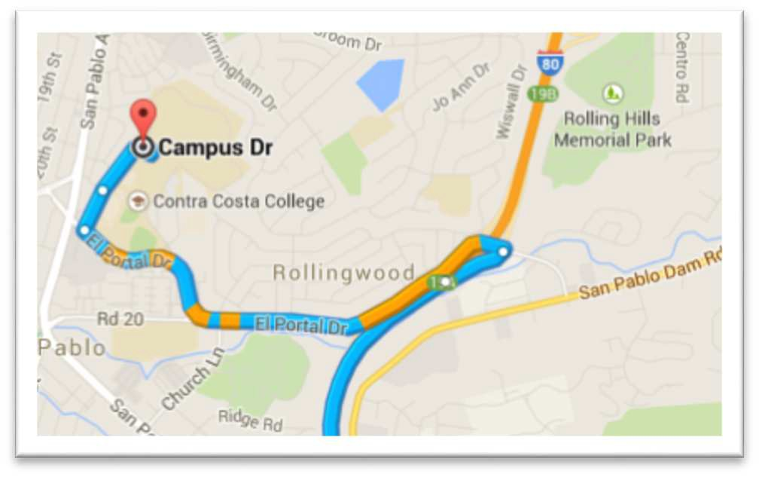
- Take I-80 East towards San Pablo, CA
- Take the Exit at El Portal Drive
- Turn Left onto El Portal Drive
- Turn Right onto Mission Bell Drive
- Mission Bell Drive becomes Campus Drive
- You’ll see LOT 1 to the Right of the Traffic Circle

After parking, please see the attached campus map for directions to the
SAB on campus.

July 18, 2016

