NEAR FINAL DRAFT

CCSF Rosenberg Library Return to Campus Protocols

Requested Re-Opening Date:
October 6, 2020

Hours of Operation: M, TH | 9:00 am-3:00 pm

TABLE OF CONTENTS

PAGE

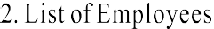

1. Building Upon CCSF Return to Campus Protocols

This plan is for the Rosenberg Library at Ocean Campus. City College San Francisco (CCSF) will provide appointment-based contact-free curb-side pickup service that will allow enrolled students and college employees to check out library materials from the Rosenberg Library at Ocean Campus by the front door on Cloud Circle. This service will be in place until the College returns to in-person instruction. Proposed scope: all circulating materials, library-owned course reserves, laptops, Chromebooks, physics kits, and technology.

These protocols are developed specifically for the Rosenberg Library and are in addition to the general CCSF return to campus (R2C) protocols. These limited R2C protocols will remain in place until the CCSF has resumed full in-person instruction, but not prior to the end of Shelter-in-Place (SIP). The general campus protocols include instructions for maintaining a safe workplace, modifying offices and enhanced cleaning, physical distancing, face coverings, screening, and training. The general campus protocols will be followed. The protocols here are intended to provide more specificity regarding the Rosenberg Library, specifically related to the building and procedures for providing services to students.

This return to library plan will be updated:

- Whenever there is updated information and guidelines from the San Francisco Department of Public Health (SFDPH), the Centers for Disease Control and Prevention (CDC), or other Federal, State or Local directives, including but not limited to Occupational Health and Safety (OSHA) and California Occupational Health and Safety (Cal-OSHA).

- After the Library has re-opened and had the opportunity to assess the efficacy of these protocols. The protocols will be dated on the cover page to indicate the most recent version.

2. Returning Employees

HR will survey for volunteer Library classified staff to return to work for limited periods. The list of available staff will then be sent to Human Resources and to Employee Relations to ensure that these employees will be compensated according to any side-letter agreements as well as to allow for proper notification to unions. The list of available and authorized staff with their scheduled days and hours must be provided to Public Safety and Custodial departments. This list will also be sent to Risk Management to verify that these employees have undergone the proper training to be allowed back onto campus. The list will also be provided to Facilities (AVC/ Director) to ensure that the Building Monitor has these names on their roster of employees to be allowed into the building.

To reduce the risk of spreading the virus, the Library will isolate the different groups and schedules.

3. Entering the Building (Employees)

Prior To Returning
All employees must complete the COVID-19 Return to Campus (R2C) training. The training is available on the VRC or in person. All efforts should be made to complete the training online rather than in person.

Per CDC guidelines, employees should stay home (or go home) when:
- Experiencing COVID-19 symptoms
- They have tested positive for COVID-19
- They have been in close contact with someone who has COVID-19 symptoms

Screening
Prior to entering the building, all employees must attest daily, via a CCSF Symptom Check Tracking form, that they:
- Are not currently experiencing symptoms associated with COVID-19 as defined by
CDC, including fever, coughing, shortness of breath, chills, muscle pain, sore throat, or loss of taste or smell.
- Have not come in to close contact (six feet or less) with a person experiencing COVID-19 symptoms or who has tested positive within the past 14 days.
- Have not traveled to a country or region on the CDC’s Level 3 Travel Health Notice within the past 14 days.

If an Employee or Student Contracts Covid-19
Students and staff in close contact with a positive individual will be sent home. HR and Student Health will be notified. According to DPH protocol, people should only be isolating/tested if there was "close contact" with the positive case. Close contact is defined as:
- Stayed within 6 feet of the Person with COVID-19 for 10 minutes or more while they were not wearing a face mask; OR
- Had direct contact for any amount of time with the body fluids and/or secretions of the Person
with COVID-19 (e.g., was coughed or sneezed on, shared utensils with, or was provided care or provided care for them without wearing a mask, gown, and gloves).
- If there was an instance of "close contact", the supervisor will notify HR & Student Health with copy to: studenthealth@ccsf.edu), to ensure appropriate communication is sent to those that were possibly exposed.
- Employees needing COVID testing in SF will be referred to https://sf.gov/find-out-about-your-covid-19-testing-options. Essential workers are able to get a test without being symptomatic.

Returning to Work after Quarantining/Isolation
Any employee experiencing symptoms of COVID-19 or that has tested positive, will follow the SF DPH guidelines for returning to work:

https://www.sfcdcp.org/wp-content/uploads/2020/08/COVID19-Return-to-Work-Leaving-Isolation-2020- 08-06-1.pdf

Entering and Exiting the Building
At Ocean Campus, the Library staff are the primary occupants of the Library section of the building at this time. The library building also houses three employees of Information Technology Services (ITS). This plan is solely for library employees. There are no plans for ITS staff to work on the premises.

On Monday and Thursday between 8:45 am and 9:15 am, designated employees will meet a Building Monitor at the main entrance in front of the building. The Building Monitor will check the designated employees into the building to ensure the safety of staff and will be on call throughout the duration of the shift. Public Safety/Custodial department shall unlock and lock the building. If an employee arrives after 9:15 am, they should call the shift supervisor to be checked into the building using the protocols enunciated here.

Employees will enter and exit from designated doors.

When re-entering the building, or entering after 9:15 am, employees will use the designated (front) door. The employee(s) will call the shift supervisor to be checked in using the protocols enunciated here if the front door is locked.

Students and employees without authorization are not permitted in the building at this time for any reason. The Building Monitor will be available to resolve any concerns or issues related to admittance to the building.

Permission to Enter a Building
The library will maintain a roster of all employees and schedules to ensure that authorized and scheduled employees will be let into the building. The Building Monitors will be notified in advance of which authorized and scheduled employees are cleared to enter the building, in order to increase safety.

4. In-Person Service Protocols and PPE Needed

General Activities
The tasks and duties on the fourth floor at the Rosenberg Library are enunciated below. Library Centers will submit their own plans.

  - Processing books and technology
  - Mail processing/sorting
  - Bringing Book-loan program materials* into the building
  - Purchasing and processing course reserves
  - Contact-free pickup of books and technology (starting two weeks after the approval).
  - Checking out Chromebooks, laptops, hotspots and Book-loan program materials*.
  - Note: acquisitions, automation services, cataloging, reference/instruction, and the Learning Assistance Center will remain 100% remote during this phase.

*The Book-loan program will be housed in the Rosenberg Library until CCSF has resumed full in-person instruction, but not prior to the end of Shelter-in-Place (SIP).

All fourth (4th) floor activities will occur per the circulation plan further below. Returned books will be quarantined and processed in the classroom on the fourth (4th) floor.

Certain staff may be authorized to access office 501 on the fifth floor (5th) to perform administrative support tasks until VPN access is provided. Employees will stay as long as it takes to complete their duties. Other staff may be authorized to access Room 334B (see, floor plan in Section 6) to perform in-person job duties. Employees will stay as long as it takes to complete their duties.

Library employees may enter the third and fifth floors to re-shelve books. Only one (1) staff will be admitted to the third (3rd) or fifth (5th) floors at a time for this task.

Staff will use the staff restroom on the fifth (5th) floor. There is no staff restroom on the fourth floor. Only one (1) staff will be admitted to the restroom at a time.

Except for the floors and rooms noted on the floor plans, the library will be closed off to both staff and students.

PPE Needed

The College will provide all Personal Protective Equipment including hand sanitizers, sanitizing wipes, gloves and facial coverings to all employees. When employees are in their work space, face coverings must be worn within six (6) feet of physical distance of any other people. The Building Monitor will resolve any disputes related to this issue.

- Everyone must wear a facial covering in the Library except when in a completely enclosed private space or an isolated area not regularly used by others;
- Everyone must wear a facial covering when in shared areas of the Library including lobbies, common rooms, hallways, break rooms, and bathrooms.

https://www.sfdph.org/dph/alerts/files/Order-C19-12-Face-Coverings.pdf

Staff will need:
- Gloves
- Hand sanitizers
- Sanitizing wipes
- Masks and facial coverings

5. Environment & Cleaning Protocols

General Library Cleaning

CCSF custodial staff will be responsible for daily cleaning of the library, including: staff restrooms, emptying garbage, and cleaning the floors. Cleaning will occur when staff have left the building.

Equipment (laptops, hotspots, calculators etc.) will be wiped down with the HDQC2 disinfectant following the procedure on the bottle before shelving.

Facilities will ensure the CDC guidelines for maintaining healthy environments is followed, including but not limited to:

  - Ensure ventilation systems operate properly and increase circulation of outdoor air as much as possible, for example by opening windows and doors.
  - Library employees will open windows at the beginning of the day, and close at the end of the day, unless doing so poses a safety or health risk (e.g., risk of falling, triggering asthma symptoms) to staff using the facility. The 3618 on duty will monitor the window protocol.

Facilities shall ensure maximum air flow and optimum temperatures at the Rosenberg Library. Mechanical air circulation systems will be used to promote the flow of air movement with mechanical ventilation systems. Facilities will verify that the HVAC is in working order and will be available to address any issues regarding temperature in the building.

6.
Building Floor Plans

All provisions will be made for maintaining a safe workplace with modifying offices, work spaces and work flow, physical distancing, screening, signage, and decals. Employees and the unions will be provided a final walkthrough to ensure the physical space complies with DPH, CDC, Cal-OSHA, R2C protocols, and employee needs for tasks and duties.

Building floor plans reviewed and approved are found in the addendum section of this document.

Addendums

Page left intentionally blank

  - Safe Handling of Materials During COVID-19
Last updated: 10/1/20
Note: This procedure is subject to change. See most current version of Safe Handling of Materials During COVID-19

This plan is for the Rosenberg Library at Ocean Campus. Effective early fall semester 2020, CCSF will provide appointment-based contact-free pickup service that will allow currently enrolled students and College employees to check out library materials from the Rosenberg Library at Ocean Campus by the front door on Cloud Circle. This service will be in place until the College returns to in-person instruction.

Proposed scope: all circulating materials, library-owned course reserves, laptops, Chromebooks, physics kits, technology.

This guide is a resource on the current best practices for handling materials in the safest manner during the COVID-19 pandemic. It will be updated as new information and guidelines are available. This guide is largely modeled after SFPL’s Safe Material Handling Procedure (pages 23-29) for the Excelsior Branch Library.

The priority of these procedures is to ensure the CCSF staff and students are safe.

Safety First

For your safety, please wear gloves while handling materials. After the task is done, dispose gloves in a waste container. Wash your hands immediately after removing gloves. Wear a face mask and practice social distancing (at least 6 feet). Sanitize your designated computer station prior to use, using the college provided sanitizing products (HDQC2 disinfectant w/ MSDS sheet).

Safe Glove Use

Gloves are used to protect the wearer from getting the virus on their hands. It may be possible that the virus will get on a glove’s surface. When wearing gloves, do not touch your face or glasses with your hands, which is the same as touching your face without gloves; gloves are worn as a reminder not to touch your face. Wearing a mask also serves as a reminder not to touch your face. After you have completed the activity requiring gloves, immediately remove and discard your gloves in a waste container and wash your hands for at least 20 seconds.

Returned Materials
Bookdrop Materials - The Rosenberg Library book drop is currently open for returns. All materials will be returned into the library book drops only (No electronic equipment in the bookdrop).

Quarantine and Check-In Procedure

- Establish a quarantine area for all returned materials and ensure staff know where it is located to avoid unnecessary contact.
  - The quarantine area does not have to be completely isolated from areas where staff are present. Viruses, including coronavirus which causes COVID-19, cannot re-aerosolize once it lands on a surface, such as a book or DVD case. In other words, the virus cannot “jump” off the surface of an item and infect someone.

- Put on gloves. Prepare a slip for the cart for incoming materials, noting the date and time and employee using the cart. Add additional signage to the cart as needed so that staff do not accidentally handle the material before quarantine ends.
- Retrieve materials from the book drop. Place materials on the cart.
- Isolate any damaged materials.
- Avoid contact with door handles and other contact points after you’ve touched materials. If you can prop open your doors, do so before you touch any returned materials. Move the cart to the identified quarantine area.
- Remove gloves, discard gloves in a waste container, and promptly wash your hands.
- After materials have been on the cart for (timeframe determined by IMLS1), you can check-in them in as normal in Alma. This includes fulfilling holds and materials that belong to different Centers.
- Damaged materials will be assessed by the 3618 on duty, who will determine the next course of action.

New Materials

- Establish a quarantine area for all new materials and ensure staff know where it is located to avoid unnecessary contact.
  - The quarantine area does not have to be completely isolated from areas where staff are present. Viruses, including coronavirus which causes COVID-19, cannot re-aerosolize once it lands on a surface, such as a book or DVD case. In other words, the virus cannot “jump” off the surface of materials and infect someone.
- Put on gloves. Prepare a slip for the cart of new materials, noting the date and time and employee using the cart. Add additional signage to the cart as needed so that staff do not accidentally handle the material before quarantine ends.
- Check in the materials in Alma or, for a reserve materials, complete the normal reserve process.

Holds Processing for Contactless Pickup

- Put on gloves.
- Follow the holds procedure in Alma.
  - To ensure staff and public safety and allow for social distancing, all pick-ups will be by appointment only.
- Pull the materials on the paging list.
- Check materials in Alma to trigger the hold.
- Place materials on the hold shelf, with hold slip, in alphabetical order by patron last name.
- The materials are ready to be picked up by the student.
- When the student arrives, check out the materials in Alma, and place the Contact Free Handout (see addendum IV) in the materials.

Contact-Free Contactless Holds Pick Up

For Walk Up or Drive Up –

- Follow set-up instructions that prevent students from entering the building and ensure safe social distance for staff and students.
- Put on gloves and wear a mask.
- For walk up:
  - At a distance of 6 feet, the student will show staff their student ID, Driver’s License, or other picture ID.

1 If IMLS is not complete at time of opening, default to 72-hour quarantine.

  - Staff place the item on a table and step back. The student grabs the item from the table after the staff has stepped back.
- For drive up:
  - The student will show staff their student ID, Driver’s License, or other picture ID while remaining in their car.
  - Staff will place items into the trunk of the car.

Information on Disinfecting Materials

Based upon information from Belfor Property Restoration, it is not recommended to try to clean books, CDs, DVDs and other circulating materials. Sanitizing solutions leave residue on materials that can damage books and the pages inside. Additionally, we cannot guarantee that we have alcohol-sanitized every touchable surface of a DVD or CD and its case if we tried to clean them, so the safest option is to quarantine all materials so that if they have any virus on them, the virus will die without us touching it.

Background Information – Resources/Articles

OCLC and IMLS Study - Reopening Archives, Libraries and Museums (REALM) Information Hub: A COVID- 19 Research Project https://www.webjunction.org/explore-topics/COVID-19-research-project.html

California Occupational Health and Safety / California Department of Public Health. COVID 19 Industry Guidance: Retail https://covid19.ca.gov/pdf/guidance-retail.pdf; see also Cal OSHA/COVID 19 General Checklist at https://covid19.ca.gov/pdf/checklist-retail.pdf
California Occupational Health and Safety / California Department of Public Health, COVID 19 Industry Guidance: Office workspaces https://covid19.ca.gov/pdf/guidance-office- workspaces.pdf

California State Library. Restoring In-Person Services in California’s Libraries
https://www.library.ca.gov/Content/pdf/services/toLibraries/COVIDGuidanceLibraries.pdf
San Francisco Department of Public Health, Health Officer Directive No. 2020-10 (issued 5/17/20), including Exhibit A: Best Practices for Retail Businesses with Curbside Pickup https://www.sfdph.org/dph/alerts/files/Directive2020-10- CurbsidePickup-05172020.pdf

Institute of Museum and Library Services. Mitigating COVID-19 When Managing Paper-Based, Circulating, and Other Types of Collections, March 30, 2020 Transcript: https://www.imls.gov/sites/default/files//webinar/transcripts/covid 19-webinar-transcript.pdf

Connecting to Collections Care, a part of the Institute of Museum and Library Services’ (IMLS) national initiative, Connecting to Collections (C2C). Collections Care in the Age of COVID-19 webinar: https://www.connectingtocollections.org/collections-care-covid-19/

Lewis, Tanya. “How Coronavirus Spreads through the Air: What We Know So Far.” Scientific American website. https://www.scientificamerican.com/article/how-coronavirus- spreads-through-the-air-what-we-know-so-far1/
University of Pittsburgh Medical Center. “Hand washing versus sanitizer: which is better?”
https://www.upmcmyhealthmatters.com/hand-sanitizer-vs-hand-washing-better/

US Department of Labor, Occupational Safety and Health Administration. Covid-19: Control and Prevention. https://www.osha.gov/SLTC/covid-19/controlprevention.html#health

US Department of Labor, Occupational Safety and Health Administration. Guidance for Preparing Workplaces for COVID-19. https://www.osha.gov/Publications/OSHA3990.pdf
US Department of Labor, Occupational Safety and Health Administration. COVID-19 Guidance for Retail Workers. https://www.osha.gov/Publications/OSHA3996.pdf

US Department of Labor, Occupational Safety and Health Administration. U.S. Department of Labor Issues: Alert to Keep Package Delivery Workers Safe During COVID-19 Pandemic. https://www.osha.gov/news/newsreleases/national/04132020
van Doremalen, Neeltje, Ph.D. et. al. New England Journal of Medicine. Letters to the Editor. “Aerosol and Surface Stability of SARS-CoV 2 as Compared with SARS-CoV 1.” https://www.nejm.org/doi/full/10.1056/NEJMc2004973

San Francisco Public Library: Main Library COVID-19 Site-Specific Health and Safety Plan San Francisco Public Library Safe Material Handling Procedures (No patrons in libraries).
https://sfpl.org/sites/default/files/2020-07/safety-plan-main07092020.pdf

USER INSTRUCTIONS - Virtual Campus instructions for posting on Library website:

Contact-Free Library Pickup Service by appointment is now available. (this will be posted when the service is actually available)

- Use OneSearch to request library materials including course reserves, Chromebooks and laptops.

- Wait for a confirmation email saying that your materials are ready to pick up.

- Follow the instructions in the email to make a pickup appointment.

- Follow the instructions in your appointment confirmation email.

Questions? Call us at 415-452-5433 Monday and Thursday from 10:00 am-2:00 pm for assistance.

  - Contact Free Handout: Loan Policies During the Pandemic
- Circulating books, calculators, laptops, chromebooks, and physics kits are due December 18, 2020. These materials are subject to recall if another library user requests them.
- Course reserve books are loaned for two weeks with the option to renew.
- Return materials (except laptops and chromebooks) to the Rosenberg (Ocean Campus), Mission Center, or Chinatown/North Beach Center exterior bookdrops.
- Return laptops and chromebooks by calling Rosenberg Circulation at 415-452-5541.
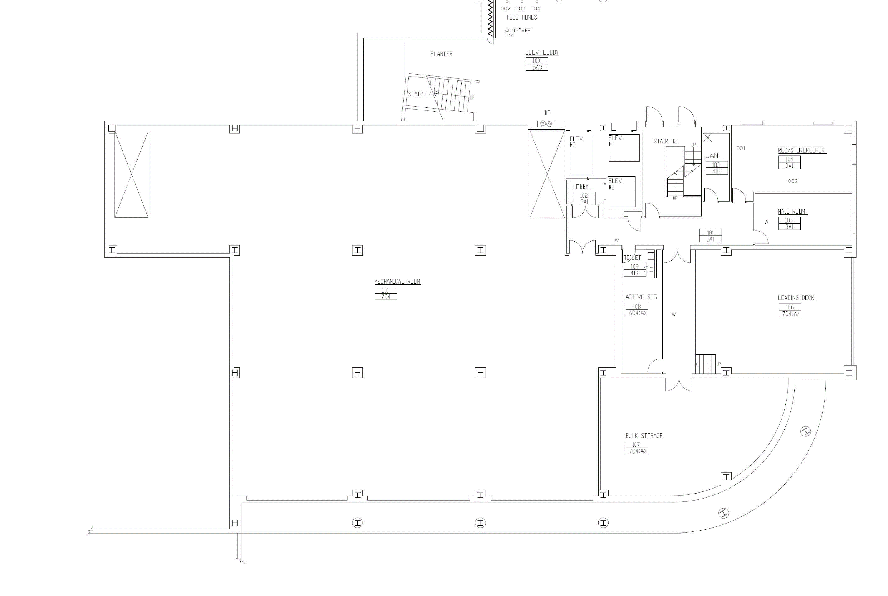
Entrance Graphic - FS1 or WS1

ROSENBERG LIBRARY FIRST
E

Authorized Entry - W1, W2, W12

No Entry - W3-A or W3-B Exit Only – W6
Primary Travel Path

Direction of Travel Graphic – F3
Automatic Hand Sanitizer Elevator Occupancy – W7
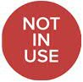 “Not In Use” – W8-A or W8-B
Restroom Rules – W9
R

Temporarily Closed – W10-A

No Student Access – W10-B

Locker Locations – W8-A or W8-C

FLOOR - OVERALL
Water Filling Station – W11

Entrance Graphic - FS1 or WS1
E

Authorized Entry - W1, W2, W12

No Entry - W3-A or W3-B Exit Only – W6
Primary Travel Path

Closed

Entry

Closed

H/ S

E

H/ S

E

Direction of Travel Graphic – F3
Automatic Hand Sanitizer

Elevator Occupancy – W7 “Not In Use” – W8-A or W8-B
Restroom Rules – W9
R

Temporarily Closed – W10-A

No Student Access – W10-B

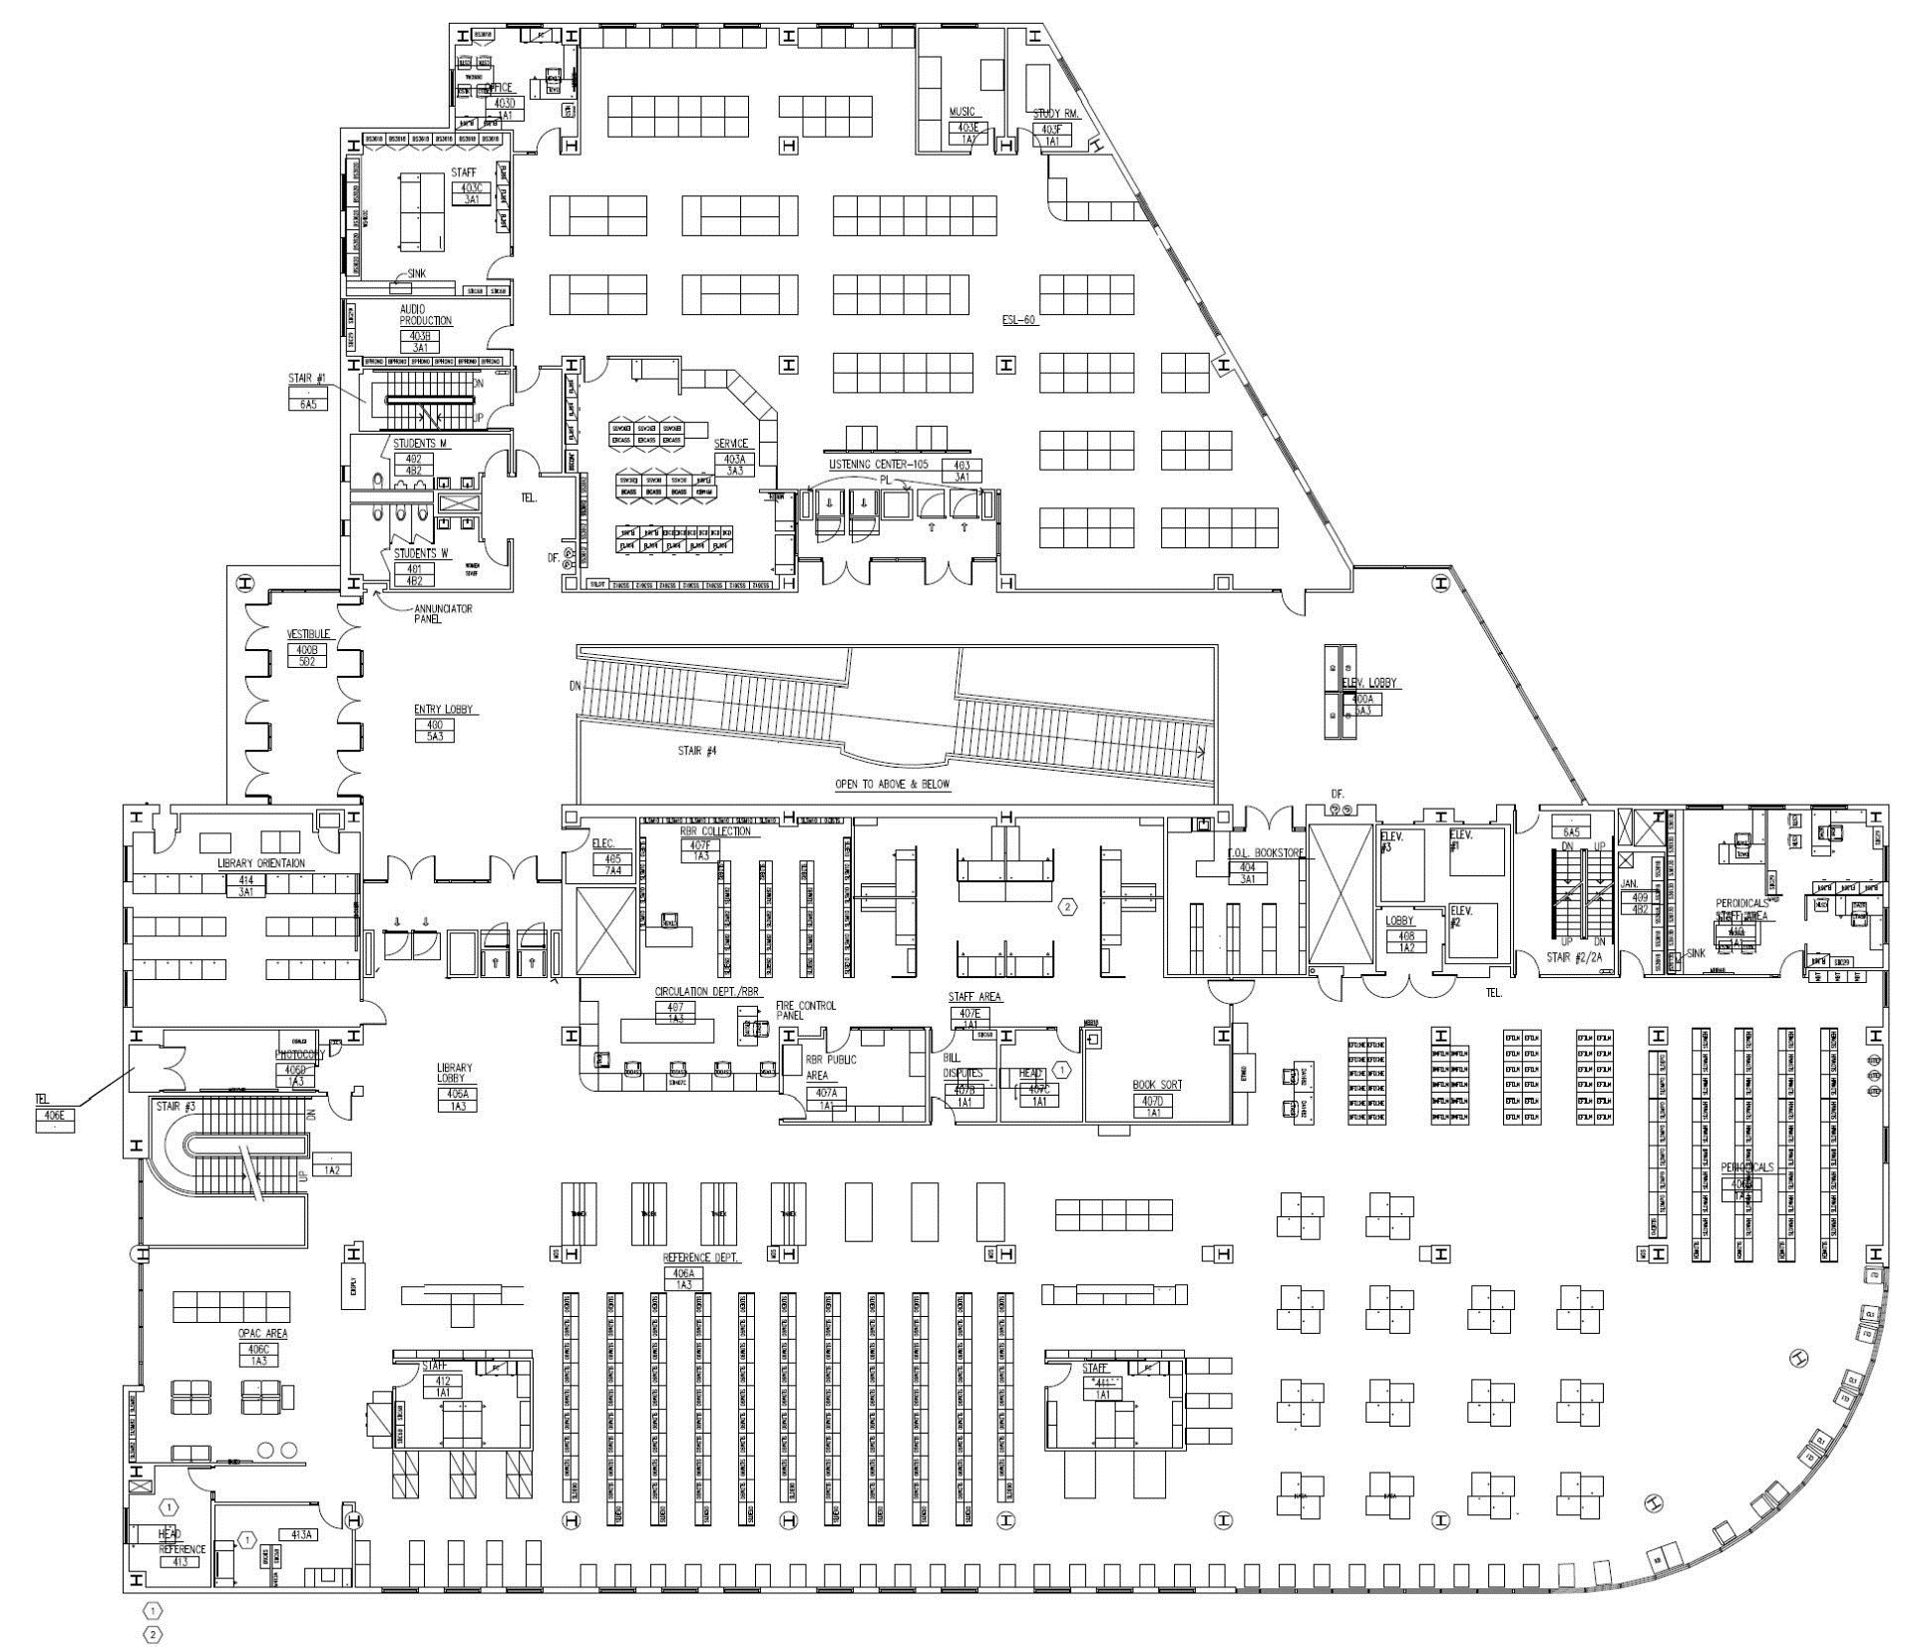

ROSENBERG LIBRARY FOURTH FLOOR - OVERALL
Locker Locations – W8-A or W8-C

Water Filling Station – W11

Entrance Graphic - FS1 or WS1
E
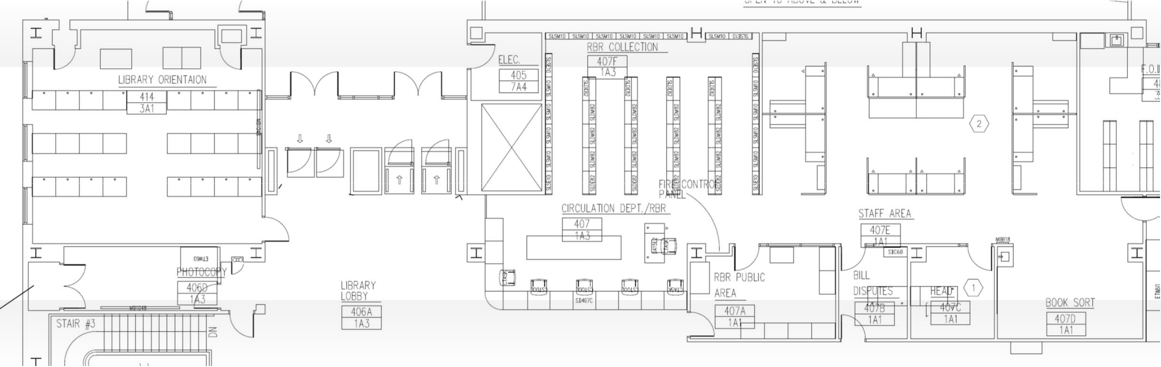
Sanitation Station Room Occupancy
1-2
S
S
2-3
1-2
S

Authorized Entry - W1, W2, W12

No Entry - W3-A or W3-B

Exit Only – W6 Primary Travel Path Occupancy
H/S

S
FOR PERIODICALS OFFICE
“Thanks for Practicing” Graphic – F1

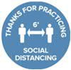
Direction of Travel Graphic – F3

Acrylic Barrier Install Location

Acrylic Barrier Install Location – Future Use

CIRCULATION DESK - ROSENBERG LIBRARY FOURTH FLOOR
Automatic Hand Sanitizer

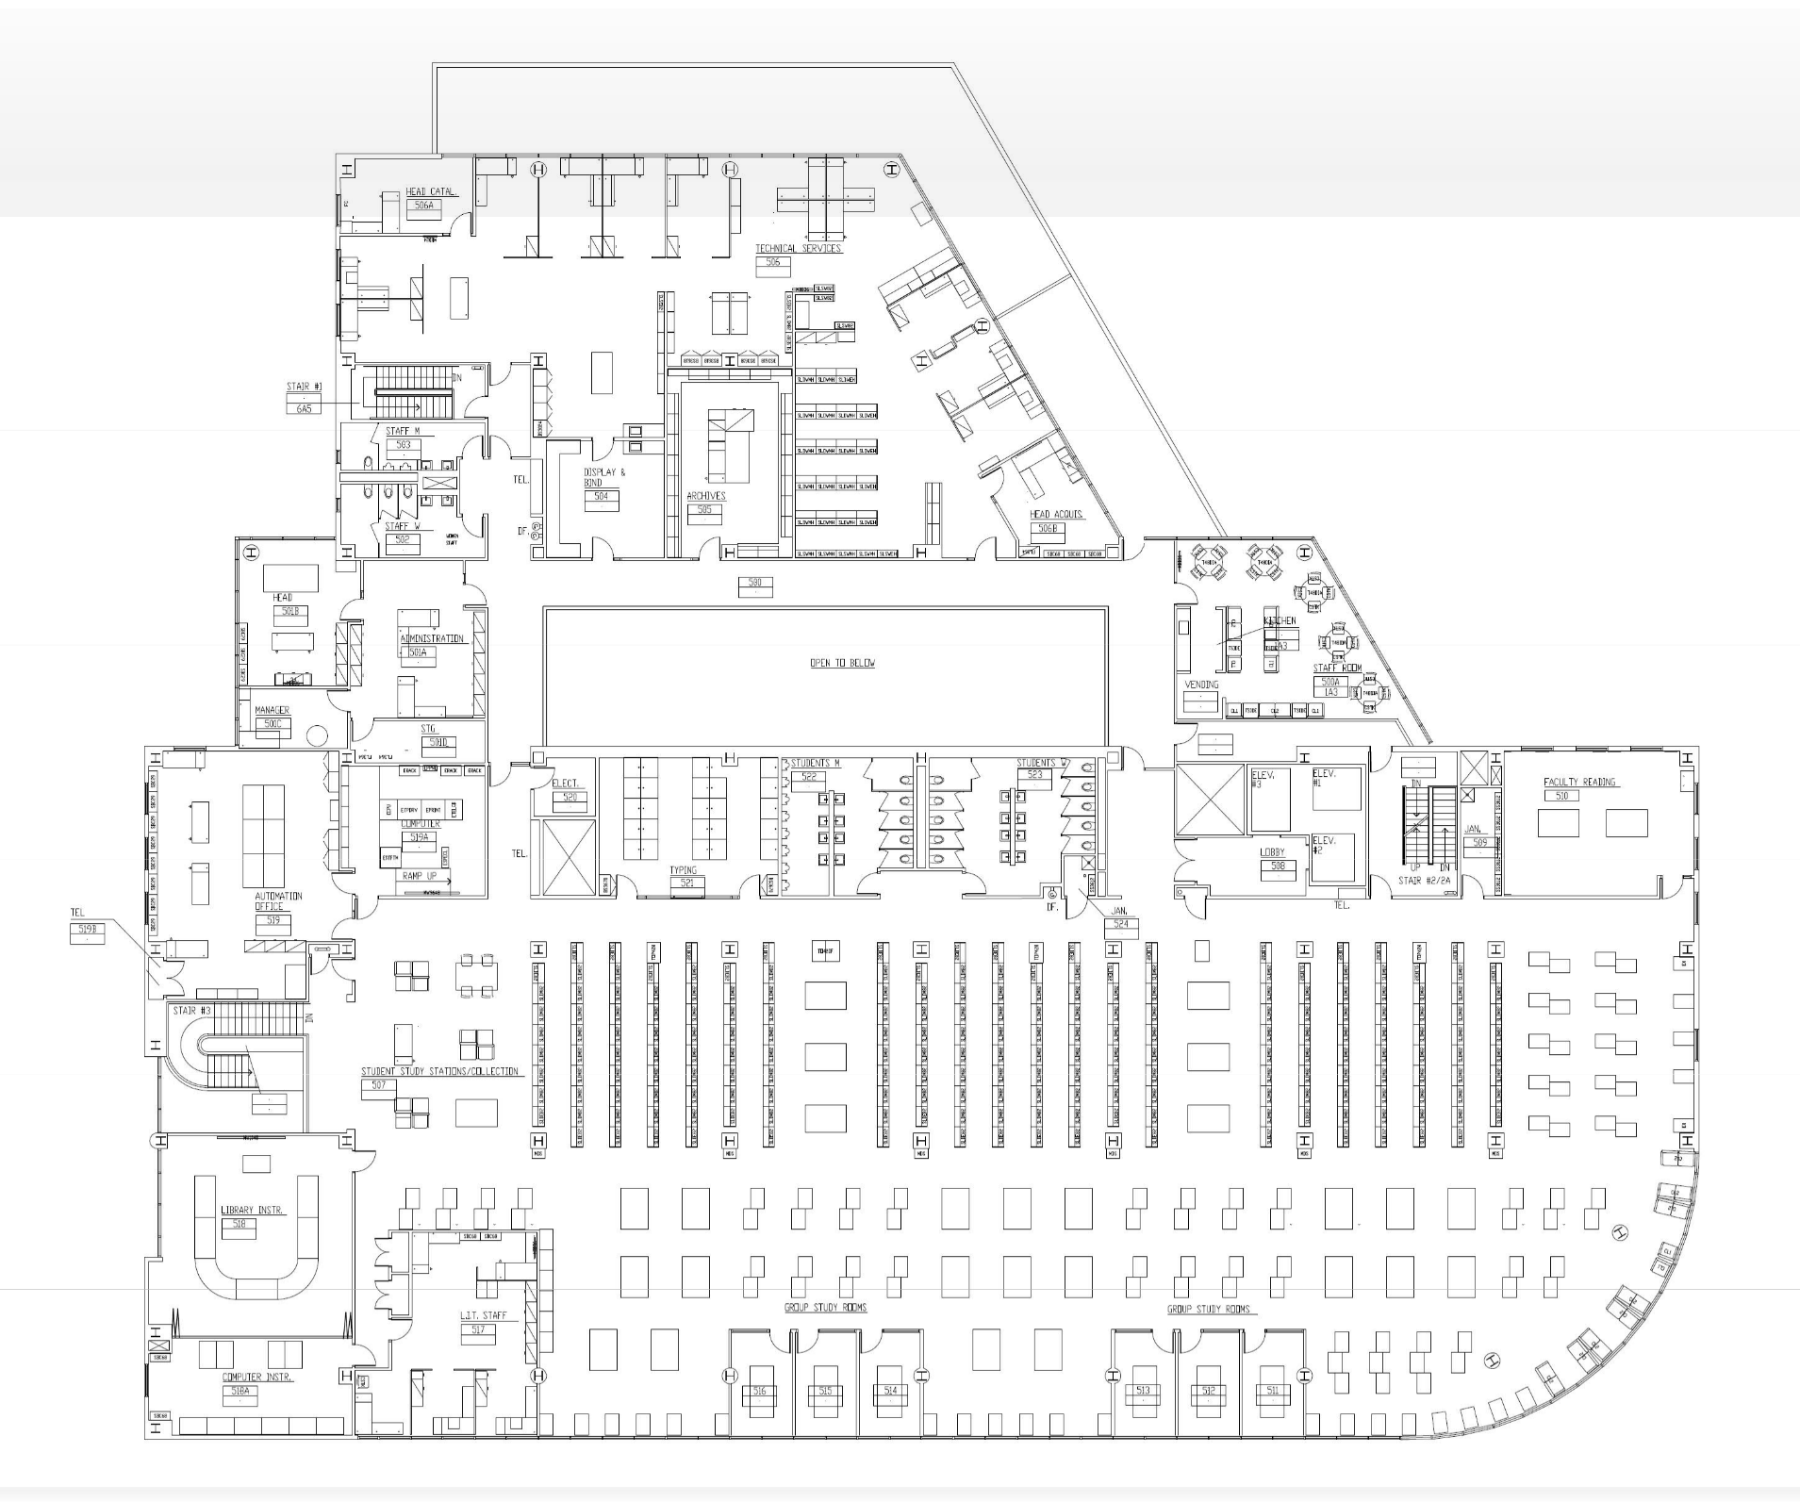
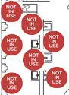
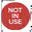
Entrance Graphic - FS1 or WS1
E

Authorized Entry - W1, W2, W12

No Entry - W3-A or W3-B

Exit Only – W6
R
R

Primary Travel Path

Direction of Travel Graphic – F3
Automatic Hand Sanitizer

Elevator Occupancy – W7
H/S
H/S

ROSENBERG LIBRARY FIFTH FLOOR - OVERALL

R R

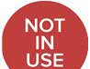 “Not In Use” – W8-A or W8-B Restroom Rules – W9
R

Temporarily Closed – W10-A

No Student Access – W10-B

Locker Locations – W8-A or W8-C

Water Filling Station – W11

STAY SAFE

CCSF ROSENBERG
LIBRARY
CONTACT FREE PICKUP

CALL 415-452-5433 WHEN YOU ARRIVE

