ALMA Quick Tips: Adding a Web-based OER to a Reading List

- Once you have created your course and reading list, go into the reading list, click on Add Citation, and select Add Brief from the drop-down menu.
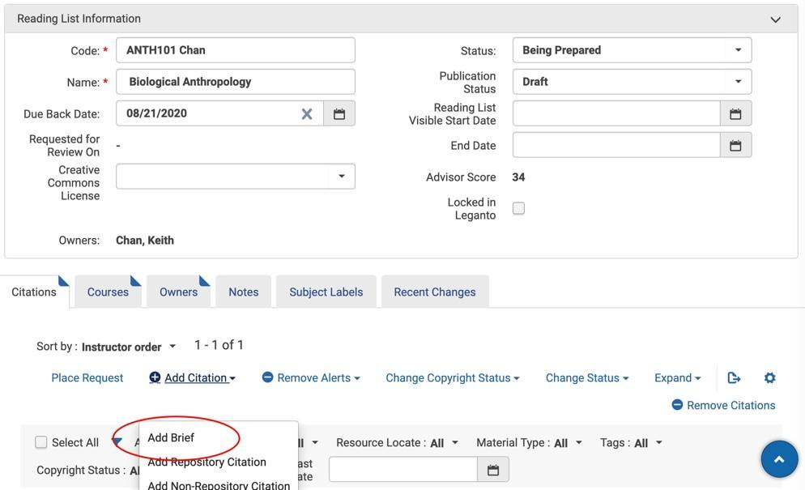
- Select Electronic Book or Electronic Article (whichever is appropriate) as the citation type when prompted.
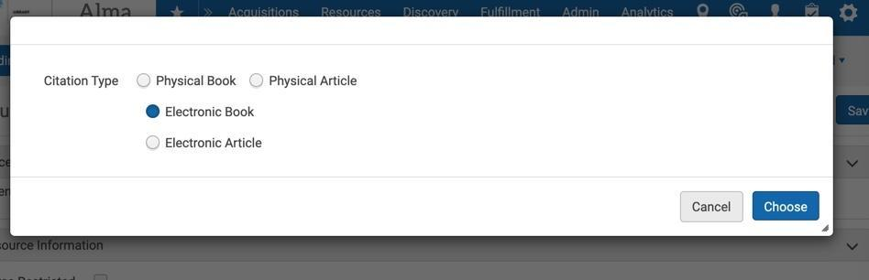
- Complete the required fields of the brief record and any additional fields you wish to include in the record. Select the appropriate library and insert the URL for the OER item in the Portfolio URL field.
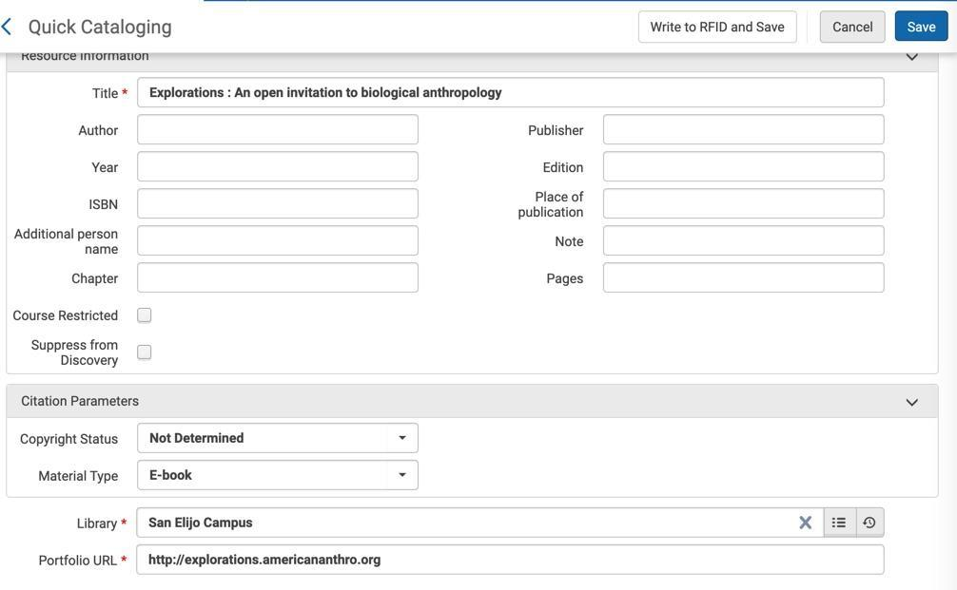
- Click Save in the brief record and then Save in the reading list.

- Go into Primo and search for the item to confirm the record was created and the link to the OER item works. Note that there may be a delay of up to 20 minutes before the item will appear.

