Circulation Work Group Meeting
February 4, 2020
In Attendance: Sara Cassetti (chair), Melissa Taylor, Antonio López, Anne O’Toole, Josh Hughey, Lauren Saslow, Lori Lisowski, Tina Boghozian
- New note taker for future meetings? Lori volunteered to take notes for this meeting. Sara suggested a rotation for future meetings unless someone is willing to do it more often. Let Sara know if you are interested.
- Review Google Form results on go-live dates for group members Sara shared the results from the group:
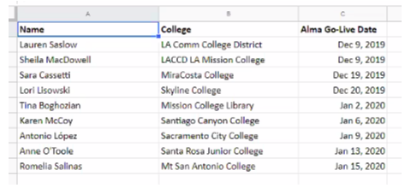
Josh (Pasadena City College) was Dec. 18.
- Check-in with group on post go-live issues Everyone reported that, in general, the initial system rollout was going well and that there was positive feedback from staff and students.
- Antonio reported on challenges SCC faces because they have satellite locations, an enormous reserve collection and are part of a four-college district. They are working out differences in philosophy and practice for TOUs and fines. They are trying to balance consistency with flexibility and to automate as much as possible.
- Sara said that MiraCosta is not charging fines, only replacement fees. She acknowledged the challenge of regulating the reserve collection without fines, but that they don’t want to punish the students who are using their services. They are looking at whether the demerit system in Alma might be useful. MC has had some issues with RFIDs and system time outs at the circulation desk.
- Lauren said the LACCD is trying to have as much uniformity in policies as possible. They do not have fines for circulating items, just reserves. She said there is some tension over the issue of fines on reserve items and concern about being punitive. Lauren was relieved that their hundreds of Fulfillment Units seem to be working. A next step is bursar integration.
- Lori suggested having another Google Form survey related to fines and fees to see how everyone is handling the issue. Sara said she would put something together.
- Josh reported that most issues are on the back end and not student facing. They are using feedback from users to refine the Primo configuration. The student assistants picked up the system quickly.
- Tina said many issues were migration-related. She discovered through submitting cases that these were often known issues that affected several colleges. She suggested that ExL put out a list of known issues with solutions or explanations. MCL is also working on bursar integration.

- Review responses from Professional Development Work Group questionnaire on top two training/PD needs Sara shared responses from the questionnaire:
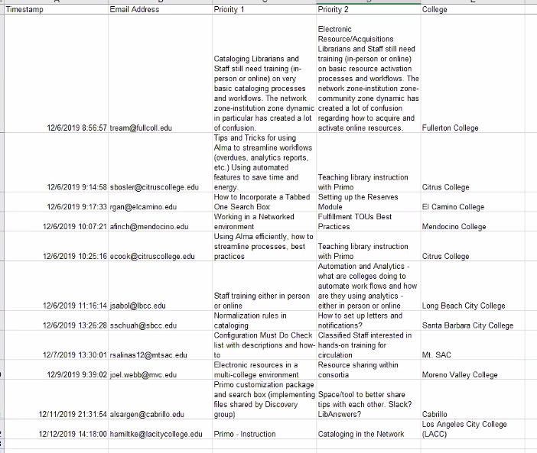
Most items did not appear to be circulation related, except for letters and notices, for which a tip sheet is coming. The group agreed that what we are currently working on covers the circulation training needs listed here.
- Updated Procedure docs: Registering new users Sara posted Lori’s revised document to the Wiki. It’s been customized for Skyline, but the added detail might be helpful as a starting point for other schools.
- New Procedure docs:
  - Fines and fees posting, and best practices for record management with damaged items Sara is working on this and will share something soon
  - Marking items “missing” Missing items can be handled in two ways—through a missing location and through toggle missing status. The latter requires a job to complete but suppresses items from discovery. Sara will send out the draft Quick Tips for review.
  - Adding a journal title from the Network zone Another school put together a 28-page document. Schools have had migration issues with periodicals and Sara said EBSCONet is not working well as a solution for MC. Sara will share the document for discussion at the next meeting.
- Fulfillment-related configuration issues
  - Temp location pop up note configuration Lori reported that the issue is a result of an API that ExL ran to move reserve call numbers out of note fields but it had unintended consequences. For now, staff is fixing the problem item by item.
  - Loan anonymization rules and previous patron info Staff are trying to find a balance between privacy and needed functionality in deciding how quickly to anonymize loan information. Sara said MC started at zero, but has increased that to five days. Lauren said the information is helpful for data clean-up and there’s going to be a discussion this week about where to set the time. Anne reported that SRJC has it set by patrons and checkouts not time, which is useful for tracking lost items. Lori said Skyline keeps information two patrons back.
  - Request rules for internal (library staff) requests for reserve/non-holdable items not requested through reading lists Sara will share a potential work-around with the group.
  - Inactive/suppressed location use for instructor-owned reserve items Sara also will share this with the group. This avoids removing and adding items to the reserves that are not being used every semester.
  - Lori reported that Skyline has been having issues with grace periods, especially over Sundays, when the library is closed and Saturdays, when they don’t want anything due because not everyone can get to the library on a Saturday. These exceptions are apparently not supported by Alma. An Idea Exchange proposal on the Sunday issue is listed as planned for adoption, but that was in June and there’s no indication of when it will happen. Lauren said that the ELUNA voting process has more clout and is a better way to make our voices heard than the Idea Exchange.
  - Anne reiterated and all agreed that the Quick Tips are much appreciated!

